Clove Toothache Compress for Pain Relief
A toothache is a dreadful thing that sends a lot of people running straight to the dentist. Unfortunately they have a nasty habit of striking in the night, thanks to changes in blood flow, and when the dentist’s office is closed. Or, you simply can’t make it to a dentist. Either way, cloves make an incredible (and inexpensive) home remedy for toothaches. Long before we had the dental care we have today, dentists used cloves to help pain because they contain Eugenol, a powerful anesthetic and antiseptic that stops pain in its tracks and wipes out germs. Eugenol remains popular and effective even now, and is still used by dentists today in a purified form that separates it from the essential oil.
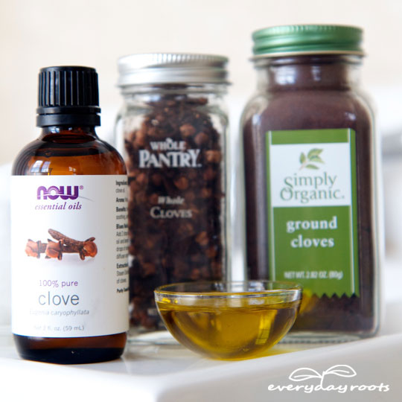
There are 3 forms in which you can use cloves to numb your aching nerve: Ground or powdered, whole cloves, or clove oil. A clove oil compress seems to work the best, especially if you’re too sore to put whole ones in your mouth.
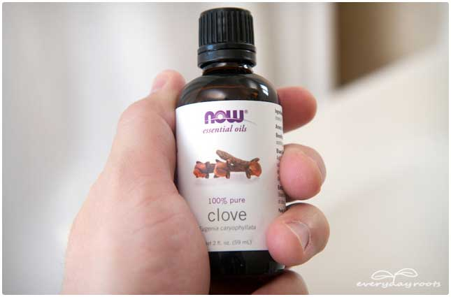
Ground: This is something that a lot of people have in their kitchen. First, rinse your mouth with warm salt water and wash your hands. Take a pinch of the ground cloves and apply it between the gum that is sore and your cheek. Your spit does the trick now, just wait while it mixes with the powder. The pain should subside rather quickly.
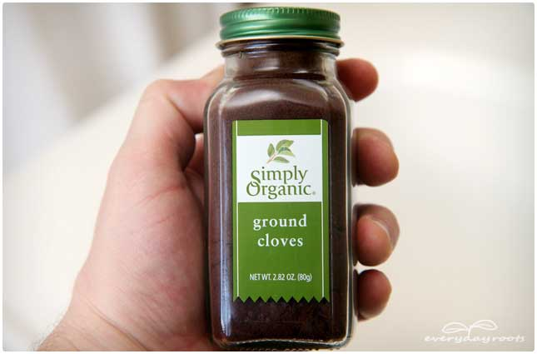
Whole: Rinse your mouth with warm salt water. Take 2 or 3 cloves and hold them in your mouth as close to the sore area as possible, and wait a few minutes until they start to soften. When they do get softer chew them lightly to release more of the oils, if you’re not too sore.
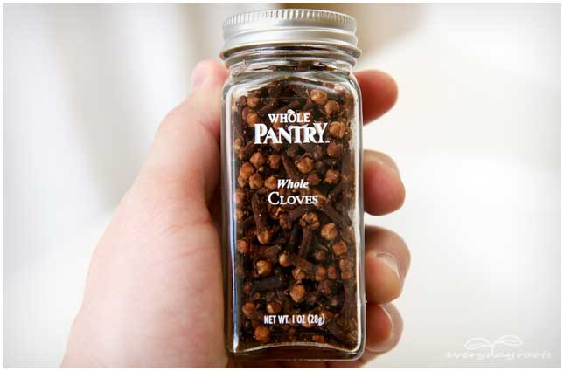
Clove Oil Toothache Compress
Probably the most effective way to use to clove to help your toothache is to make a compress.
You will need…
-Clove essential oil
-Cotton balls
-1/2 teaspoon of olive oil
-Cotton swabs (optional)
Directions
Rinse your mouth with warm salt water to get it nicely flushed out. By doing this beforehand, you’re allowing the oil to do its job the very best it can since there’s nothing to block it or make it hard to sink down into the sore spot.
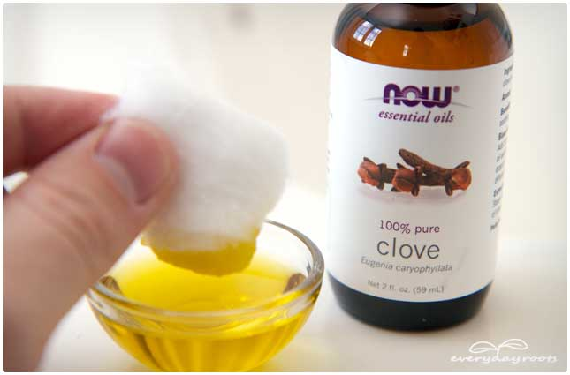
Mix a few drops of clove essential oil with ½ teaspoon of olive oil. Thoroughly soak a cotton ball in this mixture and then hold it gently but firmly against the sore tooth or gum. If you wanted to take a shortcut, you could try putting some of the oil on a cotton swab and dabbing it directly where it hurts, however, jabbing a cotton swab onto a hurting tooth or gum may not be too comfortable.
Keep in mind that this is just a solution to get rid of the pain, not something that will cure whatever is making your tooth hurt. Brushing and flossing regularly and eating less processed sugary/salty foods can help prevent toothaches in the long run as well.

