How to Make Lavender Dusting Cloths
These all natural, lavender dusting cloths are so simple to make and use. I love that I can hand them off to my kids at chore time and not worry about exposing them to potentially toxic chemicals.
Lavender is well known for its soothing, calming properties. I like my home to feel like a safe, calm oasis in the middle of a crazy world, so it’s one of my favorite scents to use around the house.
If you’re not a fan of the smell though, feel free to use another type of essential oil such as: lemon, lime, orange, peppermint, spearmint, or geranium rose.
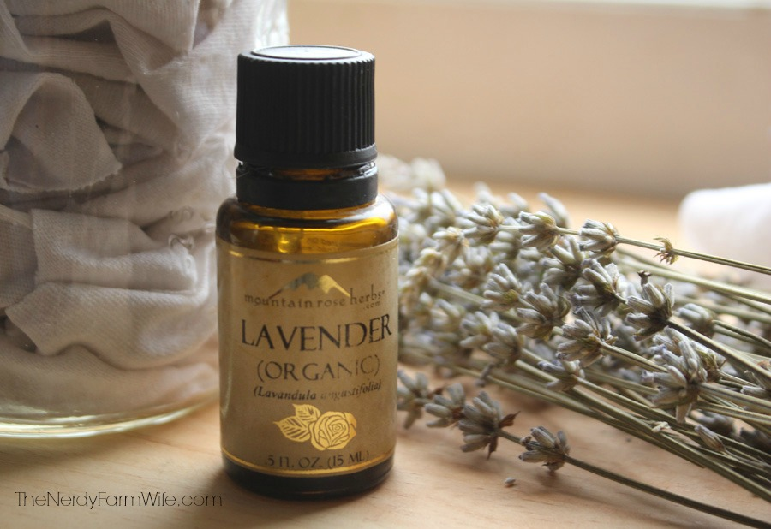
I found the original idea in The Complete Illustrated Book of Herbs by Reader’s Digest. You can buy a copy HERE on Amazon.com or check out your local book store.
I adore this particular book because it’s filled with gorgeous photos and lots of interesting projects and inspiring ideas.
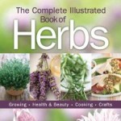

Making these dusting cloths is as easy as 1-2-3!
1. Cut an old t-shirt or other cotton fabric into squares.
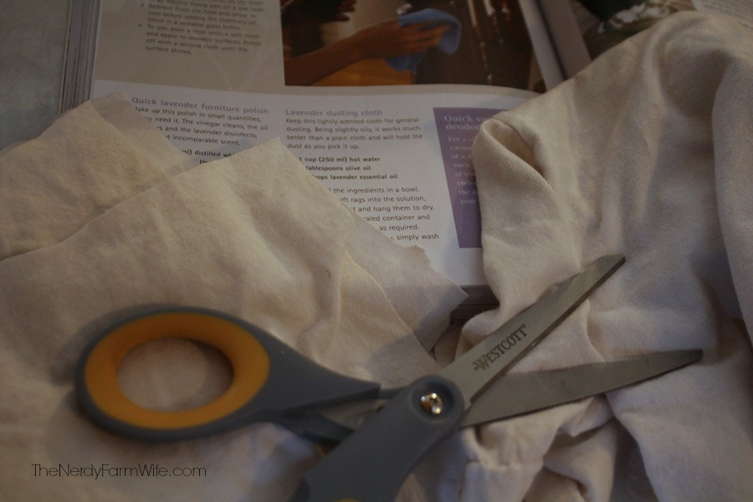
2. Swish the rags around in a solution of 1 cup hot water, 2 tablespoons of olive oil, and 10 to 20 drops essential oil.
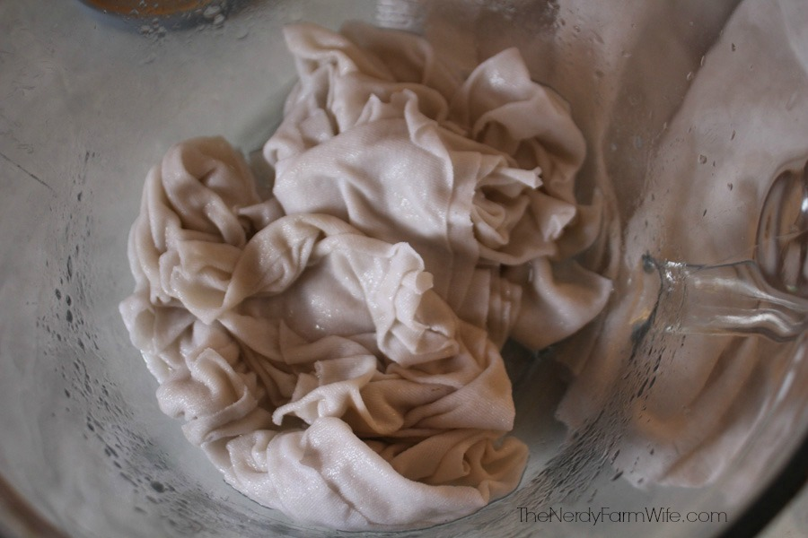
3. Squeeze the rags out and hang until completely dry.
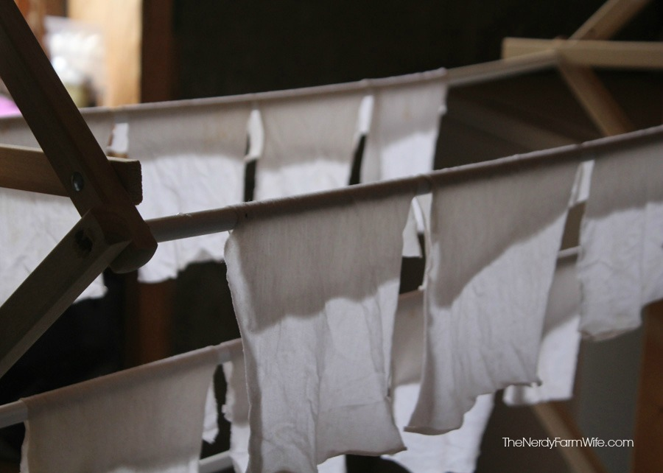
That’s it!
Store the dry rags in a tightly closed glass container. I like to add a few extra drops of essential oil before capping, for a stronger scent. (Click HERE for my favorite source of essential oils.)
Whenever you need to dust, just pull a dusting cloth out.
Because of the small amount of oil on the rag, it’s great at picking up dirt. No messy liquids or extra sprays are needed.
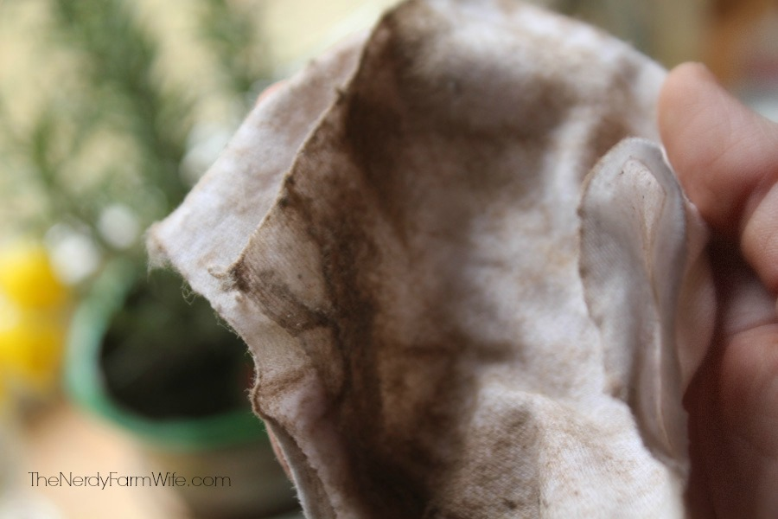
Once your cloth gets soiled, don’t throw it out!
Rinse it well under warm, running water with a small drop of dish washing liquid. Hang it back up to dry & reuse.
You can get a few more uses from it before having to resoak it in a fresh batch of oil solution.

