15 Must Have Survival Gadgets.
Collection of 'Must Have Survival Gadgets' from all over the world.
Lifesaverbottle: It's world's first all in one ultra filtration water bottle.
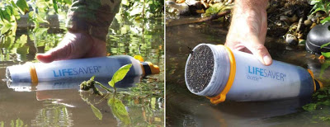
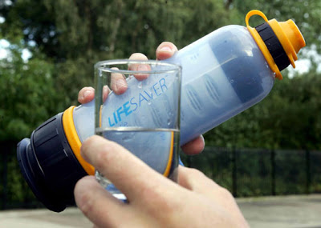
SOL Origin: It's a durable survival kit that contains a collection of tools that will let you survive outdoors longer.
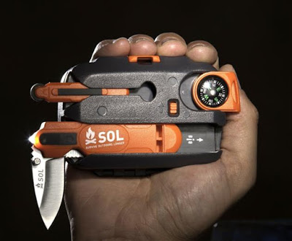
ToolLogic Firesteel Knife: This 3" stainless razor sharp blade includes a premium magnesium alloy firestarter that is capable of producing 5,500°F sparks.
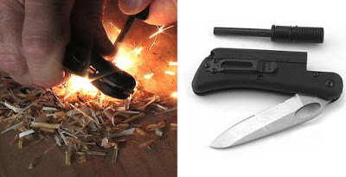
Fogo: This smart flashlight features a built-in GPS, digital compass, an accelerometer, 2-way radio, text enabled, USB recharger and more. It connects to your smartphone via Bluetooth. It allows you to connect with your friends via text message, built-in walkie-talkie, and sharing your location and other data.
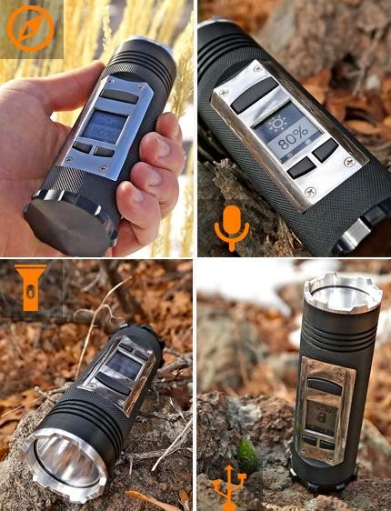
Portable Water Condenser: It's a portable water condenser designed for warmer climates, it condenses the moisture in the surrounding area to create useable drinking water.
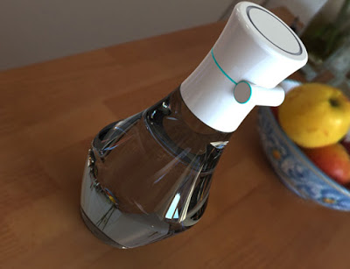
Powerpot: It's a portable electric generator that doubles as a cooking vessel; Powerpot transforms the heat you make from any heat source into electricity, using a technology called thermoelectric power generation. You can recharge any USB device (smartphones, digital cameras, lights, head lamps, radios, water purifiers, GPS, and more).
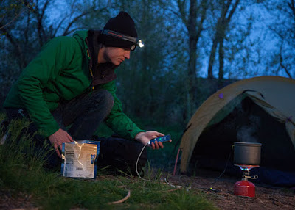
Weathermate: This handpowered radio provides you with instant access to NOAA weather radio frequencies.
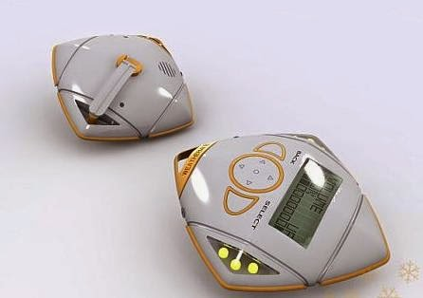
Portable Solar Rechargers: These solar rechargers come in three sizes and a five-pronged USB cable allows you to recharge up to four gadgets simultaneously. Once you are done, the rechargers can be folded for easy storage and portability.
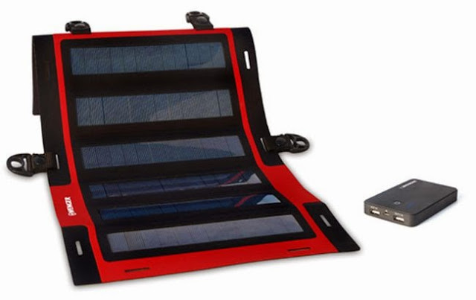
SATcase: SATcase is a rugged case that transforms your Android smartphone (presently Samsung Galaxy S4 Smartphone) into a satellite phone. All you need to do is install the SATcase app apart from satellite airtime contract to use it anywhere. It also contains a 406 beacon.
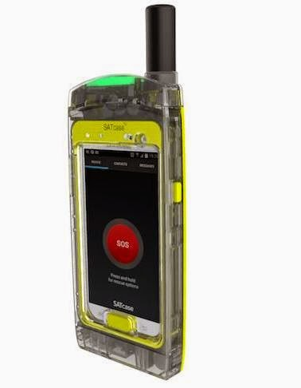
Foldable Solar Cooker: This solar cooker is foldable and lightweight; it's perfect for those who want to pack light.
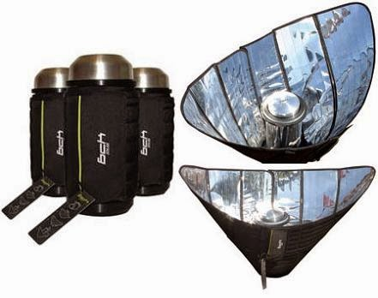
Solar Water Kettle and Thermos: The Sunrocket is a solar powered kettle and thermos that heats water for drinking, washing, cooking and more. It's perfect for traveling and camping.
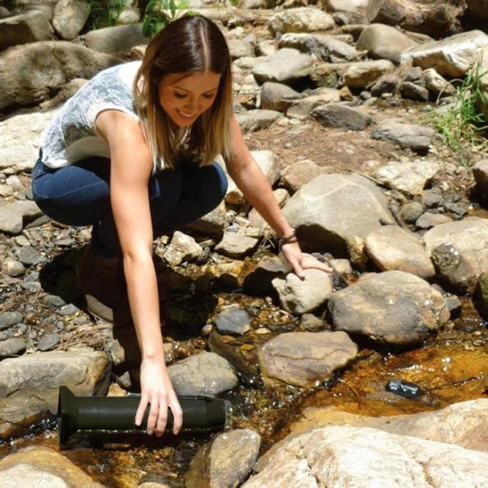
Just in case - Bracelet: This bracelet turns into 14 feet of paracord and comes with a side-release buckle, great for camping, hiking, and more.
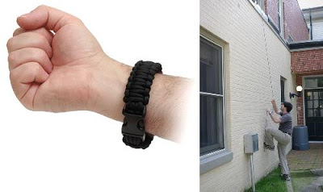
Micro Grappling Hooks: It's light weight, reusable and entirely made of stainless steel, has a storage space, and the attachment point for 550 or smaller cords.
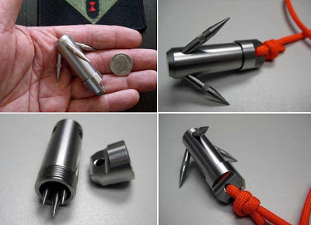
Cardsharp 2: It's a super light and super sharp utility knife, that comes in the size of a credit card.
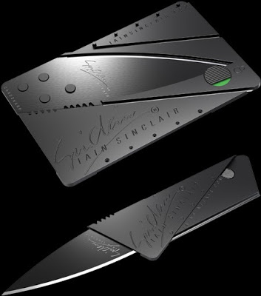
Superhammer: This multi-purpose tool features a bottle opener, multipurpose wrench, nail puller, chisel and much more.
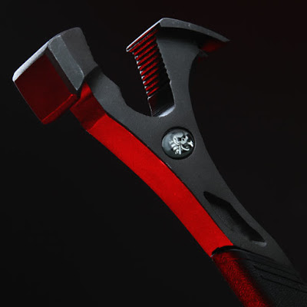
Other Posts:
15 Smart Attachable Gadgets for Kitchen.
15 Smart Bathroom Gadgets For You - Part 4.
50 Coolest and Awesome iPhone Attachments.
15 Clever and Creative Milk Packaging Designs.
15 Awesome and Coolest Wearable Bottle Openers.
15 Stylish Pillows and Decorative Pillow Designs - Part 12.

