24 Survival Tips For Living Alone
Living solo can make a few nagging home and kitchen issues even more frustrating than when you have someone around to help.

1. Open a stubborn jar using rubber bands.
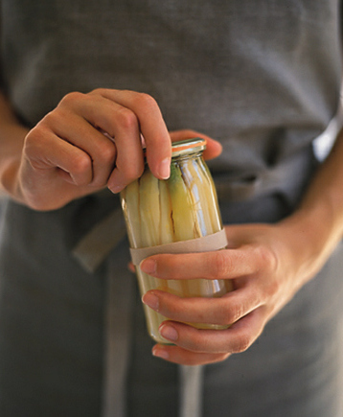

marthastewart.com
Place one rubber band around the lid, and another around the jar. With one hand, grip the jar where the rubber band encircles it; use the other hand to twist off the lid. The rubber bands provide friction, so your hands won’t slip off the jar or lid.

2. Or buy a JarPop.
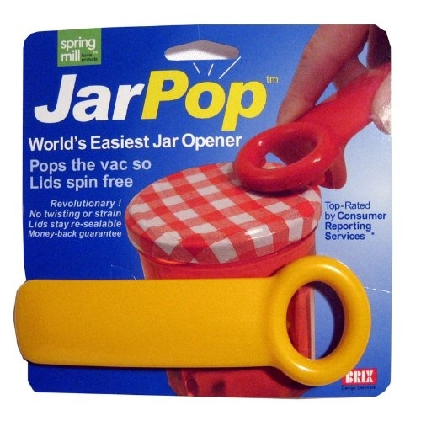

amazon.com
$6.05 from Amazon.

3. Use a mason jar to store leftover wine.
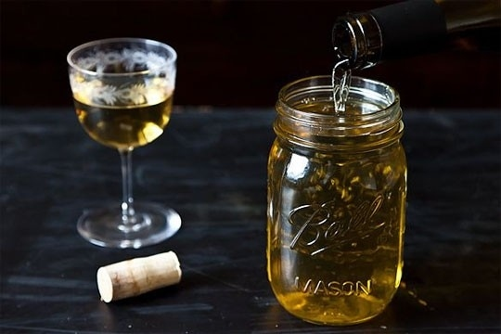

food52.com
Make sure the wine overflows so the jar is completely filled and no air gets into the wine. It’ll store in the fridge for a week. (No judgements if you’re the type who can down an entire bottle of wine by yourself.)

4. Keep a bottle of soda from going flat.
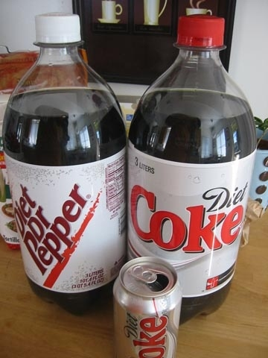

helpfarm.com
Once you’re done with your soda for the day, shake it up before putting it back in the fridge. It’ll stay fizzy for weeks.

5. Use Windex to move a heavy appliance.
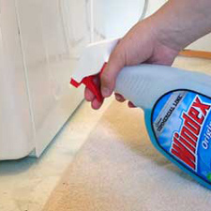

apartmenttherapy.com
Spray Windex around and in front of the feet of the appliance you’re trying to move. It will slide much more easily.

6. Pre-make pancake batter and store it in a ketchup bottle.
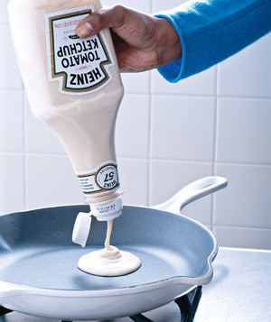

crafterholic.blogspot.com
The pancake batter will stay good for a few days in the fridge.

7. Use toothpaste to perfectly hang a picture.
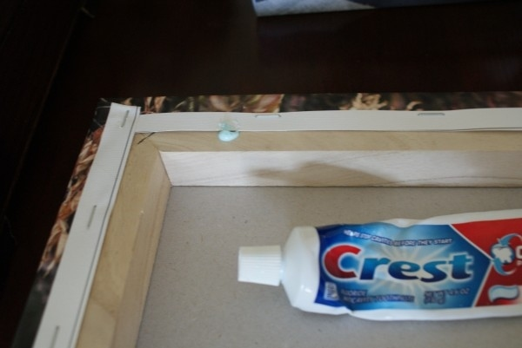

somewhatsimple.com
Add a dab of toothpaste to the back of the picture where the nail will go.
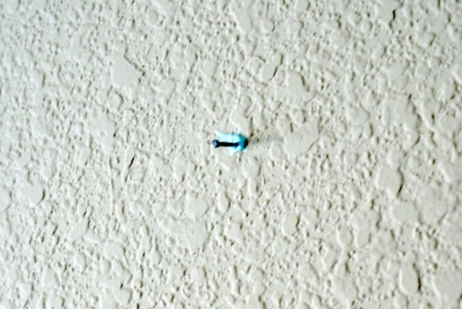

somewhatsimple.com
Once you’ve found the perfect place to hang your picture, press the picture against the wall so the toothpaste leaves a mark. Hammer a nail on the toothpaste spot. This is a great technique for hanging pictures in a straight row, or as a collage.

8. Or use Command Frame Strips if you can’t even deal with hammer and nail.
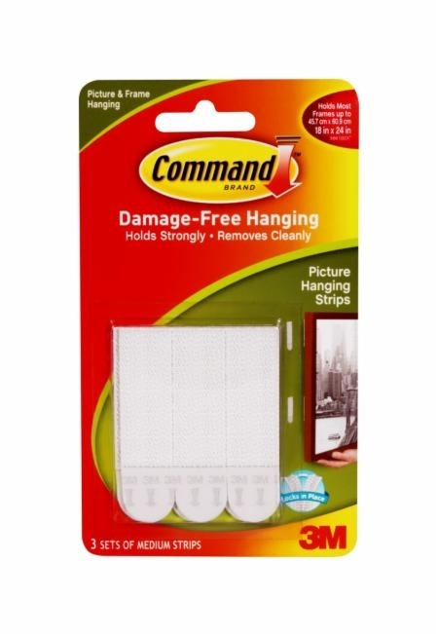

multimedia.3m.com
They’ll firmly hold pictures up to 12 lbs.

9. Get Ethylene Gas Guardian pods to make your produce last longer.
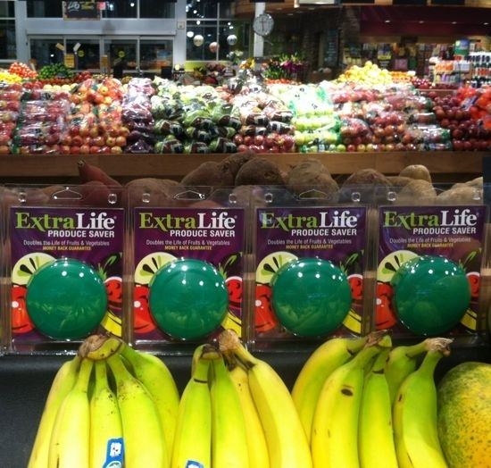

amazon.com
Just put them in your crisper. They’re known to double the life of your fruit and vegetables.

10. Use peppermint oil to deter mice.
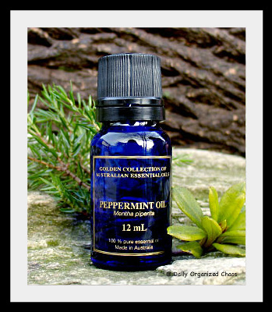

dailyorganizedchaos.com
Rodents are allergic to peppermint. Dab on cotton balls and place in area of infestation. Or, mix with water and pour into a spray bottle; spritz rodent-infested areas with the mixture.

11. Use electronic mouse traps if you’re super squeamish.
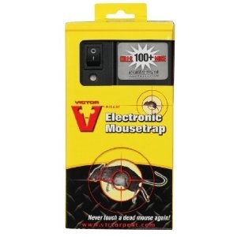

ecx.images-amazon.com
You won’t have to see or touch the mouse. It’s also one of the more humane methods out there.

12. Use a safety pin and a string to zip up the back of a dress.


primaproductions.com
1) Tie one end of a ribbon/string through the circular end of the safety pin, tying a knot to secure it in place.
2) Hook the safety pin through the hole in your zipper.
3) Use the string to pull the zipper up.
In the photo: there’s a product that does this, but you could easily make your own.

13. Use scotch tape to put on a bracelet.
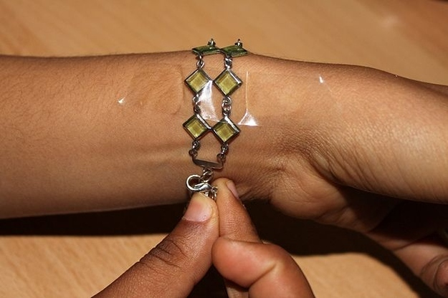

pad2.whstatic.com
It’ll keep one end in place while you hook the clasp.

14. Use baking soda and vinegar to unclog a drain.
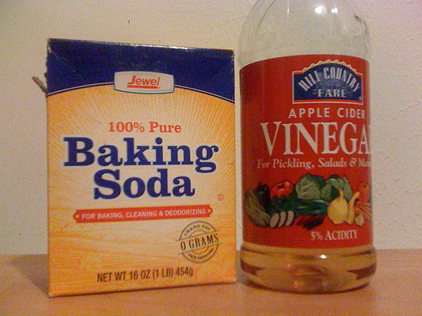

tidymom.net
1) Pour 3/4-1 cup of baking soda in the drain.
2) Pour 1/2 cup vinegar in the drain and immediately cover the drain with a plate.
3) Wait 30 minutes, then uncover and run hot water for 2-3 mins.
4) Repeat for really tough clogs.

15. Use dishwasher soap and hot water to unclog a toilet.
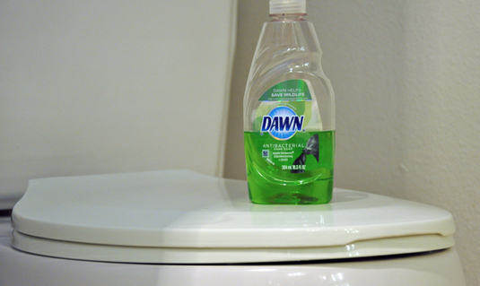

lifehacker.com
Pour hot water and dishwashing detergent into a toilet before plunging.

16. Put a duvet cover on in 24 seconds.


womansday.com
1) Fold the duvet cover into quarters so one long opening is facing you.
2) Fold the duvet into quarters.
3) Slide the duvet, long crease first, into the opening of the duvet cover.
4) With your fingers, hold the two open corners of the duvet cover, along with the duvet corners. Shake it out.

17. Wrap a shower cap around an overly-sensitive smoke detector.
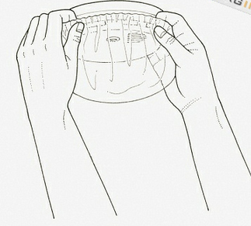

Secure with a rubber band. Now you’ll never have to get on a ladder to turn it off every time you cook or take a shower.

18. Put bay leaves in nooks and crannies to keep roaches away.
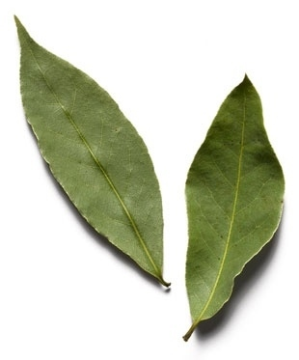

media-cache7.pinterest.com

19. Place a damp paper towel over your leftovers while microwaving.
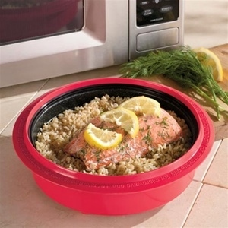

lifehacker.com
One thing that sucks about leftovers is how the rice/pasta hardens up. This trick steams and rehydrates your food.

20. Buy organic milk.
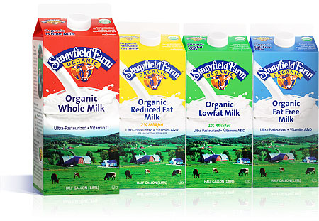

myessentia.com
It keeps way longer than regular milk.

21. Use a set of tongs to reach an item on a high shelf.
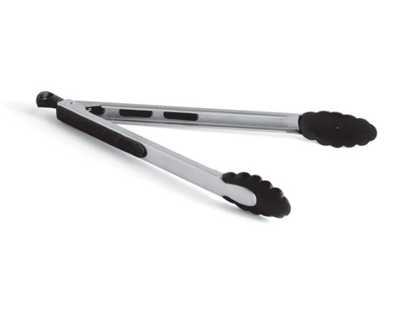

iweb.rachaelraystore.com
Like these 12” long Oxo Good Grips tongs, $12.99 from Amazon.

22. Use a small paint roller to apply lotion or sunscreen to your back.
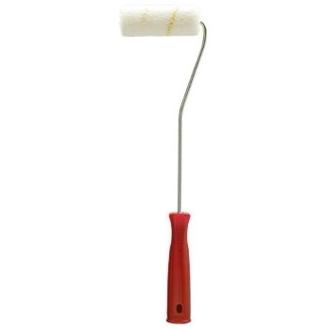

i00.i.aliimg.com

23. Save time by using your dishwasher to wash things other than dishes.
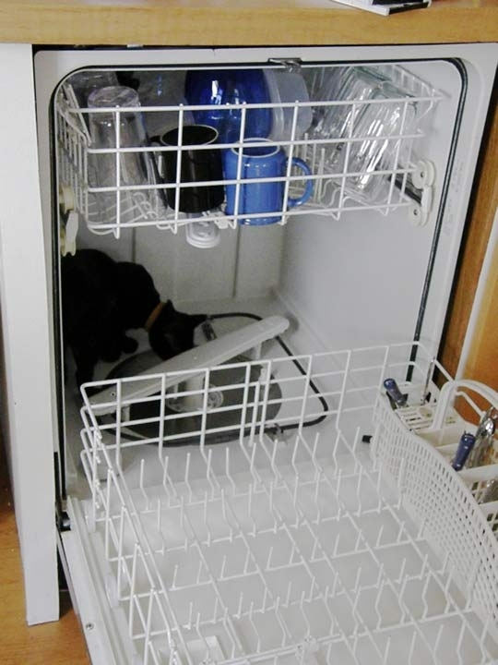

apartmenttherapy.com
Examples of things you can clean in your dishwasher: plastic hairbrushes and combs, rain boots, flip flops, baseball caps, broom heads, dustpans, potatoes, garden tools, pet toys, ceiling fan faceplates, mop heads, license plates, sink sponges, computer keyboards, makeup brushes, light fixtures, and hubcaps.
Things you shouldn’t put in there: wooden cutting boards and utensils, cast-iron pots and pans, your cat.

24. Invest in a home alarm system.
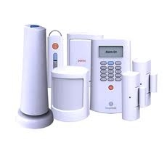

simplisafe.com
This one by SimpliSafe starts at $14.99/month.

