4 Keys to Avoid Unexpected Hypothermia

by Todd Walker
One of the top concerns of winter outdoor activities is hypothermia. We are well aware of that possibility and prepare accordingly. With summer approaching, what's the worry?
I've been chilled to the bone on a few spring camping trips in Georgia... especially in wet conditions. One I'll never forget was a fishing trip my brother-in-law and I made on the Flint River in mid-March of 1981. We motored up river, set trot lines, and made camp near a sandbar. We woke to a heavy frost blanketing our lightweight summer sleeping bags under a freezing Georgia sky. We were unprepared for the evening temperature change. It was springtime!
A good scare is worth more to a man than good advice. ~ Edgar Watson Howe
Our mountain temperatures in June are sneaky and cold enough to drain your body heat by morning. On planned overnighters, having the means and skill to regulate core temperature is critical to enjoying your camping trip. On unexpected stays, it could mean staying alive.
We tend to associate hypothermia with frigid winter temperatures. However, people can die from losing body heat with temperatures in the 50-degree range. Why?
Most people take day hikes or camp in late spring and early summer unprepared for this unexpected threat. Body heat generated from hiking a mountain trail is a double-edged sword. Yes, you're warm while active... and sweaty. The mercury drops and the wind picks up at higher altitudes. Evaporative cooling is a wonderful to a certain point. Dressed in minimal, sweat-soaked clothing, you may find yourself on a slippery slope of suffering from exposure. You must be prepared to take steps to protect from further cooling.

Hypothermia Warning Signs
Hypothermia is subtle. No matter how experienced you may be in outdoor adventures, core temperature control should be a top priority on every outing. Sadly, just two summers ago, a well-known and experienced hiker succumbed to the elements in Washington. It can happen to anyone.
Few places in this world are more dangerous than home. Fear not, therefore, to try the mountain passes. They will kill care, save you from deadly apathy, set you free, and call forth every faculty into vigorous, enthusiastic action. ~ John Muir
There are inherit risks in outdoor activities. Heck, just rolling out of bed holds its own risks. That doesn't keep adventurous types out of the wilds. Managing risks successfully keeps us alive out there.
Here are the stages and symptoms signaling a drop in your core temperature.

Mild Hypothermia
(Body temperature between 89-95F/32-35C )
- Constant shivering
- Tiredness
- Cold, pale, blotchy skin
- Numbness and tingling skin
- Blue fingers and toes
- Fast breathing

Moderate Hypothermia
(Body temperature between 84.2-95F/28-32C)
- Ability to think clearly and attention suffers
- Confusion
- Slurred speech
- Lose of judgement and reasoning ability
- Stiff muscles and cramping
- Shivering stops
- Slow or irregular pulse
- Drowsiness

Severe Hypothermia
(Body temperature below 84.2F/32C)
- Unconscious/unresponsive
- Pupils dilated
- Irregular or no pulse
- Undressing and terminal burrowing occurs in 1/4 of the people who freeze to death
- Bodily functions and organs begin shutting down
Immediate medical attention is needed to stay alive.

Reduce Your Risk
Being unprepared this time of the year is hypothermia's power. Dirt Road Girl and I have passed many day hikers happily enjoying mountain trails in early spring and summer wearing shorts, t-shirt, and maybe a water bottle with no contingency day pack in sight.
Who knows, these folks may possess skills and fitness levels to able to construct an emergency shelter from leaves and sticks to stay warm if an unexpected stay in the wilderness happens. Unless you're on a self-imposed survival adventure, always carry a minimum of core temperature control gear.

Shelter
No matter what clothes you're wearing, pack a 5 x 7-foot emergency space blanket. Add a cheap plastic painters tarp and you have two items used in constructing Mors Kochanski's super shelter. My experience with this design is very favorable if you're able to maintain a fire throughout the night.
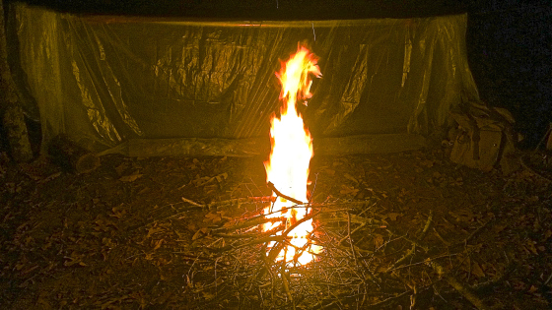
Super shelter
A bright orange tarp is also useful as a signaling device. Large contractor garbage bags weigh little but offer many uses in core temperature control. I pack two.

Fire
Fire is the most forgiving of all survival skill. Even without proper cover, a good fire can keep you alive.
Carry a fire kit with redundant ignition sources: Open flame - Bic lighter, matches; Spark ignition - Ferro cerium rod, flint and steel; Solar ignition - magnifying lens.
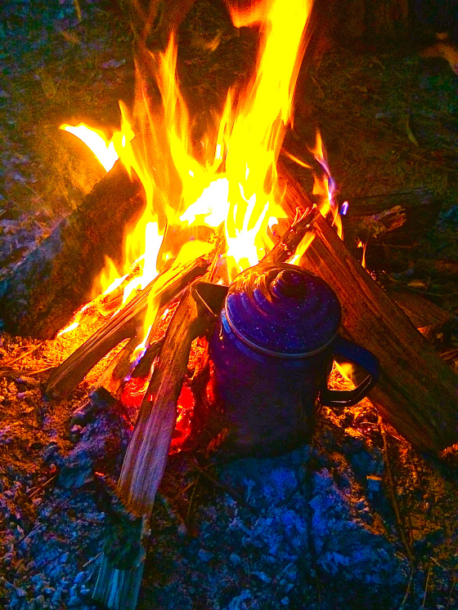
Fire and hydration
There is dry tinder material even in a wet forest. However, be prepared and carry a proven source of dry tinder in your kit. It doesn't have to be natural material either. Commercial or diy fire starters are highly recommended when fine motor skills have said bye-bye to cold hands. Also, duct tape burns long and hot. Here's a compact method of carrying several feet of duct tape.

Keep in mind that a person's early-stage shivering may stop after being warmed from radiate heat around the fire, but their core temperature may still be dangerously low. If one person in a group is experiencing obvious signs of hypothermia, it's very likely that others are in early stages as well. Watch out for each other and take action when needed.

Hydration
A well hydrated person has a better defense against hypothermia. More fluid increases blood volume and conserves heat in your core longer than if you are dehydrated.
Carry a metal water bottle which can be used to boil water in the fire you've built. A hot cup of cocoa adds some warmth to the core while hydrating the body simultaneously.

Prepare for Extremes
Check the local weather report before heading out. I just returned from a weekend with our Georgia Bushcraft group. I planned to bring my sleeping bag (MSS). The weather report showed temperatures in the 80's to the low 60's with rain on Saturday. I typically only use my poncho liner in those temps in my hammock. However, I wanted to over-prepare. When setting camp, I realized I'd forgotten my sleeping bag. That's why checklists are helpful... most of the time. I made do but was rather chilled the first morning.
The lesson on this trip was to double-check the checklist. Extra layers I had packed came in handy for warmth in the hammock. Plus, I had my closed cell foam ground mat which I employed. Coupled with my emergency space blanket, the cool, rainy Saturday night in Georgia posed no problem to a good night's sleep.
Summer temperatures are headed our way. Under normal circumstances, hypothermia never crosses most of our minds this time of the year. We welcome cool breezes and rain showers. By following the above mentioned points, core temperature control shouldn't be an issue.

