http://rethinksurvival.com/posts/72-hour-survival-game-link/?utm_source=feedburner&utm_medium=email&utm_campaign=Feed%3A+rethinksurvival+%28reThinkSurvival.com+Updates%29&utm_content=Yahoo%21+Mail

- 72 Hr Survival Game:
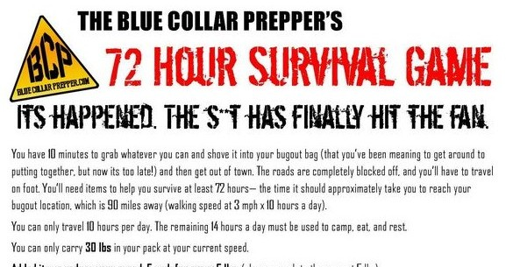
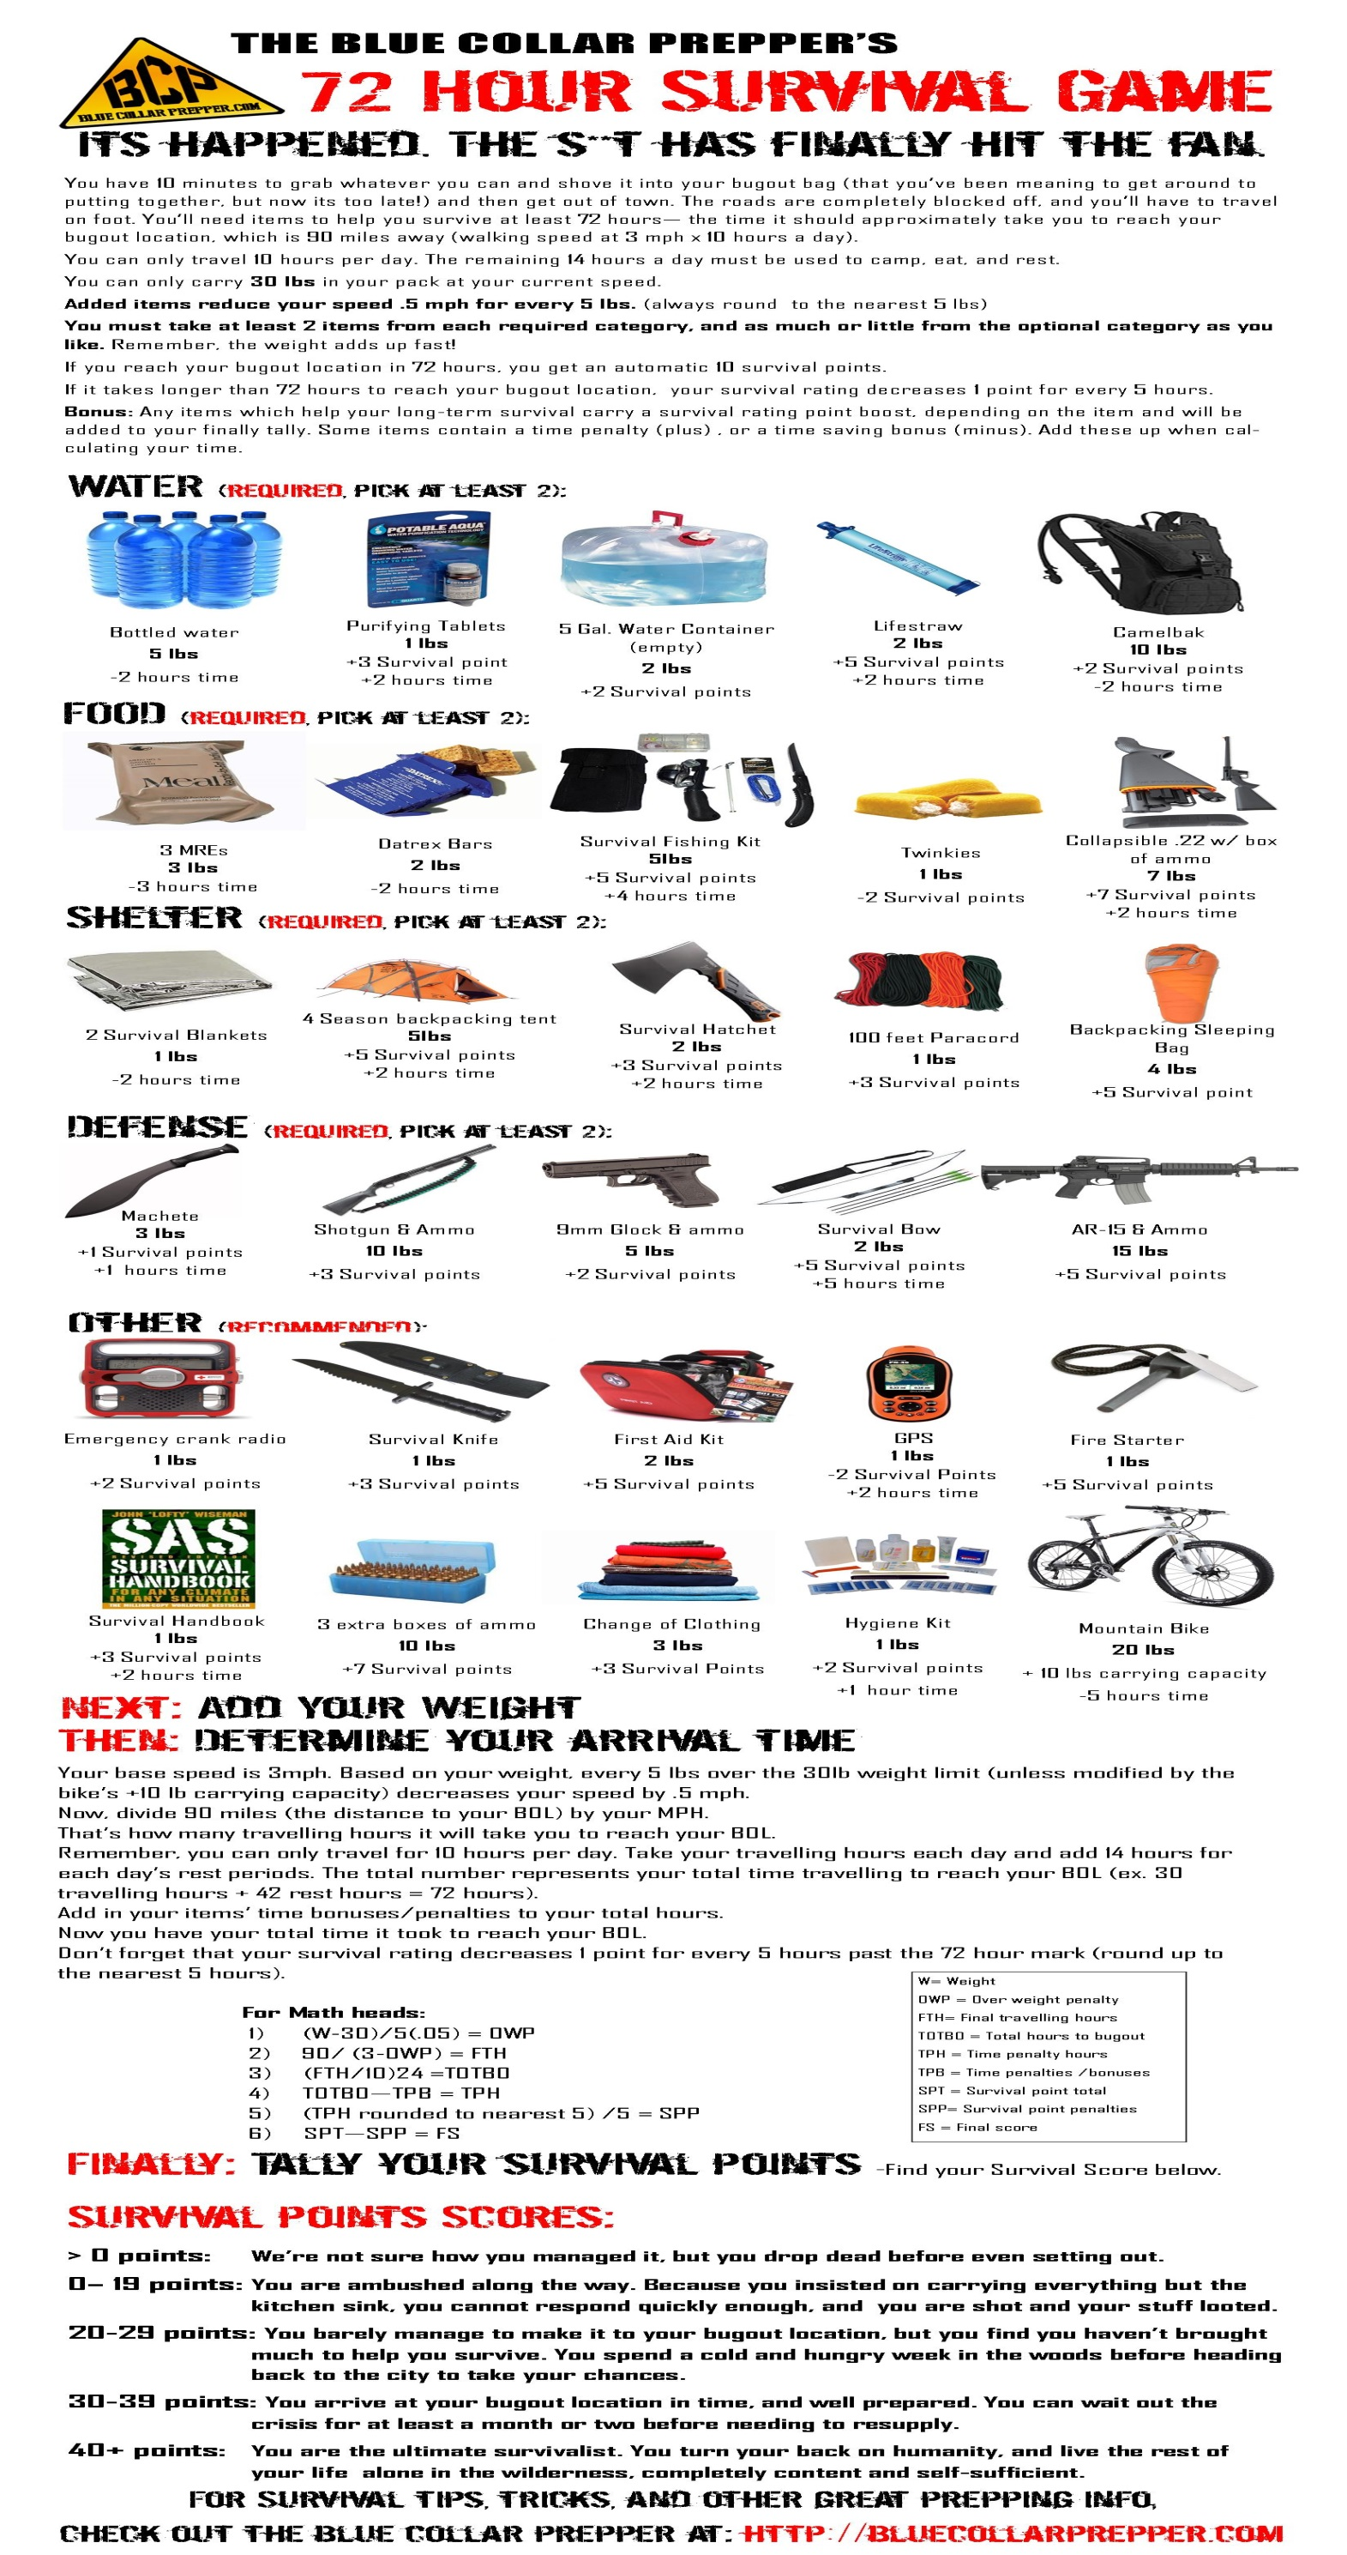
You have to bring enough to help you survive – but if you bring too much, it will slow you down. Can you make it to your bugout location in 72 hours with enough to survive?

