Benefits of Wool Gear
By SNO Man

Wool Stuff For Your Survival Kit
I’ve been prepping most of my life, and to this day I’m constantly revising and improving my plans. Lately, I have rediscovered an interest in natural fiber clothing for outdoor activities and bushcraft. I didn’t originate this idea; in my dealings with hunters, hill people, technical climbers, dog-sledders, and so on, I’ve seen a trend back to natural fabrics.
First of all, let me be honest — I have sissy skin. What I dislike the most about wool is that it’s scratchy, and I’ve never found a wool item that was completely itch-free like silk or polyester fleece. Even with the softest Merino or Cashmere, I won’t pretend it doesn’t itch at all; I just tolerate it because there’s so much to love.

About the Boreal Shirt From Lester River Bushcraft
My new Boreal Shirt from Lester River Bushcraft is the best thing since Al Gore invented the Internet. It’s one of my top favorite items of kit, next to my ESEE 3 knife, the Sport Berkey filter bottle, and my Maxpedition Falcon 2 backpack.
This sweater is made from 100% wool US military blankets, and the design, build, and features are top shelf. It is sold by Lester River Bushcraft under license from Empire Canvas Works, which makes a nearly identical item with an 80/20 wool and nylon blend.
Some outstanding features of this shirt:
- It is cut large so you have room to layer underneath, and long to cover that large mass of buttocks flesh, retaining additional heat.
- The wrists cinch shut with stainless steel snaps.
- The hood and neck gusset cinch down with draw cords.
- There’s a shock cord at the hem to stop drafts and let you adjust the length.
- The huge front pocket offers shelter for your hands, and multiple internal storage pouches. There’s even a zippered pocket for your valuables and two lashing rings to clip keys or tools.
- Naturally flame retardant and spark resistant, antibacterial, and resistant to dirt and oils.
- Pre-shrunk so you can care for it at home.
- Handmade in Duluth, Minnesota, USA. That’s Duluth. These people know about cold weather.
- It’s a loose, comfortable fit so you can really move around, chop wood, reach overhead, whatever. Yet you can cinch down all the openings to keep the heat in — or open them all up for ventilation, as needed.

Photos of the Lester River Bushcraft Boreal Shirt (click to enlarge).
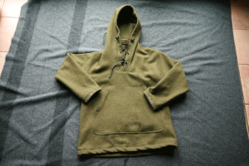
Boreal Shirt from Lester River Bushcraft. Made from 100% wool US military blankets.
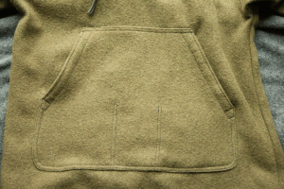
Lester River Bushcraft Boreal Shirt Large Pocket. It also contains three internal slip pockets, a large zippered pocket, and two D-rings for clipping keys or tools.
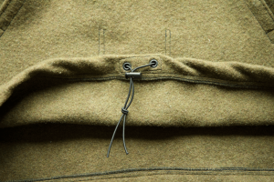
Lester River Bushcraft Boreal Shirt Lester River Boreal Shirt Hem. Shock cord can be cinched shut or cinched up to shorten. Notice the metal grommets and heavy stitching.
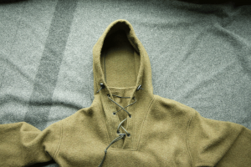
Lester River Bushcraft Boreal Shirt Gusseted Neck. Leave it open to ventilate, or shut it with the paracord cinch.
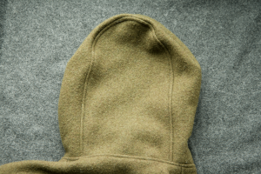
Lester River Bushcraft Boreal Shirt Rear Hood Panel. This is both functional and esthetic; it keeps the hood from falling over your eyes, and it avoids the pointy-hooded medieval wizard look.
Heads-up on a couple of things. First, let’s be honest — it’s scratchy. Just grin and bear it, OK?
Moving on. The material has no stretch, so don’t get it too small or you’ll never be able to take it back off. It’s deliberately cut large, so if you’re normally a large, it will fit like an extra-large. This is good, though, as it allows for layering and plenty of mobility even though there’s no stretch to the fabric. I actually bought a medium, which is just barely too snug with two layers under it, but I expect to wear it with just one layer, or maybe two thin ones most of the time.
If you have any questions about the fit, just call Jason Gustafson at 218.428.4766. He’ll help you decide what size you need. Tell him I sent you so he’ll know I’m loving this shirt.

Pros and Cons of Wool Gear
Wool is good for a lot of reasons, but it’s not a panacea. Make an informed decision about equipping your survival kit by considering the advantages and disadvantages.
Pros:
- Warm when damp. Unlike cotton, for example, wool can get wet and still retain some insulating ability. To be clear, wool will not keep you warm when it’s sopping wet (maybe warm-er than cotton), but it does absorb water up to 30% of its weight before feeling wet. The process is exothermic, which means that the wool garment actually generates a small amount of heat as it absorbs water. I don’t want to overstate it, though, because I don’t know how many calories of heat you get — it could be negligible.
- Water repellent. Water beads up on wool, especially if it’s treated with lanolin, or better yet if the lanolin was never removed in processing. The tighter the weave, the more it repels. Felt is the most repellent; knitted wool is generally the least repellent.
- Warm to the touch. A 30° F aluminum plate will feel much cooler to the touch than a wooden plate at the same temperature, because it is a much better conductor. The same applies to fabrics; wool base layers feel warmer than silk.
- Highly breathable. A segment in the video above dramatically illustrates how breathable wool is. I went for a vigorous hike in 5° F and worked up quite a sweat. I felt perfectly comfortable, though, because the clothing didn’t get wet. The wool base layer allowed the sweat to evaporate from my skin and passed the water vapor to the outer layer. As it passed through the outer wool shirt and contacted the frigid air, it condensed and froze on the outside of the shirt, forming little beads of ice. My second layer was a mid-weight polyester fleece jacket with marginal breathability, so imagine how well my clothing would have performed with all wool.
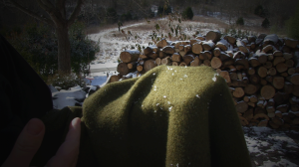
Click to enlarge. Breathable wool garments. Ice from sweat evaporating off the skin, then condensing and freezing when it contacts frigid air.
- Fire/spark/scorch resistant. It’s easy to dry wool by the campfire, but if you try this with synthetics, sparks will melt little holes in the fabric.
- Resists body odor. Wool is naturally antibiotic and resists body odor much longer than synthetics.
- Wide temperature comfort range. This characteristic has a subjective component, but it is anything but trivial; wool is better at regulating body temperature. When I wear polyester fleece, I get colder in the cold and hotter indoors. But when I wear wool, I don’t chill as easily when I go outside, and when I come back in, I tend not to overheat as quickly. In short, wool has a wider comfort range than synthetics.
Cons:
- Scratchy. For someone with sissy skin — like me — there is no kind of wool that isn’t scratchy. Period.
- Heavy. No doubt about it, it’s much heavier than synthetics. See the Ultralight Fallacy, below.
- Bulky. Wool doesn’t stuff well. Many synthetics with the same warming power will easily compress into small packages.
- Expensive. You can spend upwards of $200 on a high-tech synthetic fleece jacket, but you can also go to warehouse clubs and buy them on sale for $10. Try that with wool. (This just goes to show that wool has greater intrinsic value, so maybe this should be in the pros section).

The “Ultralight Obsession” Fallacy
If you have to tote your gear for many miles, weight is undoubtedly an issue. But it is only one of several factors that should guide your choice. Certainly, wool is heavier than, say, polyester fleece with the same warming power, but this weight penalty is balanced by greater breathability and temperature comfort range.
These two characteristics of wool are monumentally important. In the real world, they translate into greater productivity. If you’re backpacking up and down hills, alternating through shade and sun, wool will allow you to keep going, but with fleece you’ll have to stop, remove the pack, and take off a layer, strap it to the pack, re-equip the pack, and resume your course. Then, when it cools again, you’ll have to go through it all again to put the stupid thing back on and avoid a chill. This cycle is tiresome, and you can reduce its frequency with wool.

If weight is you primary consideration, you might prefer down. I have a Marmot Zeus Jacket, and I love it, but it already has campfire spark holes in the synthetic material of the sleeves.
Also, down doesn’t keep you warm when it compresses, so if you lean back in a chair, it smashes the down and you lose all insulating ability. Likewise, if you put on a heavy duster for rain protection, it will compress the down at the shoulders and you lose heat that way. I love down, but it has its limitations too. Wool doesn’t compress much, so it keeps you warm even if you lie on it.
So yes, wool is heavy and bulky, but it does things light stuff can’t do.

Recommended Wool Items
I have outfitted my survival kit with the following wool items.
- Hat. I have a Navy Watch Cap from Amazon, but I’m going to try an Ibex Meru merino wool hat. I’m hoping it will be less scratchy.
- Socks. These Wigwams are great for hiking.
- Gloves. I have a pair of these Raggs, but they have a synthetic insulating layer. When they wear out I’ll shop around for something else.
- Base layer. I got a set of midweight Minus33 thermals for Christmas, and they’re great. Very comfortable. But just FYI I’ve heard excellent things about these Ibex Woolies. Both brands use Merino wool.
- Sweater. You have got to check out the Boreal Shirt from Lester River Bushcraft. It’s made from 100% wool US Army blankets. The design and build quality are peerless. It’s scratchy, mind you, but nothing a soft neck gaiter and a thick beard can’t fix. It’s my favorite new piece of kit. Watch the video above for details.
- Blanket. Genuine US Military Issue blankets are still the best value, even though they cost 500% more than they did 10 years ago. Watch out for “US Military Style” blankets. The weave is thinner, they’re smaller, and they’re usually not even 100% wool. The real thing is getting harder to find. Check these out at $50 apiece, but shop around and see if you can find them cheaper. I found some half that price in Sept. 2013.

A Few Sensible Alternatives to Wool
I do prefer synthetics for certain applications:
- I keep a windproof, water resistant shell jacket in my everyday carry bag. It’s supposedly “breathable,” but that’s more of a marketing term than a descriptive one. However, it’s very useful; it stuffs in the pack, it’s light, and it’s large, so it fits over just about anything else I’m wearing. Plus, it was jaw-dropping cheap at Sam’s Club a couple of years ago — you can spend literally over $300 for this one, but I found an off-brand on sale for $12 at a warehouse club, so I bought four extra and gave them away. Maybe the other one is better than mine, but I’m pretty sure mine is close enough to “good enough.”
- For pants, I like the 5.11 Tactical poly-cotton blend ripstops. They come in several varieties, and I’ve reviewed a couple of them here and here. They’re rugged and well designed. If it’s very cold, I add a wool base layer. They’re not much protection in wet weather, though.
- If I ever wear a neck gaiter, it’s usually to help with a scratchy wool sweater like the Boreal Shirt in the video. I use a totally scratch-free poly fleece, but I’d like to try a soft Merino wool like this one from Minus33.
- For rain protection I really like my Outback Trading Company Stockman Oilskin Duster. There is another outer layer option I haven’t tried: The Empire Wool and Canvas Company Anorak. It’s expensive — and out of stock anyway — so it might be awhile before I can review it.
- Here’s a particularly interesting piece of kit.
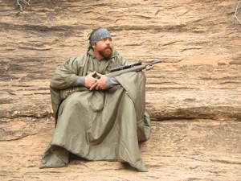
HPG Mountain Serape
It’s the Mountain Serape from Hill People Gear, a brilliant, multipurpose item; blanket, sleeping bag, great coat, and poncho. Here are several more photos and an exhaustive discussion about it.

