Bugging out on foot with a bug-out buggy
Posted July 18, 2013 in Survival by Bill J with 3 Comments
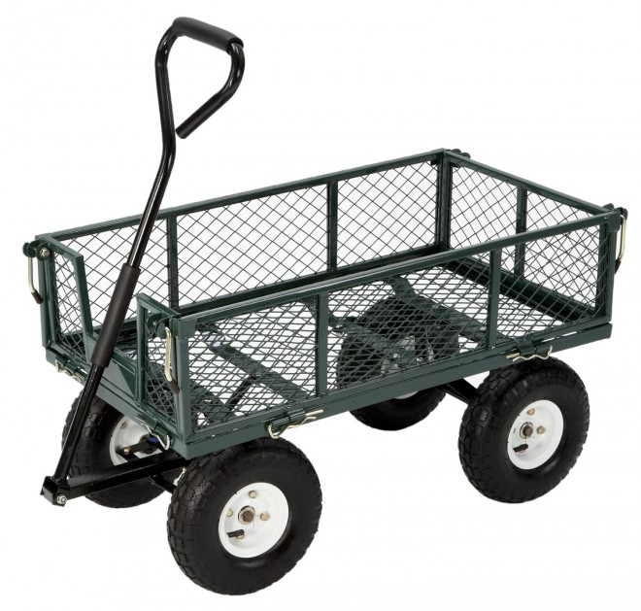
In my post on my Ultimate Worst Case Scenario Gun, I described my absolute worst-case bug-out scenario as having to leave a major US city on-foot with multiple small children in tow. God forbid it would ever come to this, but I could imagine that with a major EMP situation nobody’s cars would work and we’d all be walking. And people actually had to walk out of town with nothing but what they could carry after Katrina to escape the flooding, so while the odds that I’ll be on foot are remote, they’re not zero.
At any rate, this got me thinking about how, exactly, I’d get my family the heck out of Dodge without my uber-large SUV. It’s tough enough to squeeze everyone into the SUV for a day trip, so I can’t imagine actually trying to walk and carry a bunch of stuff. It turns out I’m not the only one who’s been thinking about this problem.
Willowhaven Outdoor has a really good article on bugging out on-foot with a family. The gist of it is that you need some kind of buggy or wagon that you can push or pull, and that can go over various types of terrain. In other words, don’t bother snagging a shopping cart on your way out of town, because you won’t get far.
The author of the article took a nice garden cart and modded it so that it has extra features and storage. It looks really great, and while normally I’d be rolling my eyes at the cammo paint job I can actually see where you might want to be able to hid this thing. At the very least, you don’t want it to draw attention to itself if it’s sitting alone for a minute.
So I’m sold on this bug-out cart concept now, and I’ll be picking one up soon for the back yard. I won’t go modding it and painting it cammo right away, though. Better to let it live in the back yard as an actual garden wagon so that the neighbors don’t think I’m nuts, and then stash the mods somewhere so that I can apply them in a few minutes if the time ever comes.

