Bushcraft Trail Fork
By Creek
When I go on an overnight camp/hike I enjoy the ‘camping’ more than the ‘hiking’. I always look forward to picking a site, setting up camp, and getting a fire going so I can relax. I hate pushing a hike up until dusk looking for a site. I prefer to choose a site well before dark so that I can get everything in order and work on what I call ‘camp-craft’. I always work on little projects once I’ve set up camp. Whether it’s building a tri-pod to hang a cook pot or carving a spear, I like a good camp-site project. I like to improvise when it comes to some camp tools as well – source from nature what I can when it makes sense. Not only does this give me something to do, but it also allows me to carry in less gear – which is always a plus.

One such little project is what I call the Trail Fork and it can be made in less than 1 minute.
I rarely eat Ramen Noodles at home but when it comes to a camping trip they are one of the first things I grab. They are cheap, easy to prepare and delicious. And, they are best eaten with a fork. To improvise a quick fork from nature, look to the trees. Typically, I look for Pine or Maple. Pine and Maple branches consistently grow in the fork-shaped pattern we are looking for and both trees are non-poisonous. In this post example, I am using White Pine. I prefer Pine because of the aroma and slight flavor in the finished fork. It adds a very natural element to any camp meal. Below are 2 branches with about 6-8 nice forks hidden in-side. Instead of Where’s Waldo, let’s play Where’s the Fork?
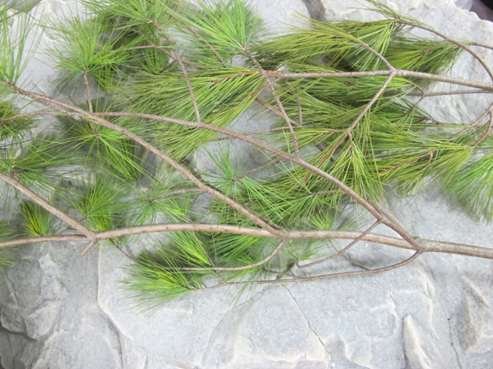
I know that you already see where I’m headed with this. You are looking for the areas where the branch splits off into 2-4 branches.
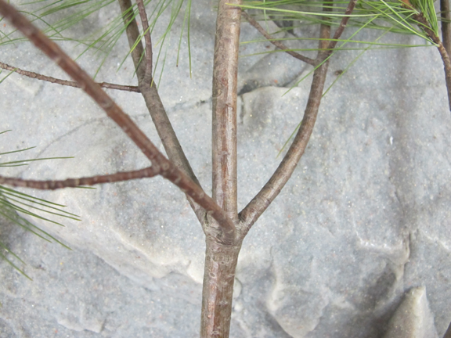
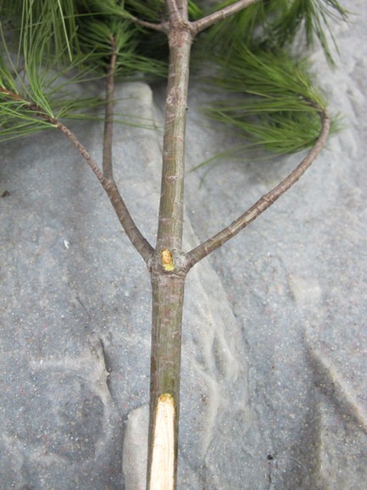
Often, you will find this useful arrangement multiple times on just one branch if you need forks for a group.
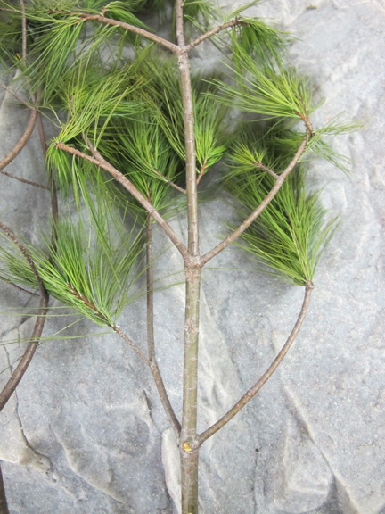
Just a few quick slices with your knife and the forks begin to take shape.
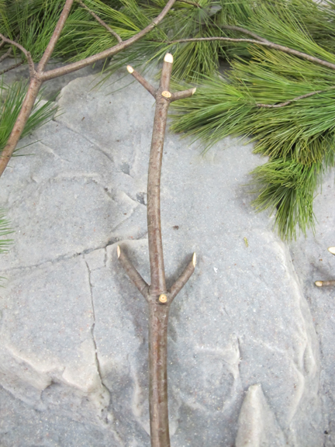
Cut at 45 degree angles so the ends are already nice and sharp.
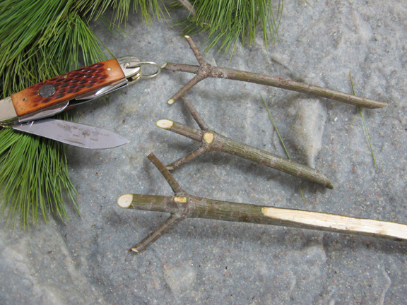
You can use them ‘AS IS’ or spend another 15 seconds and trim off the outer bark.
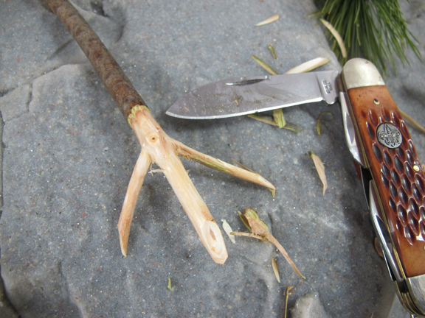
These trail forks are prefect for Ramen Noodles and also work great for stirring small pots of soups and stews.
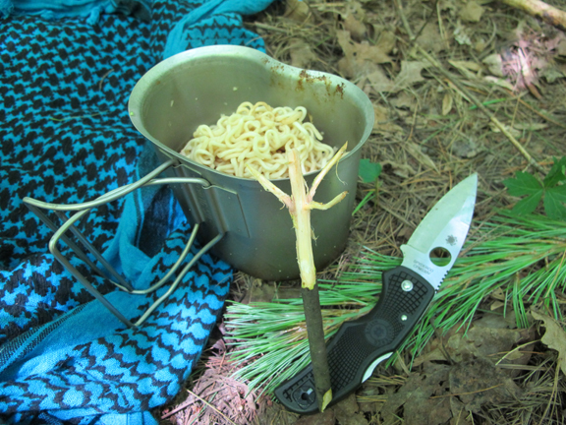
Next time you’re eating a meal at camp take a moment and give it a try.

