Creature Comforts for Luxury Camping
by CTD Suzanne
I know it’s surprising, but not everyone enjoys camping. It can be a real bummer when a loved one pooh-poohs a trip to the great outdoors. Bugs, dirt and uncomfortable are all words I’ve heard used to describe camping, but it doesn’t have to be that way. Camping doesn’t necessarily have to mean your roughing it. In fact, I invest in a few creature comforts to make my time in nature a little more comfortable. A warm shower and a good nights rest never hurt anybody.
As a gift for yourself, your family or a loved one, here is a list of items that will make a regular camping trip a little bit more luxurious.

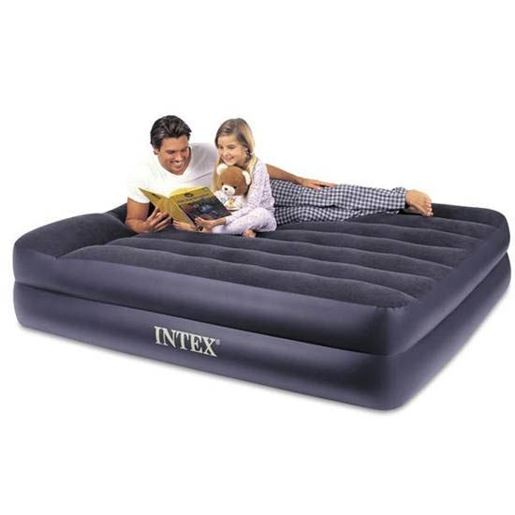Intex Recreation Pillow Rest Air Bed Queen With 120V Pump 67701E (9-48379)
As an adult, I have never enjoyed laying a sleeping bag on the floor of a tent. Unstable ground, rocks and sticks—combined with a bad back—means a night of unrest for me. An air mattress is a camping staple of mine. The Intex Recreation queen pillow rest raised airbed is a step up from my basic blow up air mattress. The waterproof sleeping top sits 18.5 inches above the ground, making it feel more like your bed at home. The true-to-size queen mattress inflates in about three minutes using its built-in electric pump. One button quickly inflates or deflates the air mattress. What is truly luxurious about the Intex pillow rest airbed is its adjustable firmness feature. It holds up to 600 pounds and measures 60 x 80 x 18.5 inches. However, note that the built-in pump requires an AC power supply to inflate the bed. If you don’t have an AC adapter in your car or your campsite has no electricity, you’re out of luck with this air mattress.
She may not be a real princess, but you can certainly treat her like one. Make sure she doesn’t feel the pea here.

Zodi Outback Hot Tap On-Demand Hot Shower (9-46259)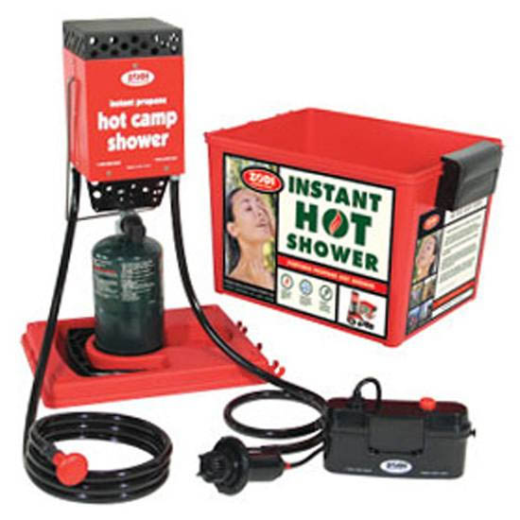
Even though I am not one, I completely understand those who won’t go camping without hot running water. Camping is dirty, dusty and sweaty. A hot shower always feels nice. The Zodi Outback Gear Hot Tap portable shower heats up any water source in less than 10 seconds and adjusts the water temperature up to 100 degrees Fahrenheit. Its single stainless steel burner connects to either a 16.4-ounce small propane cylinder or a 5-gallon barbecue propane tank. It has a single push button to ignite the burner and a 6-volt water pump that requires 4 D cell batteries. Simply place the pump in any water source and you have an instant hot shower. The Hot Tap on-demand shower includes a showerhead, an 8-foot flexible shower hose and a 4-gallon water storage tank—enough water for a 10 minute hot shower. Not only is the Hot Tap compact and easy to transport, it does not take up much room at your campsite. Better still, the Hot Tap serves a dual purpose—hot water for showering and cleaning up after meals while camping, but also as an emergency hot water source for during natural disasters or city water outages.
Gonna get in the water! Rub a dub with me here.

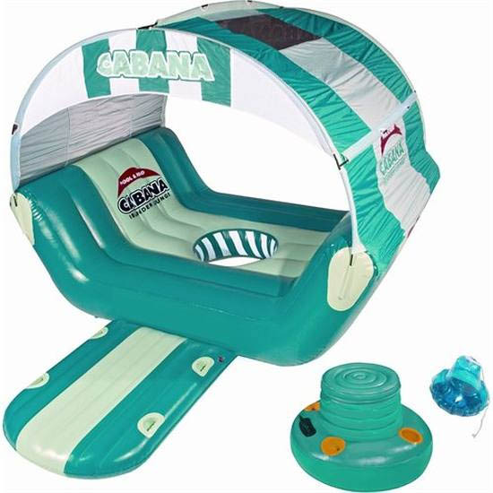SportsStuff Cabana Islander Lounge Inflatable Room for 6 with Floating Cooler (5-5405405)
If camping out at the lake is your thing, the SportsStuff inflatable cabana islander lounger is a fun and well-worth splurge. Though the Cabana Islander fits six adults, four is the perfect number. It is made of heavy-gauge PVC and has a detachable nylon wind-resistant top. In the center is an open hole for dipping your toes in the water or to take a dip. It also includes a floating inflatable cooler with a zipper lid, a mounting platform for easy in and out, and an anchor system. It measures 82 x 76 x 102 inches wide. The lounger makes it fun and easy to float leisurely all day in the lake, taking turns napping in the shade and swimming.
All you need is a palm frond fan. Get your own private oasis here.

32 Ounce Stanley Adventure Carbonated Beverage Bottle (9-72572)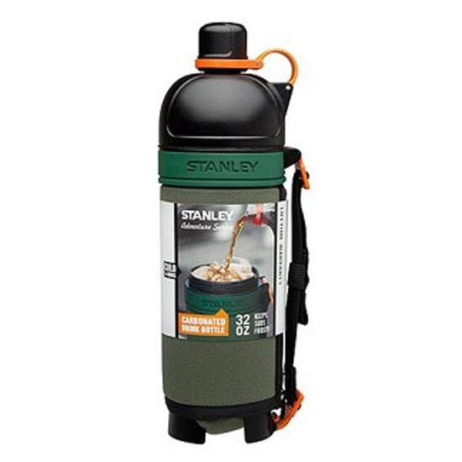
One of my favorite things about camping is enjoying a nice ice-cold beer in the hot sun. Truly, for the person who has everything, the Stanley Nineteen13 carbonated drink bottle holds 32 ounces of your favorite carbonated beverage—it keeps beer, soda and even champagne cold and bubbly for about three hours. The twist-off lid reveals a wide-mouth spill-proof opening large enough to fit ice cubes. The special design of the bottle-cap spout means your drink won’t go flat. An insulated outer sleeve not only keeps your drink cold, it prevents the bottle from sweating. You can be confident in how long the Nineteen13 adventure carbonated beverage bottle will last. Stanley has a reputation for their rugged durability. I still have my dad’s original old-school Stanley metal thermos that keeps coffee warm and water cold. One great feature while hiking, the bottle prevents foaming and explosions.

