Skinning and Cleaning Animals
by Frank Sherwood
Before I start to explain how to skin and clean an animal, never forget that you have removed a living, breathing creature from the flow of life. Whether it's a beetle or a buck, it has the same spirit and not to utilize the whole animal would be a waste. Give thanks and appreciate that a living being gave up its life for you.
Most animals, regardless of size, are done basically the same way. One of the most important things to remember is to take care and not puncture any organs with a knife while skinning or cleaning. By being careful, you'll not contaminate the edible parts with urine, feces or any other bad substances; also, take care not to spread these substances with your hands or knife. For example, deer have scent glands on the inside of their rear legs. If you touch these and then handle the edible parts, they will spoil quickly.
Most animals, except for fish, will need to be skinned out. Frogs and reptiles should always be skinned. Slit their skin down the belly and up to the chin, then peel away the skin with your fingers. Birds may taste better if they are plucked, but it takes a lot less time to skin them out.
Now, let's skin an animal. Lay it on a slight incline, having the head uphill. With a male animal, tie off the penis with string or cord to prevent urine from getting on the meat. Then, starting at the tail, make a cut just beneath the skin all the way to the chin. Next, cut down the inside of each leg to the joint above each hoof or foot. Once this is done with smaller animals, just peel the skin off like a coat. With larger animals, use your fist and work the hide off, using a knife only in the real tough spots so you won't cut the hide and ruin it for when you brain tan it.
To clean an animal, make a cut just in front of the anus and sex organs, opening up the stomach cavity, past the breast bone. Be careful not to cut deep enough to slice any of the organs. Next, cut around the anus and free up the sex organs, tying off any tubes that leak wastes.
Now, cut through the diaphragm and reach up, finding the wind pipe and gullet. Cut these and pull them out with most of the rest of the internal organs following along.
Pull everything out, leaving it below the animal. Put all the edible organs in a separate container so they won't get contaminated. If some meat has been contaminated, it will turn rancid fast. If it does, cut out the bad section along with any badly scarred tissue or ulceration. Use your eyes and your nose. If it looks, tastes, or smells bad, cut it out.
Now, prop open the chest cavity with a stick. Let the animal cool in the open air, yet in a protected area to keep it out of the rain. In cooler temperatures, about 40 degrees (F) or less, it could hang for a few days without spoilage. Make sure to keep it off the ground, away from the critters. In hotter weather the meat will spoil much quicker and flies will start to lay eggs on it. The maggots are not a sign of spoilage, but in the warm weather you'll want to utilize the animal quicker to prevent spoilage.

The Basics of Skinning Animals
By Richard Simm
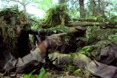
As a hunter, there are many essential skills that you should have. However, these skills do not only involve shooting, accuracy and stalking skills. One very important skill that you should learn would be the art of skinning. Although it can be scary for first timers, a hunter that doesn't know how to skin their catch would not be considered as a hunter at all. So, here are the basics of how to skin animals, particularly foxes, rabbits and kangaroos.
Skinning A Fox
Use a cord or gambrel to hang your catch from its hind foot. Make a cut just above the pad of each hind foot and another from one foot to another at the front part of the anus. Make another two cuts on both sides of the anus to connect cuts at the tail's front. Use your knife and cut its hide and getting rid of its feet. As soon as there are no more feet, you can pull off the hide in the hind belly and the hind legs.
If you caught a male, you need to make a cut around its testicle. You'll see its penis. Pull down its hide up to its penis' end and cut until free. Keep on pulling around the tail's rear part. Use a tail stripper to get rid of the tail by cutting it down from the inside then opening all the way. As soon you finish that, you would just need a little pull to pull off the whole hide.
Look for 2 cartilages which mark its ears, cut them off. Go on until you reach the eyes, cut but be careful in doing so. Pull the nose down and cut it off at its base. Any you're done!
Skinning A Rabbit
Find a flat surface and lay it on its back. Pinch its skin at the lower belly's loose part. Use a knife to cut a small hole through the skin. Be careful; do not puncture its stomach lining. Pull the skin apart and tear all through out around it. Use loosened edges to grasp the centre belly's skin halves. Pull the skin hard on both ways 'til you free the back and front legs.
Cut off its head. Snap the lower portion of all legs to get rid of the feet. Cut through its groin and remove the anus and intestine. Make a 'V' shaped cut into its flesh in which its tail joins, remove the tail. Take care and do not cut the intestines. Now, cut its stomach lining and then remove its guts. Look for the liver and the other internal organs. If you see any white patches, spots or growths on them, discard your rabbit. If not, retain its liver, kidneys and heart and then get rid of all other innards. Rinse its insides out using clean, cold water. Make another inspection to check if it's really clean inside, and you're done!

Gutting A Deer

How to Remove the Entrails or Gut Out a Deer
Gutting A Deer is not a complicated task for a deer hunter. But gutting out a deer is a responsibility that must be taken seriously and done right. It needs to be done as soon as you have located your whitetail deer or very shortly thereafter. This is also the time you would want to take any photos of your deer for keepsake, hunting albums, and deer hunting memories. Do that just before you remove the entrails or gut your deer. This way you have good, clean pictures of your deer without the stains that blood would leave.

Minimal Mess
Removing a whitetail’s entrails, or gutting your deer, doesn’t have to be a messy, distasteful job. Done right and efficiently this process should only take 5 to 10 minutes. With years of success and practice, any whitetail deer hunter will master this gutting process. A sense of responsibility, duty, knowledge, and the right hunting equipment is all that’s needed. After reading and reviewing this article; click on this link and study this video of me gutting out a deer that I harvested with bow and arrow.

Responsibility
As ethical whitetail deer hunters we need to know that gutting out a deer is as much a part of deer hunting as the act of shooting a deer. In most advanced hunting courses this is taught through diagrams and or pictures. It is not pleasant for the squeamish or those who have weak stomachs. But again, it must be done and done properly. If you have shot a buck you will first need to cut off the testicles and penis, discard them. After doing that I turn the deer over on its back, brace its hind legs open with my knees. I then pull the hide up, and away from the stomach. This allows the internal organs to fall back away from the hide. With a sharp knife, I then open up the lower chest cavity by cutting through the hide, careful not to cut the stomach or rumen. Decide now if this is a trophy deer in which you will want a shoulder mount done by a taxidermist.
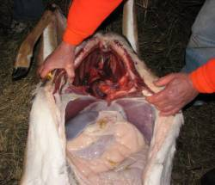
If it is, then I would cut the hide forward towards the neck no further than where the front legs would be when the deer is standing (note approximate location of Mike’s left hand in picture). Now, while holding the rumen down, with the knife blade facing up, I cut the hide open all the way up through the chest cavity. On a large deer you may need to use a bone saw to the brisket to get to the esophagus (wind pipe). I then need to reach as far as I can into the throat and cut the esophagus off. After this, note the membrane lining on each side of the rib cage (by right thumb and left finger tips), cut that as close as possible to the ribs all the way down to the backbone

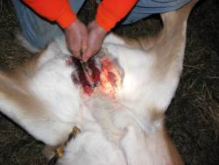
I now proceed down to the pelvic area (by the tail) of the hind legs. I Carefully (do not cut the bladder, this will taint the venison meat) cut the hide back to the anus area. I now use a small bone saw to saw through the pelvic bone while holding down (away from the saw, and yes, my brother Mike is not doing this) any flesh, glands, or intestinal tissue. After this I go back up into the chest cavity, get a good hold of the esophagus and start pulling back, towards and through the hind legs. Everything should come right out with a little effort. You may have to trim some membranes along the rib cage; but if you pull hard continuously, all the entrails will come out. Once done, I roll the deer over to drain out any pooled blood. Fallow all game laws as they pertain to tagging your deer and leaving evidence of sex, if required. Now I would make a plan as getting my deer back to camp. Take care not get your deer dirty or bruise the venison meat.

Duty
When deer hunting, it is a hunter’s duty to accept this part of the hunt. We owe this process of removing the entrails, or gutting our deer, to the game we hunt and those deer hunters we have fallowed, and the deer hunters who have mentored us. By gutting your deer as soon as possible, we allow the venison meat to start the important process of cooling down.

Knowledge
Many articles and diagrams have been written and published on the process of “gutting out a deer”. There may even be a good video of “Removing a Whitetails Deer’s Entrails” or “Gutting your deer.” If you’re lucky, you have been taught how to gut out a deer by your father, an uncle, a brother, or another deer hunting partner. Note the type of hunting equipment they have used.

Hunting Equipment Needed

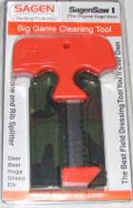
Bone Saw For Cutting the Pelvic Bone

All that is really needed to gut out a deer is a good sharp hunting knife, small bone saw, and field-dressing gloves. Many knife manufactures make high quality knives and saws. I use “Buck” and/or “Gerber” equipment; both are reasonably priced. It is important to keep you hunting knife razor sharp. You can do this with a good knife sharpener like “Chef’s Choice” or a set of “Smith’s Stones”. It is also a good hunting tip to have a small foldaway bone saw or other cased bone saw in your daypack for gutting your deer.
Protective gloves can be found in sporting good stores or even drug stores that carry medical gloves. If you are allergic to latex materials, you will need to find and use either vinyl or rubber gloves. These gloves will help protect you, the deer hunter, from potentially harmful bacteria and viruses that may be present.

Field Dressing Your Deer
By Mike Guerin

Your persistence has paid off; your deer is down, now what do you do? What you do now will determine the quality of your bucks meat at the table. Proper care of your deer is very important in making sure that its taste good when it is served at the table. This article is to tell new hunters how to field dress, skin and prepare a deer for butchering. Experienced hunters might also learn something new.

False Hoods
One of the most persistent beliefs among hunters is that you must bleed your deer by cutting the deer's throat as soon as you get to it. This is suppose to bleed the deer off blood and make the meat taste better. Never cut a deer's throat. This has no positive effects. Once a deer is dead the heart no longer pumps blood. If the blood is not circulating then cutting the throat will not bleed any blood from the deer. It can however mess up a cape (the deer's hide around the head, neck and shoulders) if you decide to mount the deer. It opens the deer's up to dirt in an area that would otherwise have been protected from dirt and bacteria. It is in a word "USELESS".
If you want to bleed your deer you will first need to hang the deer (best done head down) and then make a cut at the lowest point so that the blood can gravity feed out of the deer. I don't do this myself. I get the blood out of the deer after the deer is home via soaking the meat in an icechest for a few days. This has the added benefit of ageing the meat a bit before it is frozen.
Another fallacy is that you must cut off the tarsal glands of the deer or the meat in that area will be ruined. This is nonsense. It didn't taint the meat while the deer was living and it will not taint it after the deer is dead. You don't want to touch the tarsal gland and then touch the meat however. If the animal is not yet dead, simply shoot the animal again. It is very dangerous to approach a buck that is wounded from the front and down right stupid to try to cut its throat with a knife.

FIELD DRESSING A sharp knife is better than a dull knife when it comes to field dressing a buck. A sharp knife will actually reduce bad (unneeded) cuts and will make the entire procedure easier. Take your time when dressing a buck, mistakes due to haste will often require you to make a trip to the hospital to get stitches.
Prop the animal on its back and begin field dressing by making a cut from just above the genitals up to the rib cage. You now have to make a choice. Some people cut through a number of the ribs in the rib cage to make it easier to reach up into the deer's chest. I find this unnecessary but its up to you. If you do plan to cut through some of the ribs you should do it of center to avoid the sternum. When you make this cut from just above the genital to the sternum take care not to cut too deep. You only want to cut through the hide and through the animals stomach muscle. If you go to deep you will puncture the deer's intestines and you will have to deal with the smell.
Now turn the deer on its side and allow the guts to fall out. They will require help from you by cutting away the fat that will hold the intestines in. This is usually at the top of the cavity in the area near the spine. Care must be taken to not puncture or break the deer's bladder.
The bladder will be in the area where the cavity narrows down at the hips. I leave this part of the deer's intestines intact but many or most do not. If you plan on removing all of this then you must have a very sharp knife and must ream the deer out from the back. Cutting around the anus and tying it off with string. Then cutting either forwards or backwards from the abdominal cavity to remove this entire area. Easier said than done. Care must be take not to puncture anything here this is where the deer droppings and urine are located. The deer's abdominal cavity is separated from the chest cavity by the diaphragm. This separates the lung and heart from the stomach and intestines. This must be cut out to remove all of the intestines.
This is how it usually works for me, with the guts half in and half out I cut the diaphragm away from the deer's chest cavity, I then reach as far up into the deer's chest as possible and grab the deer esophagus. With the other hand I carefully slide the knife into the deer's chest and work my knife up into the chest to cut the esophagus just above my other hand. After it is cut I simply pull the heart and lungs out and with it comes the rest of the intestines.
Wash up.
Drag the deer out.
Load in truck.
Go home or to camp for skinning.

SKINNING
When skinning a deer it can either be hung head up or head down. I now skin mine head down. But if head up then begin by making a circular cut around the deer's neck. Connect this cut with the cut made in the stomach during field dressing. Remove the hide by grasping the skin and pulling down hard with both hands. Use your knife carefully when freeing the hide from the carcass to avoid cutting the skin. If the flesh begins to pull off with the skin, stop pulling and try again after cutting the flesh back with the knife.
NOTE: If the cape is to be saved, you can cut the middle and rear portion of the hide free by starting skinning just behind the shoulder and working down from there.

When you have the hide down around the shoulders you will have to cut off the front legs with a hacksaw just above what you would think is the deer's knees. Then on the inside of the deer's legs cut toward the chest and connect this cut with the one made up through the chest and abdomen during gutting. After you work the hide free around the front legs with a knife. You can continue to work the hide down the deer's back towards its feet and tail.
Once you get the hide down around the deer's tail, simply cut the tail off with a knife. Let me say this again. When you are pulling and cutting the hide from the deer and you can see that the hide is now coming off of the tail, you can now simply cut the tail free. This cut you understand is not through hide but only through the tailbone itself because you have pulled the hide down far enough so that it exposes the tailbone under the hide. That's a long explanation for something simple just so you will not get confused. Continue until you get the hide down around the deer's tarsal glands (the dark patches on the inside of the hind legs) then take a saw and cut through the leg just above the tarsal gland.
By now you are tired from unpacking, driving, getting up early and dragging the deer out of the woods, skinning and gutting. But you are not finished yet. You must still store the meat for butchering. I will not go into great detail at least not today but this is how I do it. I first cut out the backstrap and tenderloins out and place in an ice chest. Then I cut the front legs free (no bones to cut) and place them in an ice chest. Then I cut the back hindquarters free with a knife. You can works a hindquarter free with just a knife if you work your way to the ball and socket joint that holds the hindquarters to the hips. Just work the point into this joint and work around the ball.
Once both tendons are cut the hindquarter will be free. Place any other meat such as ribs and neck into the icechest. Now place a bunch of ice in the icechest with the meat. I am now totally exhausted from all the work. So I am in no mood to begin butchering the deer. So I usually wait a couple of days before I begin butchering.
Each day you need to drain the water and add new ice. I usually will do a little butchering each day until I am finished, this usually takes me 5 to 7 days. I could do it all in one day if I wanted to but cutting up one hindquarter is easy but butchering an entire deer is work so I spread it out.

How to Skin, Gut and Joint a Rabbit (applies to squirrels too!)
1. Lay the rabbit on a heavy chopping board or block of wood and with a meat cleaver or old knife and hammer, chop off all the feet just above the ‘knees’. Cut off the tail and then, using the same tools and technique, remove the head (the most unpleasant bit).
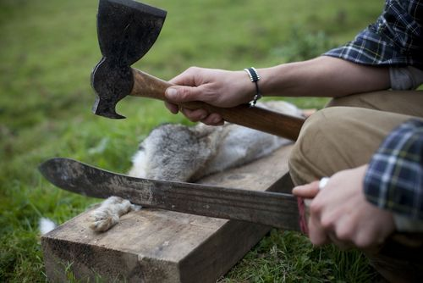
2. Lift the fur at the belly and make a horizontal incision and pull the skin away from the rabbit. Insert the knife into the horizontal cut taking care not to pierce the stomach, then, holding the knife upside down so the sharp edge faces upwards slowly cut the skin from the belly up to the neck.
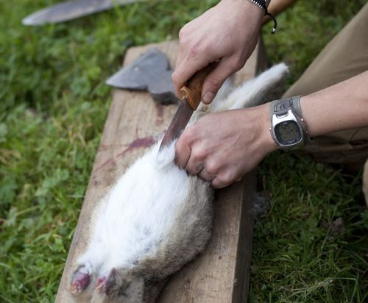
3. Gradually pull the skin away from the rabbit’s flesh, which if fresh, should come away easily. Work your way around the body of the rabbit to begin with and then upward to the front legs. The legs must be popped out through the skin, The best way to do this is to pull out the skin around the leg and push on the stump of the rabbit’s leg from the other side – a bit like taking off a jacket.
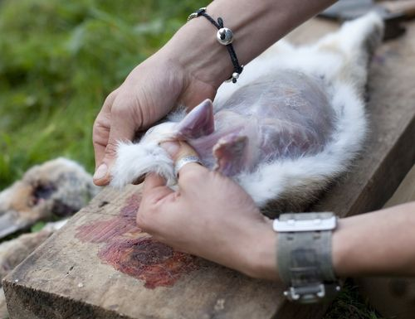
4. The final stage is to grip the shoulders of the rabbit and pull the skin down over the back legs, again, like removing an item of clothing.
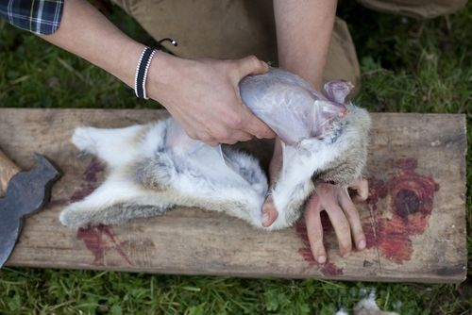
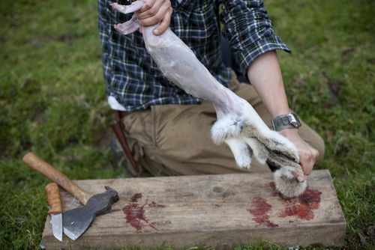
5. Next you must paunch or gut the rabbit; this will prevent it from spoiling. Make another horizontal cut across the belly (this time try not to pierce the intestines), and gradually slice open the stomach. Reach in and upwards to the ribs and grasp the intestines and remove with one firm tug. Put aside the rabbit’s liver for eating – this is the best bit!
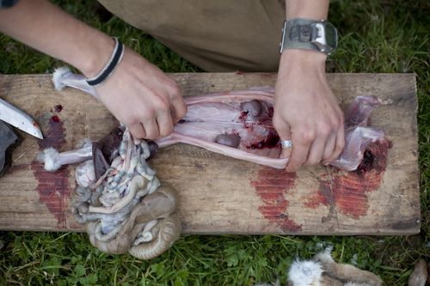
6. Cut through the diaphragm and pull out the lungs and heart. With a knife cut out the rabbits ‘bottom’, make to cuts to form a ‘V’-shape where the tail was and remove any remaining droppings from the rectum. Give the rabbit a scrub under running water; it is now ready to be jointed or cooked.
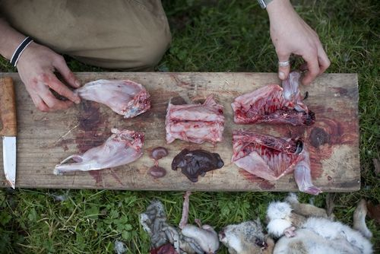
7. A rabbit is usually jointed into five sections: the two hind legs, the saddle and the two front legs and rib cage. The first chop is just made above the hind legs. Once separated, chop down the middle of the hind legs. Then chop the top of the saddle, just below the ribcage and then split the front legs and torso down the spleen.
Rabbit meat has long been referred to as ‘tasting like chicken’. To make this as accurate as possible, the practice of soaking the meat overnight in a salty bath arose, making the meat slightly paler and removing any hint of gamey flavour. Absolute piffle! Why make rabbit not taste like rabbit?
How you cook your rabbit depends on its age: younger rabbits are good for roasting and frying and older specimens for stewing. Generally, I take a different approach that ensures you get the most meat of the beast, this also applies to squirrel.
Once skinned, gutted and cleaned, simmer the rabbit’s whole in simple stock made up of carrot, onion, celery, one bay leaf, a few peppercorns and a sprinkle of salt. Simmer the rabbits for 2 hours; remove from the stock and leave to cool. The meat is now tender as you like and simply falls off the bone, leaving you with a generous portion of meat and the starting point for 101 different options. This is also the only way you will be able to fit a whole rabbit into two jam jars…
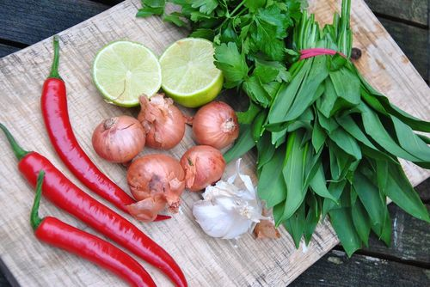
Instead of making a rabbit pie or stew, I decided to take the hunter-gatherer approach and make something with a lasting quality; so potted rabbit was the obvious choice. Again, I could have made a simple potted rabbit in the traditional sense: add a bit of cayenne pepper, pinch of mace, dollop of mustard, chopped gherkins and capers- all very well and extremely tasty, but I wanted to try something different…
Chimichurri hails from Argentina and as such is amazing with beef (and lamb too, in fact with anything!), it consists of four main ingredients that really stand out: chillies, parsley, garlic and vinegar. Legend has it that an Irish meat importer named ‘Jimmy McCurry’ came up with the concoction whilst on a buying mission to the country. Needless to say the locals loved it and adapted it as their own, the name is odd but it is because the natives couldn’t pronounce his name…True story, I shit you not! It really is a wonderful sauce- a must for anyone who likes a bit of BBQ action, it is a playful recipe so you can chop and change extra ingredients. As it is just coming into season, I substituted wild garlic leaves for the garlic cloves.
Potted Rabbit with Chimichurri
For the Chimichurri:
3 red chillies
8 garlic cloves (or a bunch of wild garlic leaves)
2 large handfuls of parsley
4 TSP dried oregano
5 TBSP cider vinegar (red or white also good)
5 TBSP olive oil
1 TSP black pepper
2 TSP sea salt flakes
2 shallots
Juice of 1 lime
Finely chop all ingredients, place in a bowl and add the liquids, mix well. Set aside for at least two hours or overnight if you can.
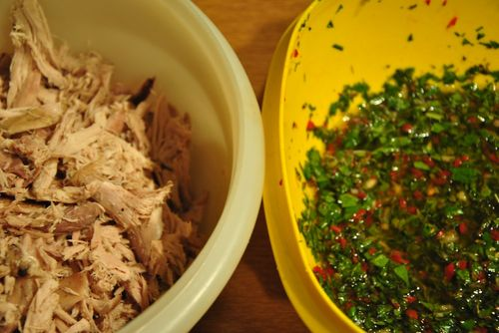
For the Potted Rabbit:
2 rabbits
4 rashers of bacon
100g butter
2 bay leaves
1 stick of celery
1 onion
1 carrot
Olive oil
Salt & pepper
Once you have prepared your rabbits as mentioned earlier, they have a tendency to be dry and tough if not treated correctly. Roughly chop the vegetables and stick them in a big pan with the rabbits and bay leaves and a generous pinch of salt, cover with water. Bring to the boil and then turn the heat down and simmer for 2 hours.
Fry off 4 rashers of bacon and chop up finely to add to the rabbit later.
Remove the rabbit from the stock and leave aside to cool. Once called pick off every scrap of meat you can and place it in a mixing bowl, break it up as much as possible by hand- do not stick it in a blender- rustic chunks are preferable!
Pour over the chimichurri sauce and add an extra drizzle of Oil and the bacon, then mix vigorously until well combined. Have a taste, if you think it need a bit of seasoning- go for it.
Potting up the rabbit:
Take 5 sterilised jam jars (kilner jars are best) and start spooning and pressing down the rabbit mix. Fill to within half an inch of the top.
In a small pan, melt the butter over a low heat until it separates. Pour the clarified butter (take care not to pour in any of the milk solids at the bottom) and fill to the top. Place in the fridge (or outside in English February) to set. Once set, for a little decoration I added a star of pickled ash keys, which are the wild equivalent of capers- excellent with rabbit! Slap on the lids and consume within 2 weeks once opened. A jar of potted rabbit will last unopened for up to 6 months.
Here's the money shot:
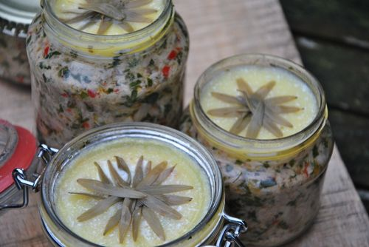
Wow that was a long post! If you have managed to get this far…well done! Other stuff going on at the moment- forest saved as you all know- woohoo! I am setting up a foraging school this year- Hunter:Gather:Cook- the only Sussex based foraging school too I might add and it looks as if its going to be really quite something! Course dates are being drawn up as we speak and land is being acquired so do get in touch if you are interested.

How to Gut and Scale a Fish
From Hank Shaw

1. Start Scaling your Fish
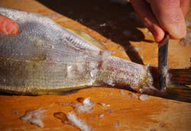
You will want to do this outside, or in a place where you can clean up easily -- scales will fly everywhere. I learned this the hard way: I scaled many fish in an old apartment of mine, only to find scales attached to the ceiling when I moved out, years later.
The easiest tool to scale a fish is a butter knife. They make special scalers, but you don't need one.
Start scaling your fish by holding it firmly with one hand and scraping from tail to head with the knife.

2. Scale Up to the Edges
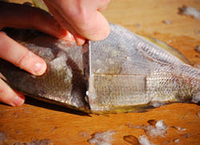
Make sure you get the scales on the top of the fish and near the fins -- and don't forget the tail.

3. Scaling: A Forgotten Part
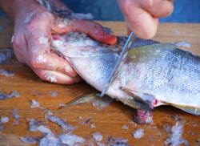
Don't forget the collar of the fish! It is often the tastiest part, but you wouldn't want a mouth full of scales when you bite into it, would you?

4. Starting the Cut
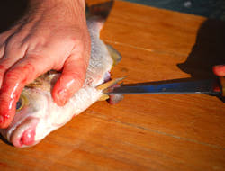
You start the gutting process by slipping the tip of your fillet knife into the vent and slicing upwards -- away from the fish, and away from the guts -- toward the head.

5. Cut to the Gills
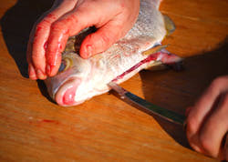
You complete the cut by forcing the knife through the bony portion that lies between the pelvic fins (the ones that are paired up on the belly of the fish) and on up to the base of the lower jaw.

6. Removing the Guts
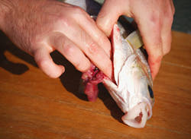
You remove the guts by reaching in and grabbing them right at the base of the head, where you will feel everything connect. Pinch that spot and pull the whole lot out. On large fish you will have to cut this with your knife -- be careful you don't cut yourself!

7. A Gutted Fish
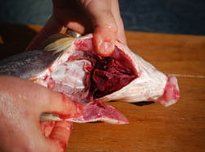
This is what you should have when you remove the guts. At this point you can scrape out the liver, which is attached to the backbone of the fish, and cut out what remains of the swim bladder, which is a whitish sac that also attaches itself to the cavity.
You are almost done!

8. Snipping the Gills
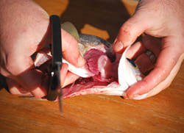
The gills will impart a bitter flavor to your fish, and will make it spoil faster, so they need to go. You can most easily do this by cutting them where they attach at either end of the arc that they form. I use kitchen shears, but you could use your knife. On small fish, you can just rip them out.

9. Removing the Gills
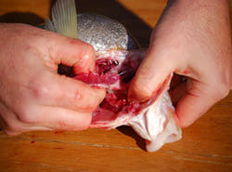
Once the attachments are cut, you can remove the gills easily.
Now wash the scaled, gutted fish well in ice-cold water, then pack on a bed of crush ice until you're ready to cook it.

