How to make a Paracord Rescue Belt
by stuwegie
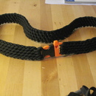

1
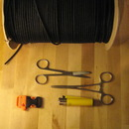

2
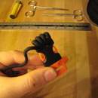

3
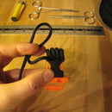

4
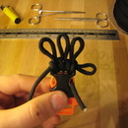

5
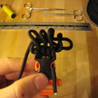

6
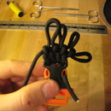

7
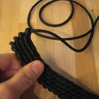

8

9
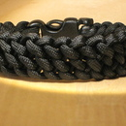

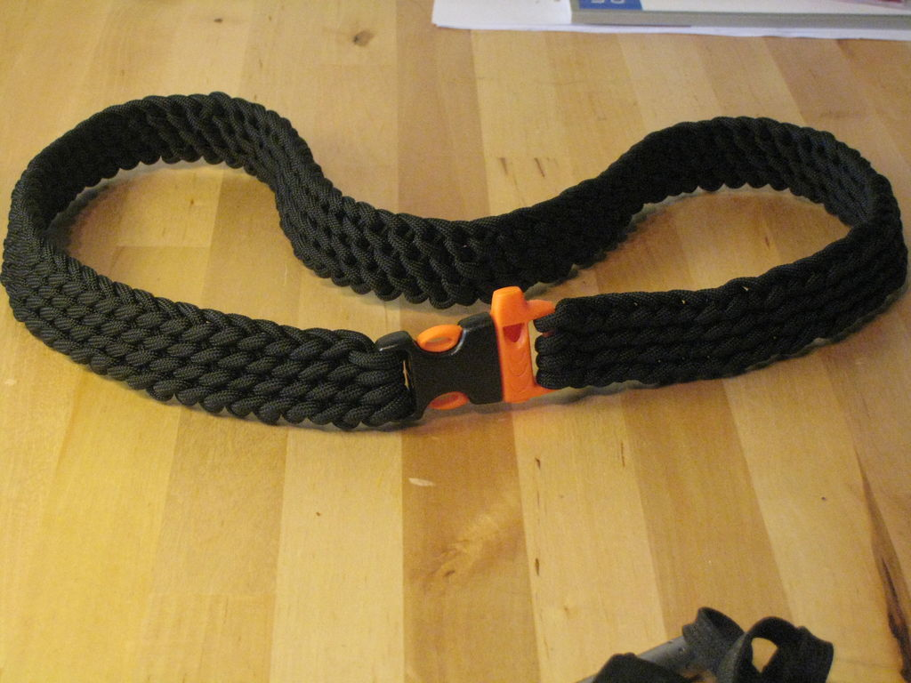

I will be showing you how to create a Paracord Rescue Belt. While bracelets can be useful they simply do not contain enough cord for a real emergency. 8-12 feet can certainly be handy in some situations but think of what you can do with 50 feet!
The belt essentially has two main functions.
1. The buckle is a high decibel whistle for attracting attention
2. The Belt section itself is a single length of 550 Paracord which can be unravelled literally in seconds for a whole manner of rescue techniques.
In my opinion speed is what makes the difference in a survival situation. You can unravel the entire belt with one pull, there is no need to undo a whole series of knots or weaves.
Depending on the method you use to weave and the size of your waist, the belt can supply you with a length upwards of 70 feet of cord, This particular belt used 50 feet for my 32" waist however i will explain how to increase or decrease the amount of cord you can carry while maintaining the same length of belt.
Although the side release buckle means that the belt is not adjustable, there is about 15% elasticity in the belt so you need not worry if you put on a little holiday weght, your belt should be able to acommodate you. The elasticity also means it will remain tight but flexible if you are wearing it during outdoor pursuits.
Its worth noting that this same technique can also be used to make a bracelet which i have pictured at the end of the instructable.

Step 1: Materials

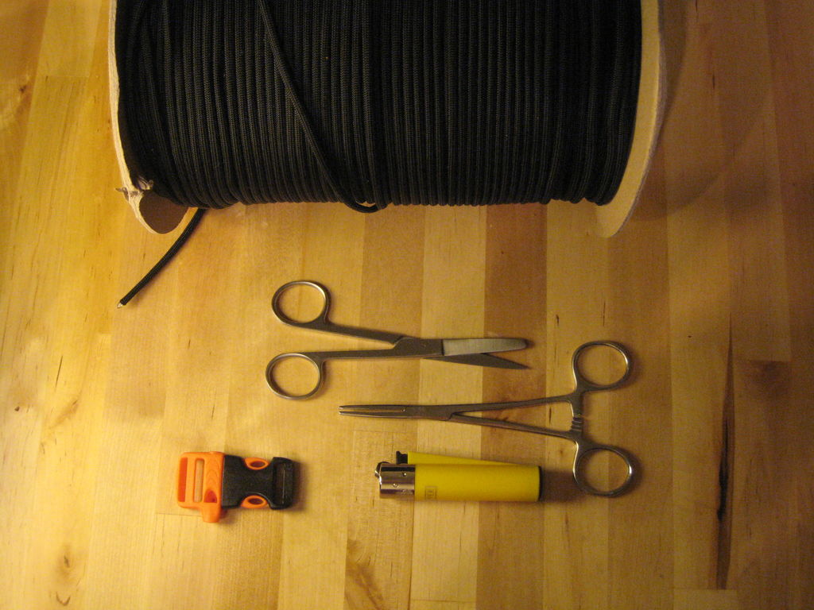

For best results use genuine 550 Paracord.
As with anything in life you get what you pay for, if you are intending on using this as a rescue belt you want to have the best cord available and with suplycaptain they guarantee the quality and authenticity of their cord. Many online retailers sell similar looking but poor quality cord with no guarantees on the breaking strains.
1. 550 Paracord
You can use any colour you like. You will need approximately 50 feet of cord for the belt shown.
2. Fastener
Im using an emergency whistle side release buckle which can be picked up online or in any good outdoors store.
3. Scissors
To cut the cord
4. Lighter
To seal the ends of the cord so they dont fray.
5. Forceps (optional)
Depending on your dexterity you may benefit from using forceps or needle nose pliers to help pull through the cord, i managed the whole belt without.

Step 2: Threading Your Buckle

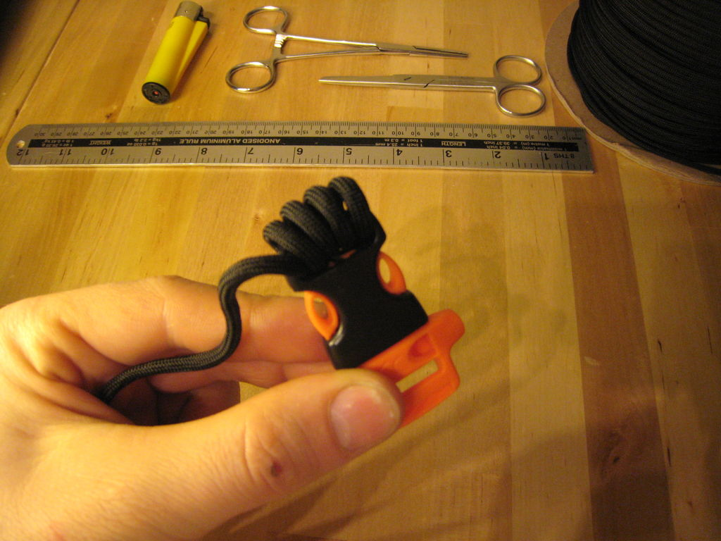

FIrst of all make sure youve sealed the end of your cord with the lighter so it doesnt fray.
You do not have to cut the length of cord to size beforehand as the weaving method used means the cord doesnt need to be cut from the reel until the desired length of belt is reached, this saves wasting cord.
Take your buckle and from left to right make 4 loops through the belt loop..
Ensure that the loops are loose enough to pass some cord through the centre.
Leave a tail of cord on the end a few inches long and secure this to the buckle to prevent the cord working loose during the next steps. ( i passed it through the small hole on the orange section of the buckle to hold it in place)
Ive highlighted the 'working end' of the cord in the picture, This is the piece you will be using for all further knots.

Step 3: Your First Loop

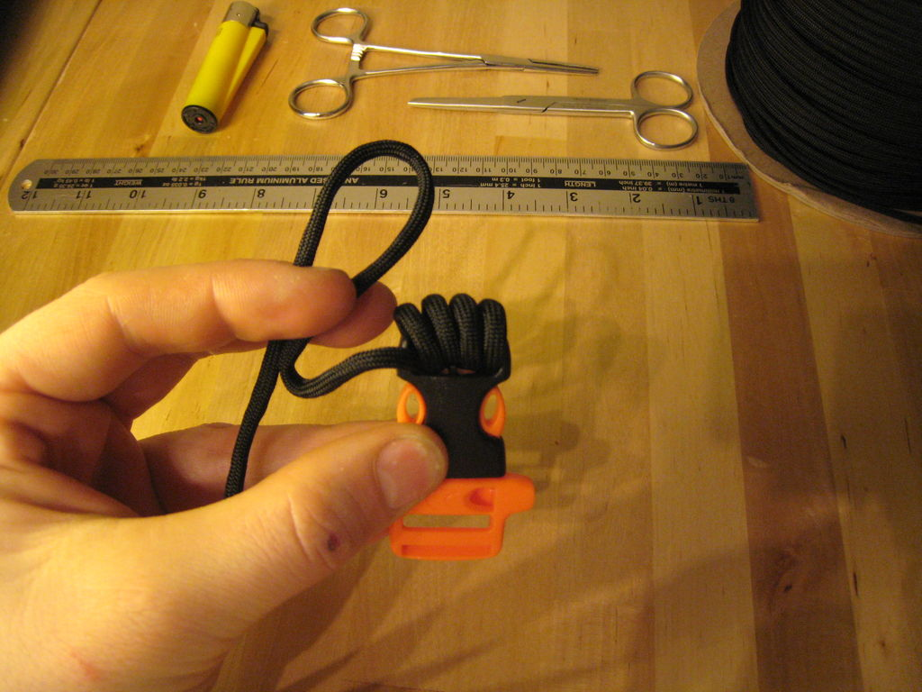

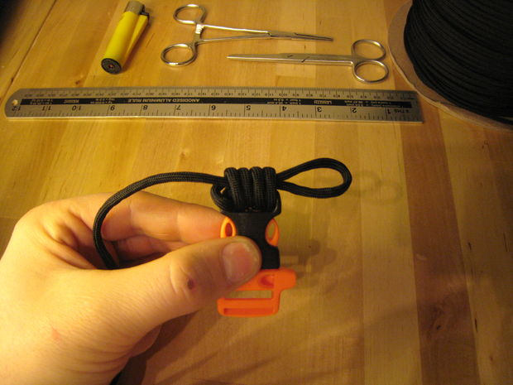

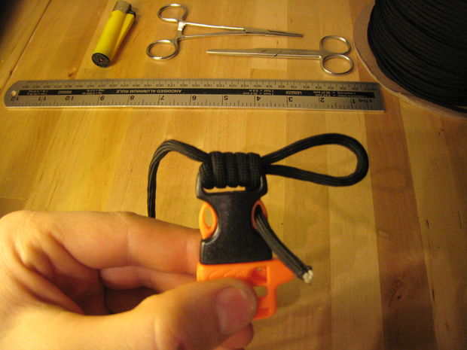

Take the working end and make a loop in your hand.
Now thread this through the centre of the 4 loops you made on the buckle.
Leave a couple of inches sticking out the end on the right.
Once you have fed this through then tighten up the 4 loops round the buckle. For consistency you should tighten them from RIGHT to LEFT.

Step 4: More Loops

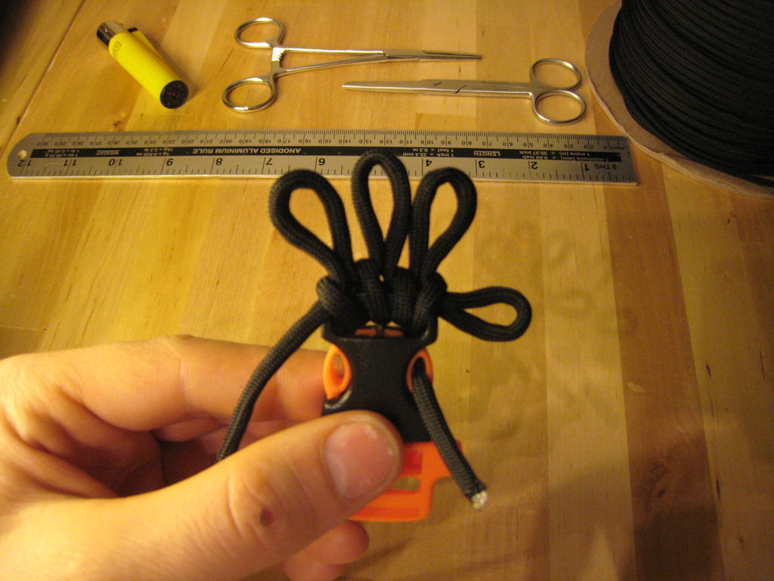

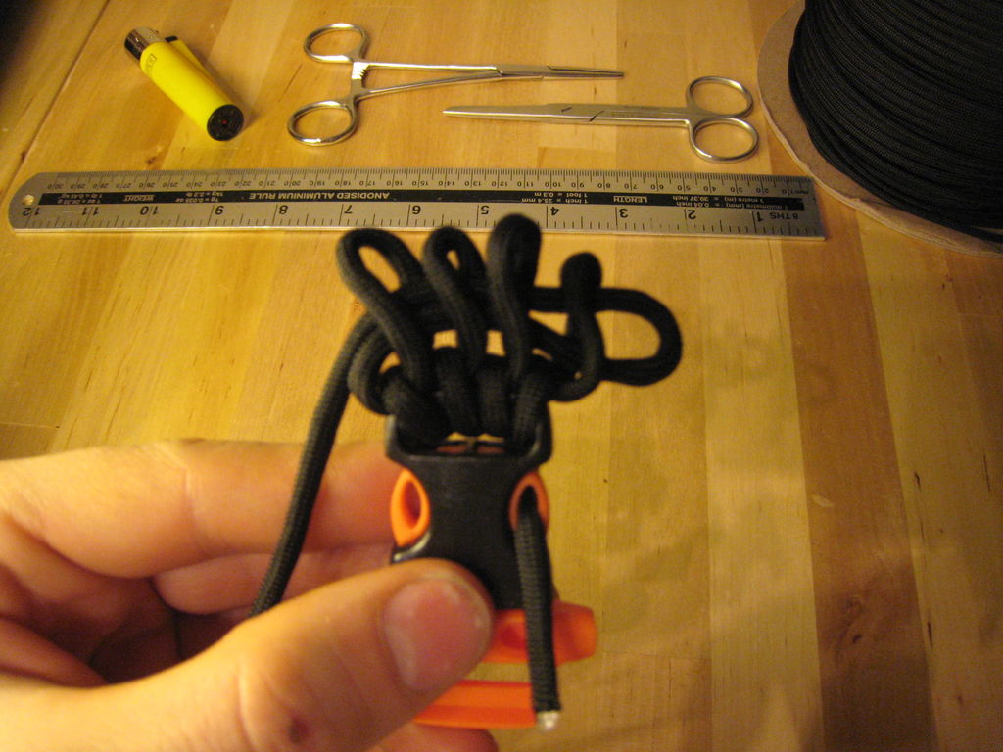

Gently ease apart the 4 loops you have around the buckle.
Using your fingers or your forceps, pull through the running end of the cord to form a total of 4 loops.
This should consist of three that you pull through and the loop left from the end of the last step.
Twist the loops slightly in an ANTI-CLOCKWISE direction (so the left side of the loop is to the front)
Feed the running end of the cord through all 4 loops as before leaving a few inches sticking out the end again.

Step 5: Complete your first row

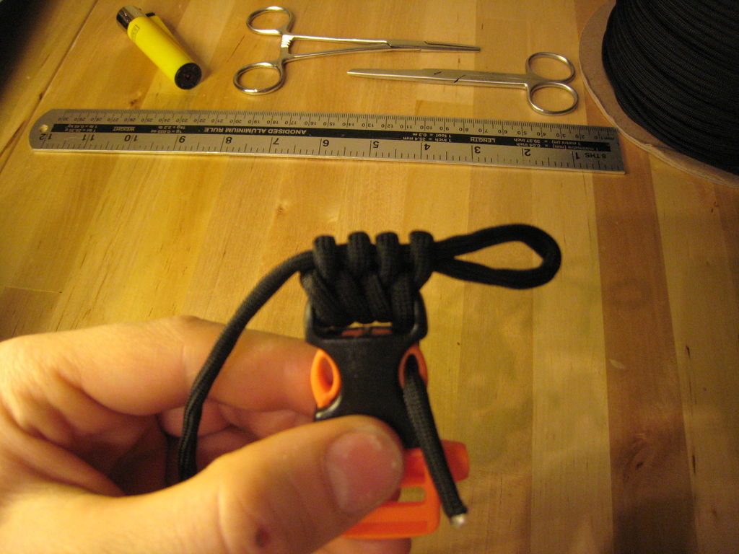

To complete the first row simply lighten the loops from RIGHT to LEFT
Once you get to the left you pull on the loop sticking out of the end on the right to tighten completely.
IMPORTANT NOTE
Because of all the loops we are putting in the cord it naturally becomes twisted. You need to un-twist the cord as you are tightening each loop. If you dont do this the finished weave will look very messy.
Also do not over tighten your loops. If you do, it will distort the final weave pattern and again your belt will look a mess. Over tightening will also make it harder to pull through the next row of loops.

Step 6: Repeat Repeat Repeat.................

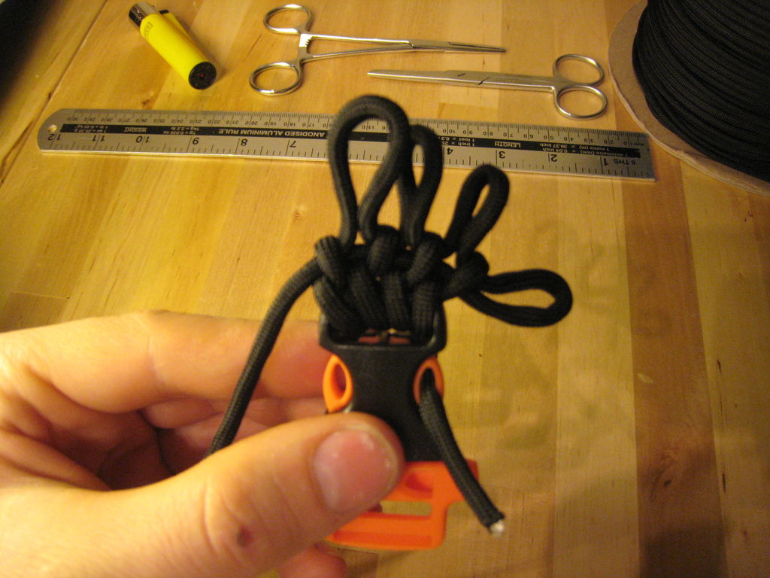

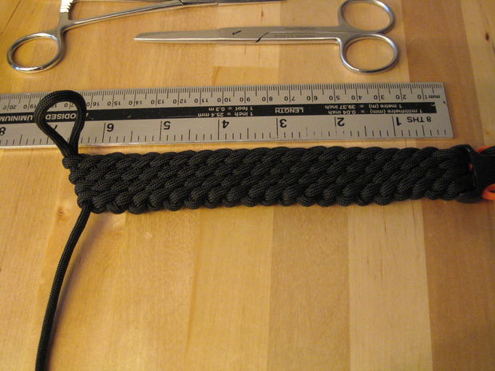

To continue your belt simply repeat steps 3,4 and 5 over and over and over until you get your desired length.
This 6.5 inch length of belt used 10 feet of cord. So for an average 32inch waist you will use approximately 50 feet.

Step 7: Finishing your belt

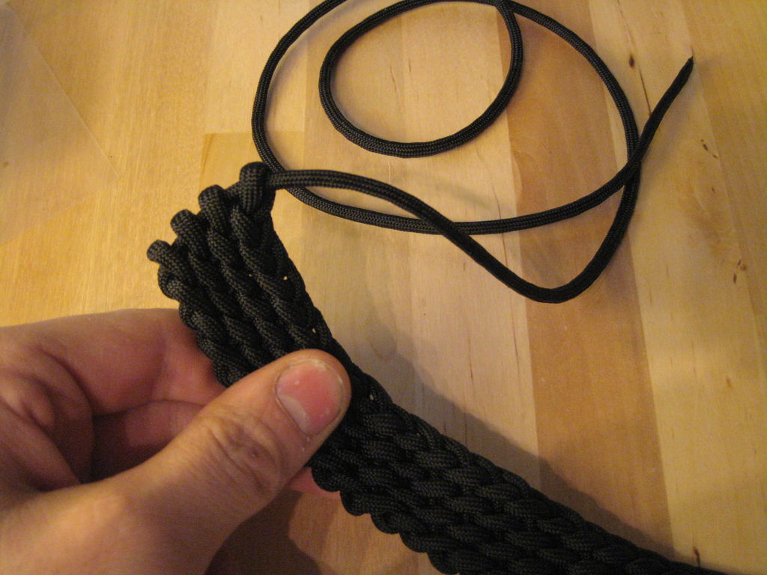

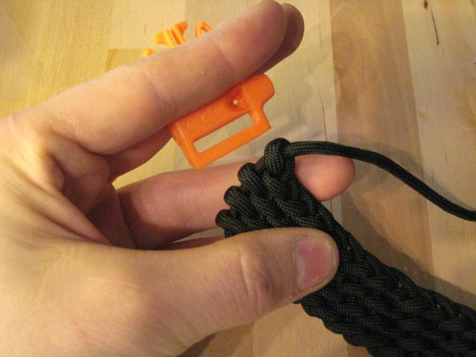

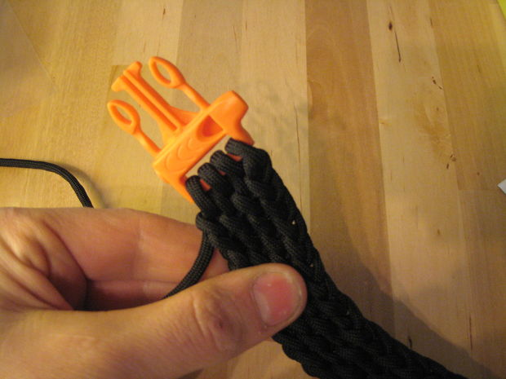

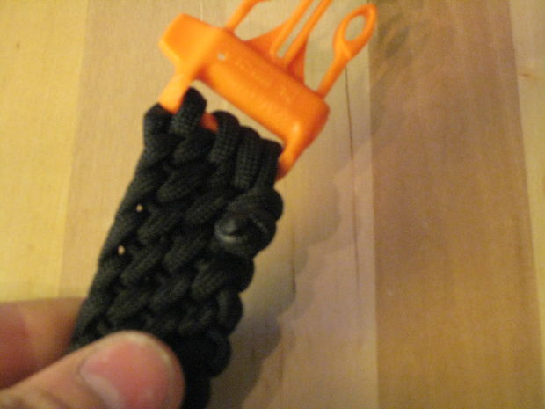

Once you have reached the desired length of belt you can cut your cord from the main reel.
Pull the working end all the way through so its sticking out from the right.
Seperate your loops again slightly
Get the other half of the buckle (make sure its orientated the correct way for fastening)
Loop the working end through the buckle then back through the cord you exposed when seperating the loops. Once you have looped it through the buckle and belt 4 times you are ready to finish the belt.
You have two options for finishing.
1. You can thread the end through any of the loops you like and using the lighter, melt it in place onto the belt.
2. Thread the end through any loop you like and tie an overhand knot in the end to stop it passing back through,
The benefits of the second method are that you do not need scissors or any other item to release the end of the cord if you need to unravel it in a hurry, you simply untie the overhand knot.

Step 8: How to use your belt in an emergency

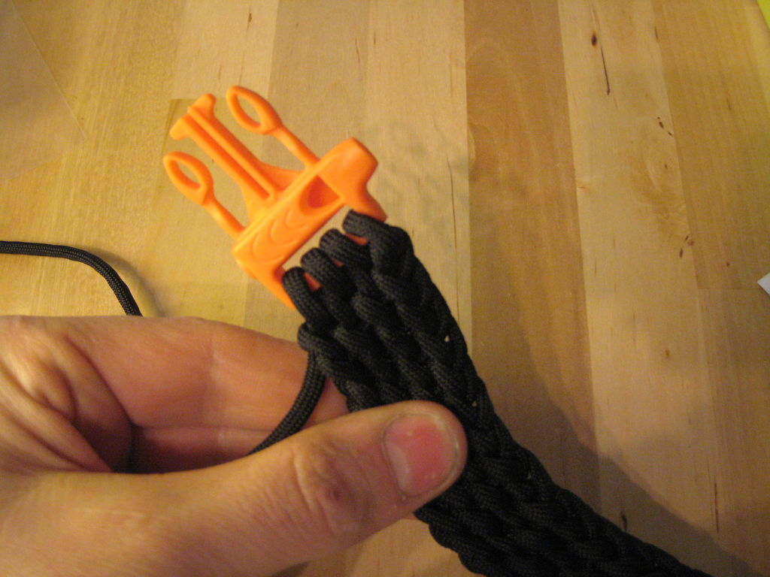

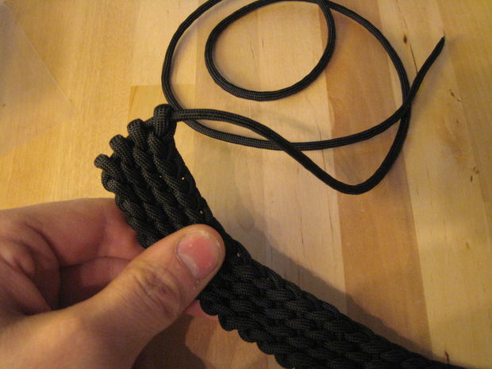

To utilize your cord in an emergency simply untie the overhand knot on the end of your cord.
Undo the loops around the buckle ( keep the buckle for attracting attention)
Pull the length of cord back through the first 4 loops to release your working end
Pull hard on the working end and the whole belt will begin to unravel. From start to finish you can undo the entire belt in about 20 seconds (a painful thought when you realise how long it took to make)
Alternatively if you have a knife or a pair of scissors simply cut where shown, remove the end with the buckle and pull on the cord you cut to unravel.
Dont forget to use your emergency whistle to attract help if you need it!
Paracord is fantastic stuff but its no substitute for another pair of helping hands!

Step 9: Bracelet and knot diagram,

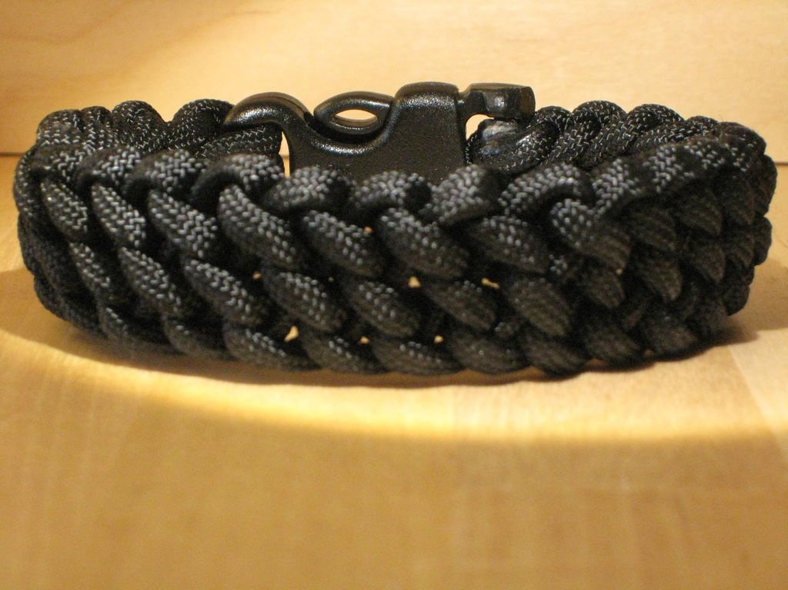

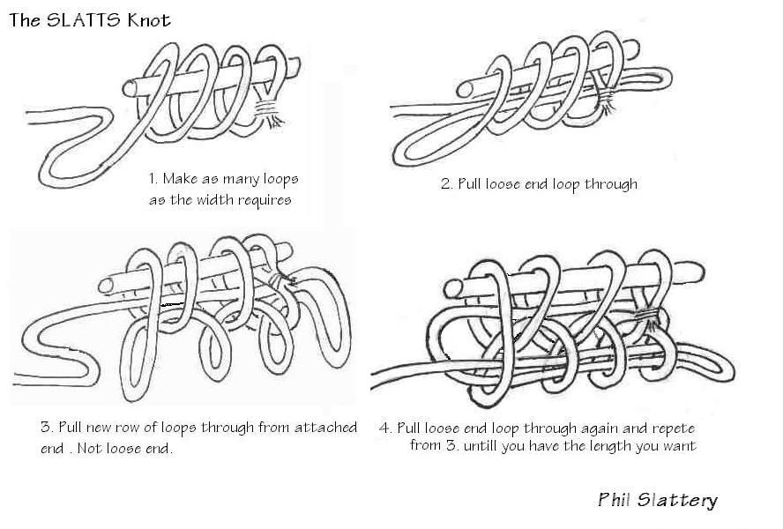

As I mentioned at the start of the instructable you can utilize more or less cord to make the belt.
If you would like a longer length of cord and more width in your belt simply use 5 or 6 loops in each row instead of the 4 i used. In theory you can use as many loops as you like as long as your buckle is wide enough.
Similarly, if you would like a thinner belt with less cord use 3 loops as demonstrated in the bracelet i made.
I made my belt after finding this diagram on the internet. I would recommend anyone interested in paracord crafts buy some of the many books on decorative and functional knots available.

