Improvised Vegetable Oil Lamp for Emergencies
By SnoMan

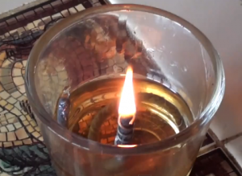Instead of throwing away your used frying oil, save it for an oil lamp, the old fashioned kind that doesn’t use kerosene or petroleum-based lamp oil. I improvised a simple lamp from materials I had around the house. It took about 15 minutes and cost nothing.

Make an oil lamp from common household materials and supplies
- For a “lamp” I used a tea light cup, but you could use a pyrex measuring cup or metal can, a shallow oven-proof dish or ramequin — anything that tolerates the heat without cracking.
- The wick is a string from an old mop, but it could be a shoelace or a strip of cotton underwear, maybe some burlap. Just experiment to see what works.
- Vegetable oil worked great as a fuel. Even used frying oil burns without odor and without smudging.
- The wick-holder is just a piece of wire wound around a nail. Its job is to hold the wick up out of the oil. You’ll need to find a way to make it easily adjustable — as the wick burns down, you need to keep feeding a little more, and ideally there would be a way to do this without putting out the light. Right now I hold the coil with a pair of pliers and push the wick up with a toothpick, but there has to be a better way. One free set of Kudos to the first reader who comes up with a better solution.

Don’t use vegetable in a kerosene lantern
- The oil would burn for a few minutes, but then the wick would burn down and smolder with a stinky black smoke.
- I think what’s going on is the oil is too thick to draw up the wick fast enough to keep feeding the flame. Maybe if the wick holder was not so tight it would work.

Other observations
- The improvised oil lamp burns at least an hour before the wick needs to be adjusted again.
- This was made from unused items sitting around the house, so you really are capitalizing existing assets. Even the used frying oil eventually just gets thrown out — but no more!
- It’s satisfying to know that we can have some light if we run out of candles.

