Mylar Blankets- Do you have yours?



Mylar is not meant to keep you warm like a blanket
These are not military "casualty blanket" which look similar but have another layer to them.

What it can do is be a wind breaker or rain protector and it can be an insulator within the clothing you have on.

BUT.........with that said

In first aid

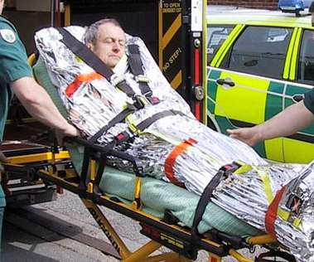
Hypothermia - prevent/or help reverse
The airtight foil reduces heat loss. Heat loss which can be caused by evaporation of perspiration, moisture and or the blood can be minimized by the same thing.
To a limited extent the reflective surface inhibits losses caused by thermal radiation.

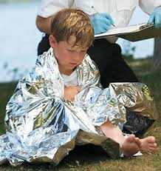
People who are in shock
They are also used with people who are in shock. This helps them beause it conserve their body heat.
Frostbite
You can wrap your hands in them and put gloves or extra socks over them to keep you from getting frost bite.

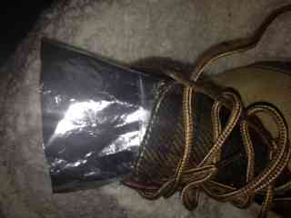
Keep feet dry
Cut the blanket up to line your shoes are boots it will help keep the warm and dry.
Other Uses
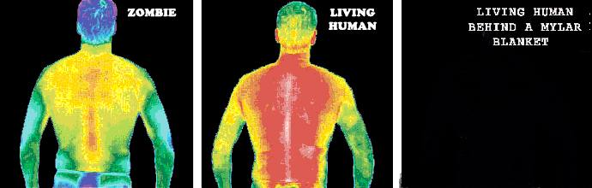
Hide
Mylar blanket can be used by to hide your heat signature from heat detection devices.
Which may be what people mean when they say it can be used as light insulation for indoor gardening???? Heat detection??? Wonder what they are growing??? All kidding aside I am sure it help boost the grow light to start your garden seeds ....ya that the ticket.

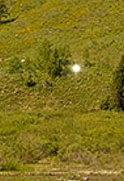
Use as a signal for help
They are shinny and reflect the sun great. To wave it like a flag or to even mount it in a place where people will see it can save your life. Or try to reflect sunlight off a folded one.

Trail Marker
Take strips and tie them on trees to help mark the trail you are on.

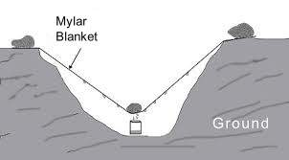

Water
It can be used it several ways to gather water.
- You can dig a hole and you can get place a container in the middle of the hole cover it with the blanket and place a small stone in the middle over the container…to collect water condensation from the ground
- If you have rain you can dig a hole and place in in it to catch rain water
- Next you can make a sapling into a circle and use some cordage to tie the Mylar to it, making it like a fishing net type bag to carry water from a water source to where you are. Then tie it so it hangs from a tree branch like a hanging sink or bucket of water at your site.
- If you have a fire going and a little creativity you can fuse the sides together with a hot stick and make a bag. But not sure if the seam would be strong enough to hold water.

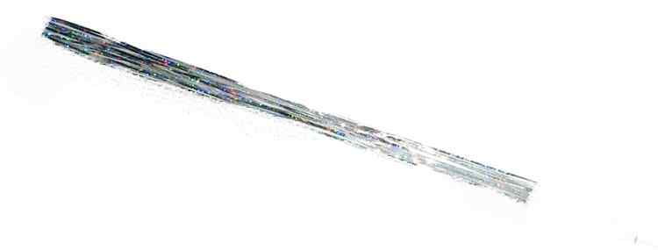
Cordage
Cut it into strips and twist it and you have Cordage. This can be used for so many things. From tying up a shelter or carrying things, fishing line. Even replace a missing show lace. If you braid the strips tight you will have a bit of stronger cord if needed.

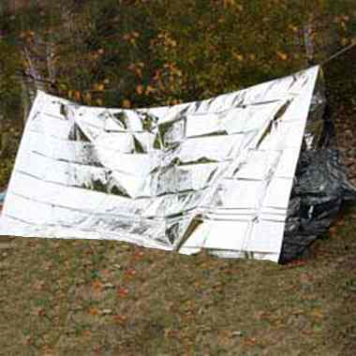

Shelter
You can make a lean tune shelter with some sticks in the ground and a few stone alone the bottom
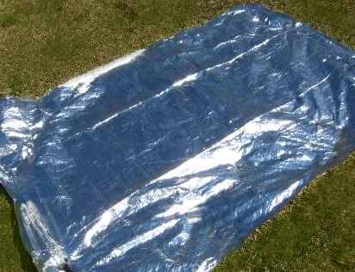

Groundsheet
Mylar is a great drop cover because it is waterproof and the bonus it is does not allow the ground under it to get colder, it keeps the heat in.

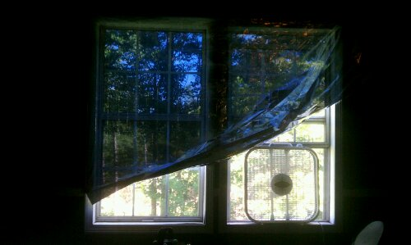

Sun Reflector on a hot day
Because they reflect the sun these are great to set up to get shade on a hot day these can actually make it significantly cooler. You can use this outdoors or inside a house you may be stuck in.
Which is why….

It can make an ok solar over
With some sticks and maylar cordage you could fashion a semi ok solar oven to reheat things. Warm water, melt snow. Not so sure about water purification. Although some say it works...but it has to come to a boil. Has anyone had luck with that and Mylar?? And maybe if you make meat really really thin it could cook it if you have it in the mid day sunlight.
Make the most of your fire
I like the fire reflector in this set up so I had to share it with you. Smart use of the mylar.

Set the blanket up behind your camp fire so that it reflect the heat from the fire to you. (don’t set it up to close ya don’t want it to melt.)
Get the most out of your candle

Same deal as the fire but on a smaller level. Place a small piece behind a candle and it will double the light in the are you are in.
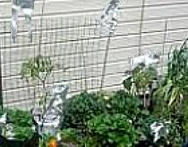

Animal deterrent
Now this can be a good or bad thing….if camping or lost this hanging it around you camp will keep wild critters away because of the crinkle noise and reflective aspect of it. But if you are in a SHTF situation….you just may not want that crackling noise going on.

Many farms now use strips of it as their modern scarecrows.

Fishing lure
Same reason why you keep a small piece of foil in you altoid fish kit. Because a small piece tied to a line look like bait to a fish.

