One Woman’s Perspective on an EDC

My husband is thrilled – after several false-starts, I finally have an EDC that he and I agree is practical and useful.
Before you laugh, let me explain. In three years I’ve had four Hubby-attempts to supply me with a Every Day Carry Bag. The first was an expensive, backpack purchased for my birthday. It was too big, too heavy and … it was camouflage. Couldn’t you just see suburban-mom, with kids in tow, at the mall, with a big camo-mollie-pack? Needless to say, it stayed in the trunk, under a concealment blanket so the boys at Lowe’s wouldn’t peak their eyebrows when helping to load a bag of mulch. This is not what Hubster wanted for his wife’s EDC.
The second Hubby-attempt was a double-stitched, tactical fanny-pack and it had similar results. Let’s just say that it wasn’t very stylish when wearing stilettos and my skinny-jeans.
However, I did find myself making room for a few useful items. I liked having a handy flashlight and I did use the multi-tool a few times. I was seeing the benefits of having items close at hand.
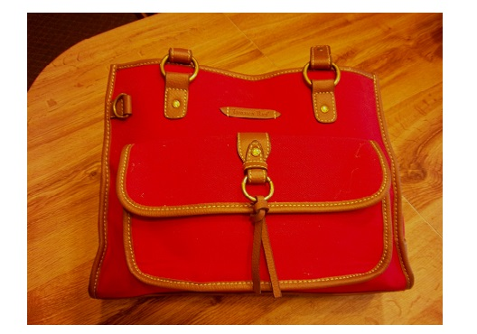
The positive side to the failed attempts was that Hubby and I learned what didn’t work for me. For one thing, I was already carrying a purse, and the last thing I needed was a second bag to keep track of in addition to 3 kids. In the end, I felt that a well built purse would better suit an EDC for me.
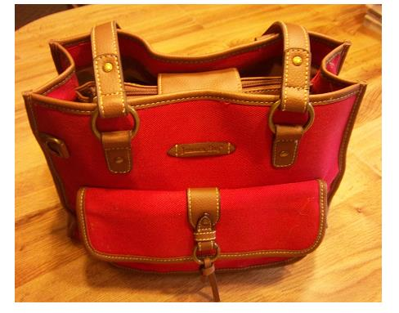
I have two rules for a purse: It can’t weigh more than 7 lbs., and, I don’t want the contents spilling out all over the floor should one
of the kiddos knock it over. My goal was to carry a feminine purse with tactical elements. I do not carry a firearm in my purse. With those rules in mind, I have a set-up that I actually use, and love! My new purse – ut, um, EDC is 10” tall, 12” long and 6” wide.
Side Compartments
A compartment on each end of the purse holds convenience items for easy access. One compartment is home to a hair scrunchy, hand sanitizer, a measuring tape, Tic tacs and (this time of year, chapstick.
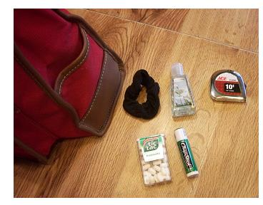
The other side contains electronics, including my cell, AC and USB adapters, and phone charger
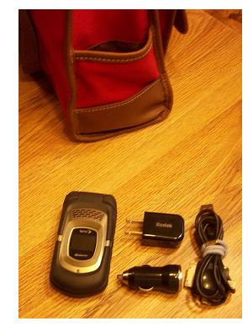
Outer Compartments
The purse also has front and back compartments. In the front I keep spare glasses and eyeglass repair kit, a tide stain removal pen and paperclips.
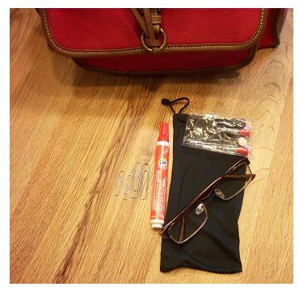
The rear compartment includes a small notebook and calculator. There’s even spare room for coupons or a paperback.
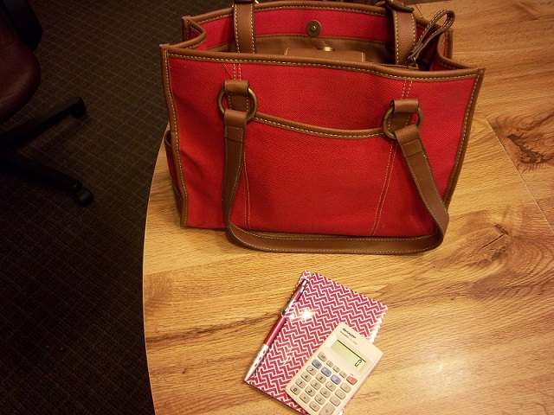
Inner Compartments. There are three inner compartments.
The zipper compartment includes glow sticks, a winter hat, a pair of socks, panties, a bandanna vacuumed sealed (to reduce bulk) and a pair of work gloves. They come in handy when loading lumber, concrete blocks or other Hubby requests for his many projects.
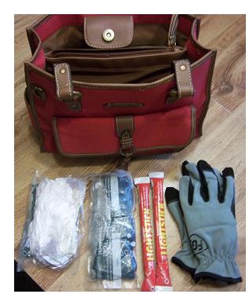
One inner compartment includes “normal” purse items including a coin purse, thumb drive, my purple bag with makeup and other girly-items, a hair brush, a Sharpe, highlighter, ink pen, mechanical pencil and sunglasses.
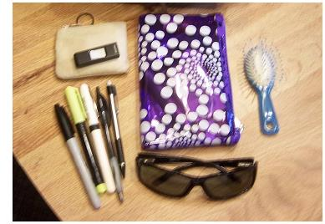
The last compartment is the one that Hubby is especially excited about. It probably holds more than an EDC needs to, but I’m not sorry that I have its contents. I keep things organized with 4 green bags about 3” wide x 2.5” deep and 7” long. I’m not in love with the green color, but they were cheap at the Dollar Tree and the perfect size.
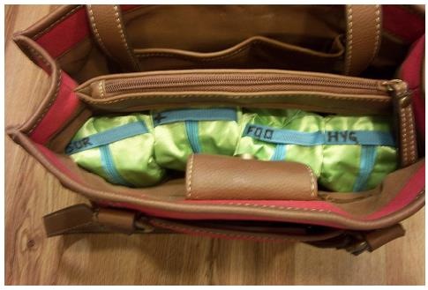
At some point, I’ll upgrade the little green bags. I’ve recently found the Cube Packing System. The ¼ Cube seems to be close to the same size, as my green bags if you’d like something similar but in a more subdued color.
Hygiene Bag
The Hygiene Bag is my travel bathroom kit that I use at work as well as for the kids. It includes a toothpaste, sunscreen, lotion, moist towels, mouthwash, foot powder, floss around a large paperclip, soap, hair clasp, deodorant, tweezers, nail clippers and a nail file.
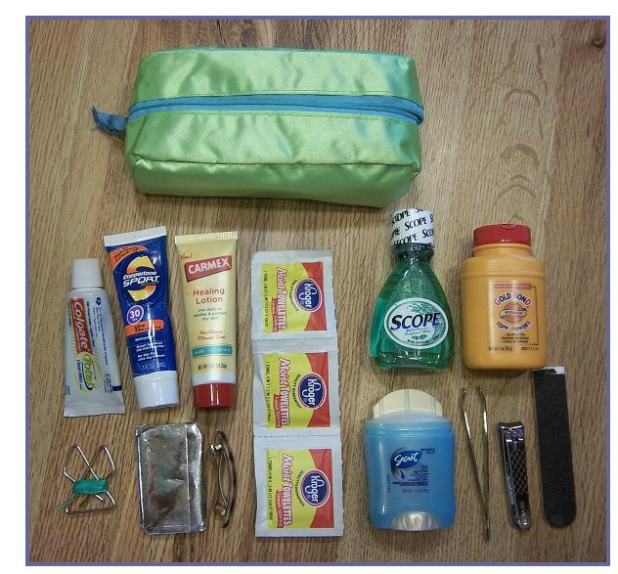
Survival Bag
The Survival Bag is my least used compartment but it provides Hubby with the level of security that he was working toward when originally encouraging my EDC habit and includes N95 masks, an emergency bivy bag, duct tape heavy-duty aluminum foil, flashlight batteries, water purification tablets, safety pins, BIC lighter, multi-tool, matches, mosquito repellent, tie wraps, rubber bands, and eye-protection. (i.e. swimming goggles)
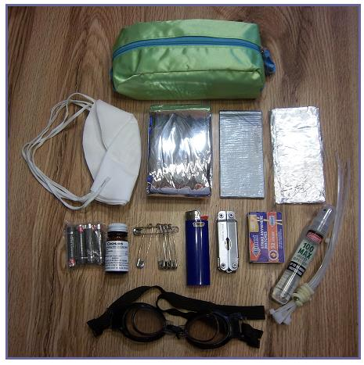
First Aid Bag
The First Aid Bag provides me with lightweight support for everything from skinned knees to an occasional cough and includes: Q-Tips, ACE Bandage, medical exam gloves, Flew-Away pills (a homeopathic blend of herbs to stop colds before they latch on). L-lysine (I get cold sores), Celox –blood stopper, a condom (no, it’s not for that type of emergency!) it’s a sterile bandage. Advil, Tylenol & Excedrin. Fiscars folding scissors, alcohol swabs, moist towel, 2”x2” gauze bandages, cough drops, triple antibiotic, butterfly closures and Band-Aids.
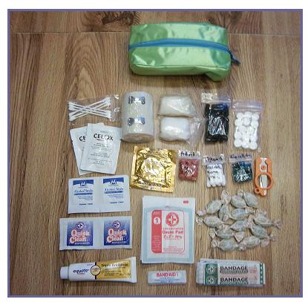
I purchased the small clear plastic bags at the craft store. They help to keep small items organized and easy to find.
Food Bag
The Food Bag is designed to tide me over when driving the Mommy-Taxi or to provide a hungry child with a snack attack, until something more is available. I carry gum, protein bars, electrolyte (Gatorade) water flavorings, Sfork, 2 lawn and leaf trash bags and several paper napkins, tea bags, and instant oatmeal.
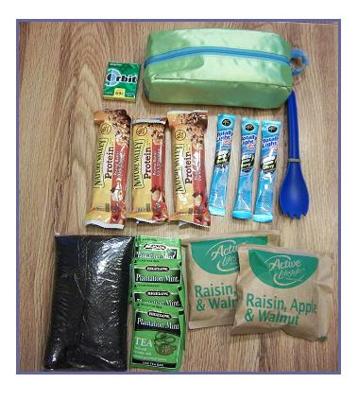
An EDC is unique to each person. What I carry is probably different than what you need or want to carry. I continue to revise it as needed items come to mind.
If you are a woman, looking to build an EDC, and you, like me share have the habit of allowing everything to amass in the bottom of the purse – you’ll be frustrated. Success is organizing like-items into small bags.
If you are a man looking to encourage your wife to carry an EDC, ditch the camo. Buy her a beautiful, well-made purse with compartments and a few lightweight useful items. She’ll come to love it and she’ll add items that are useful and appropriate to her.
MsKYprepper

