Paracord Laced Pallet, Hanging Chair
by Twotim221
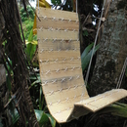

1

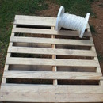

3
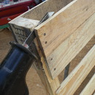

4
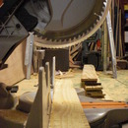

5
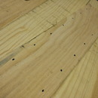

6
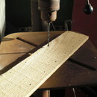

7
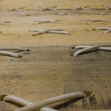

8
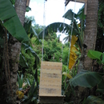

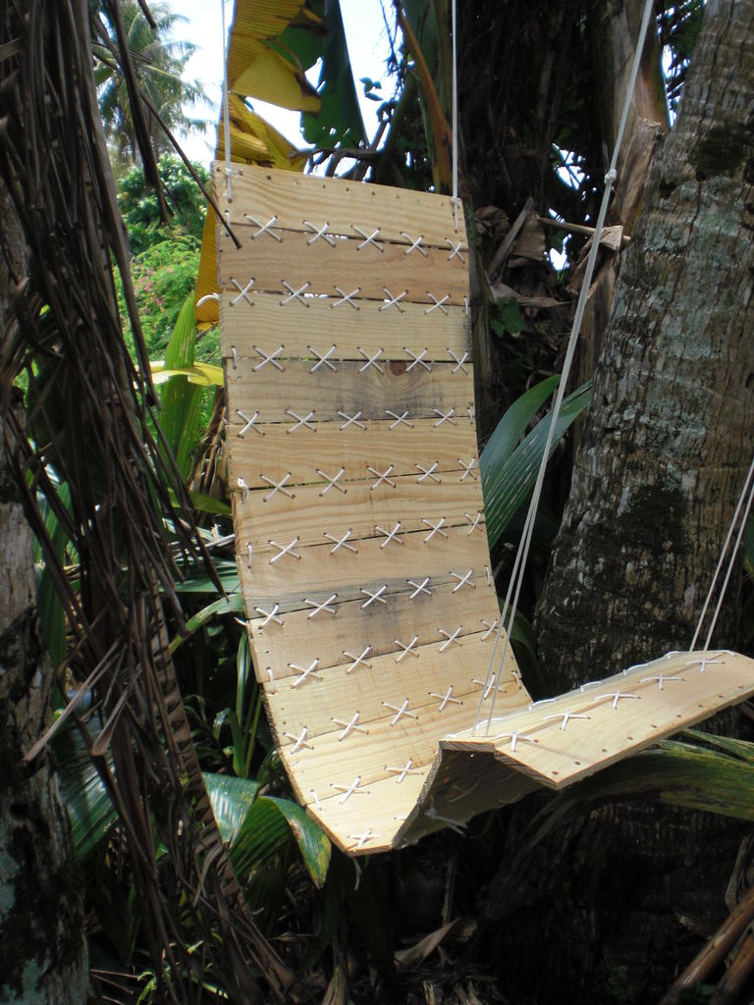

Very comfortable, very easy to make chair from a pallet and some paracord.
I know that there are a lot of different kinds of chair instructables already, but I have never seen a chair like this before. It is so easy to make and it is comfortable because it conforms to your body. I don't know how I came up with the idea and as I was making it I wasn't even sure if it would work out. But it did and I am very happy with the results. So here goes- my first instructable.
This instructable will show you everything I did to make the chair, but I am sure you will find ways you can customize yours to meet your needs.

Step 1:

Step 2: Tools and Materials

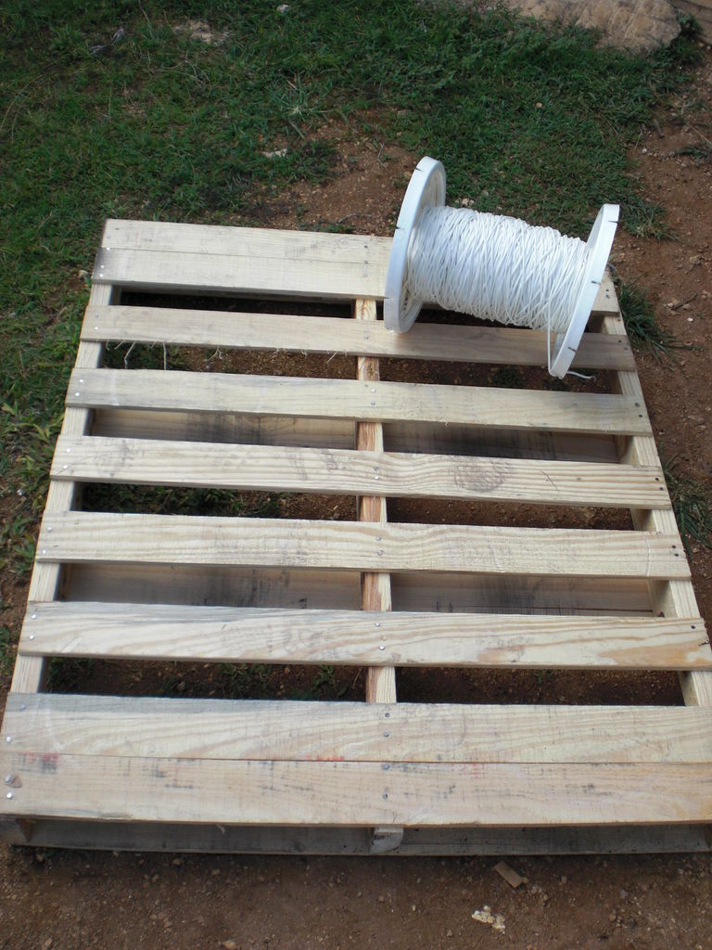

Stuff you will need-
Tools:
Drill
Saw
Lighter
Sawzall (optional)
Materials:
Paracord
Pallet (I was able to get by with just one but it all depends
on how much usable wood you can get off of each pallet)
I used pallet wood because it is hardwood and free but, as with all treated wood, you need to use precaution when handling this wood. Make sure you are wearing a mask when cutting and gloves at all times. When you are finished with all the cuts and have drilled all your holes, it is important that you seal the wood.
I used paracord because it is small yet strong and does not stretch as much as other ropes. Paracord is also easier to work with because it doesn't unravel or fray like other types of rope, and because the ends can be melted to make lacing with it easy.

Step 3: Take Pallet Apart

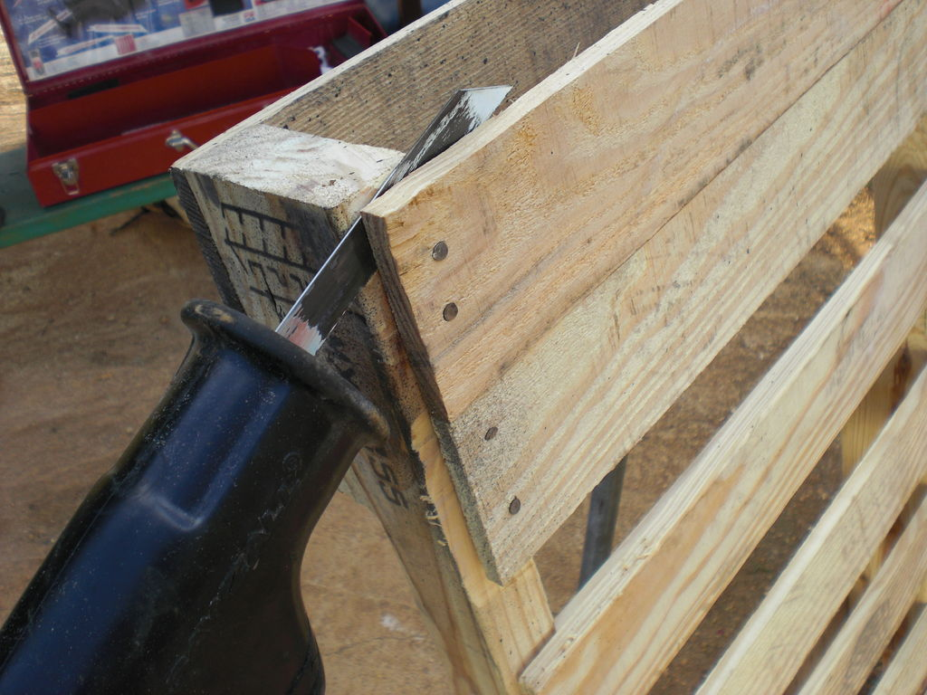

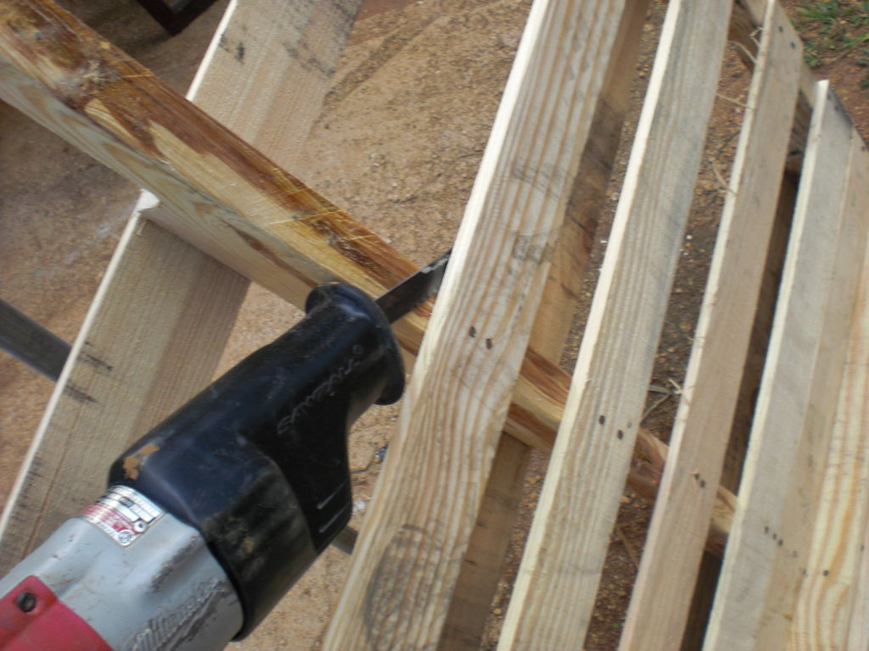

There are many different ways to take apart pallets in order to use the wood for something else. I have found that prying them apart causes a lot of damage to the wood and is a lot more work then is necessary. So, my preferred method is to cut the pieces apart using a sawzall.
All you have to do is cut through the nails that are holding it together and you are good to go (with minimal damage to the wood). If you want you can pop the remaining parts of the nails out of the wood.
Just take the sawzall and cut right between the piece you would like to save (the top piece) and the thick frame. Try to cut just the nails and not too much of the wood. Once you get the hang of it it will go really fast.

Step 4: Cutting the Wood to Size

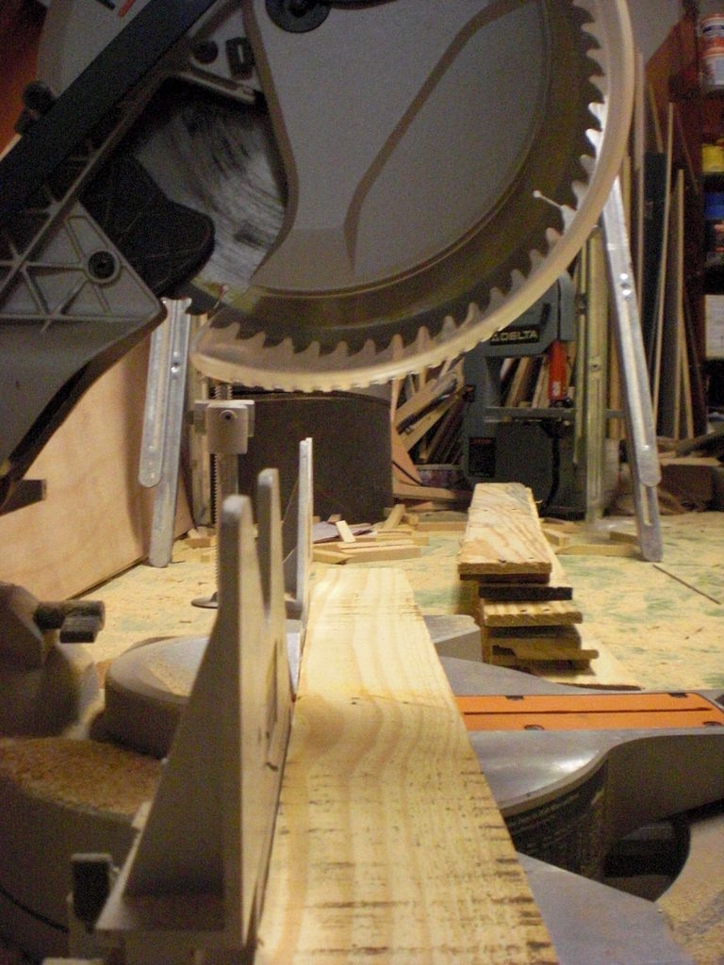

Now here is where you need to decide how wide you would like your chair. I guess you should base the size on the hiney that will be siting in it. With the pallet that I had I was able to just cut the boards right down the middle (20"). Butt the size is up to you :)
The amount of board is also up to you. I ended up using 16 boards for my chair.
Warning:
Make sure you look out for left over bits of nails in the wood as you are cutting.

Step 5: Marking Wood for Lace Holes

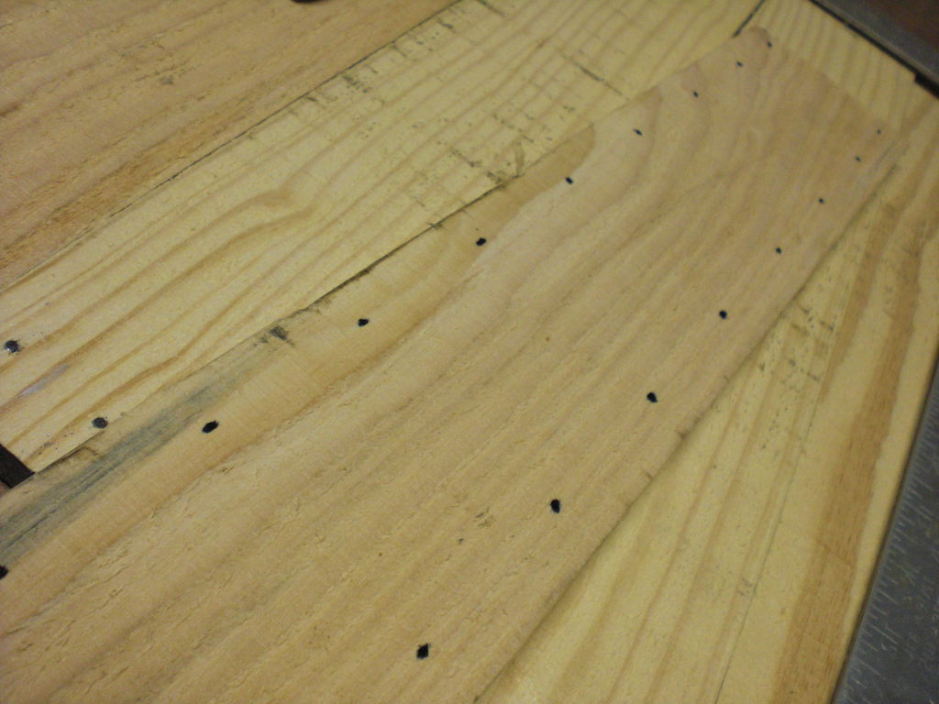

Now what you want to do is take one of the boards and mark where you want to put the laces.
I put my laces 1/2" in from the edge of the board and put them 2" apart.
Depending on how you would like yours to look you can make the laces further apart or closer together. As long as they are in far enough from the edge so that the board does not break once it has weight on it. Keep in mind also that if the laces are spaced further apart, the boards will tend to pull away from each other more, making a gap where things might get pinched (fingers, "cheeks", etc.)

Step 6: Drill the Holes

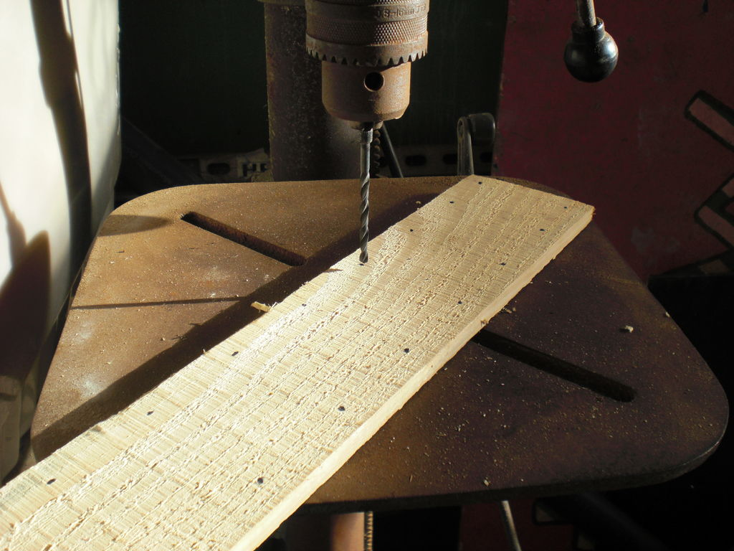

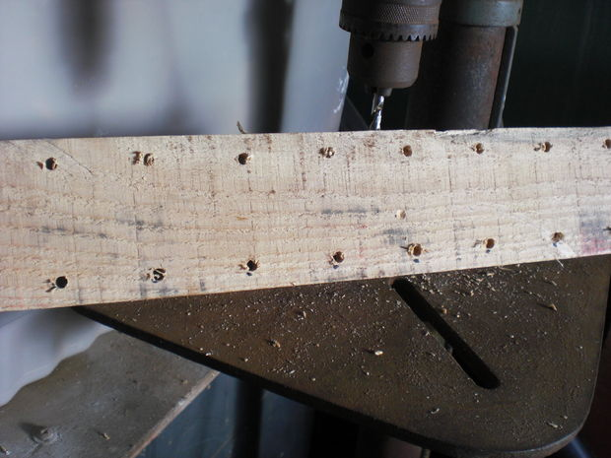
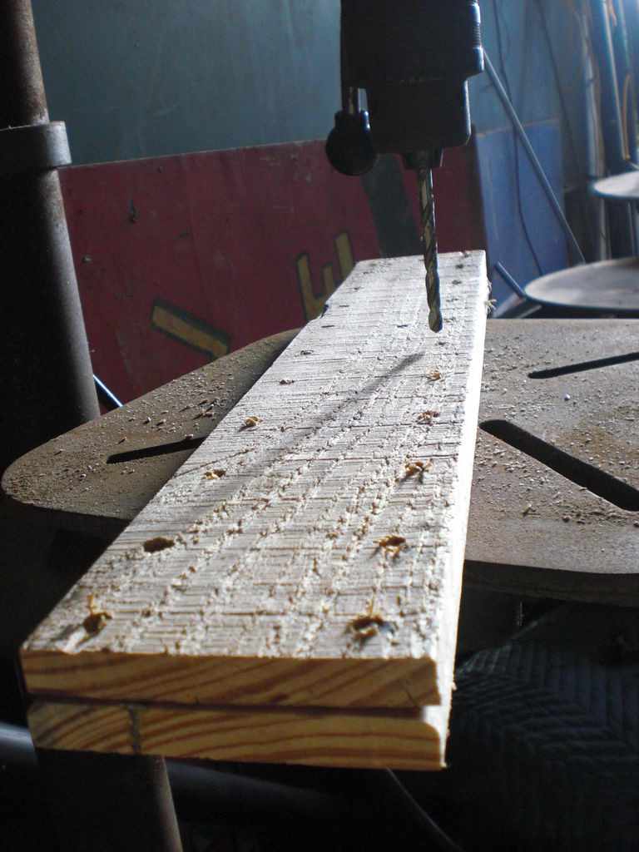

Now that you have you holes marked you can start drilling. I used a drill press but a regular drill will work just fine.
I started by drilling all the holes in my first board and then I used that board as a jig to do the rest.
You will want a drill bit that is a little bigger then your paracord so that the cord fits easily through the holes.

Step 7: Start Lacing

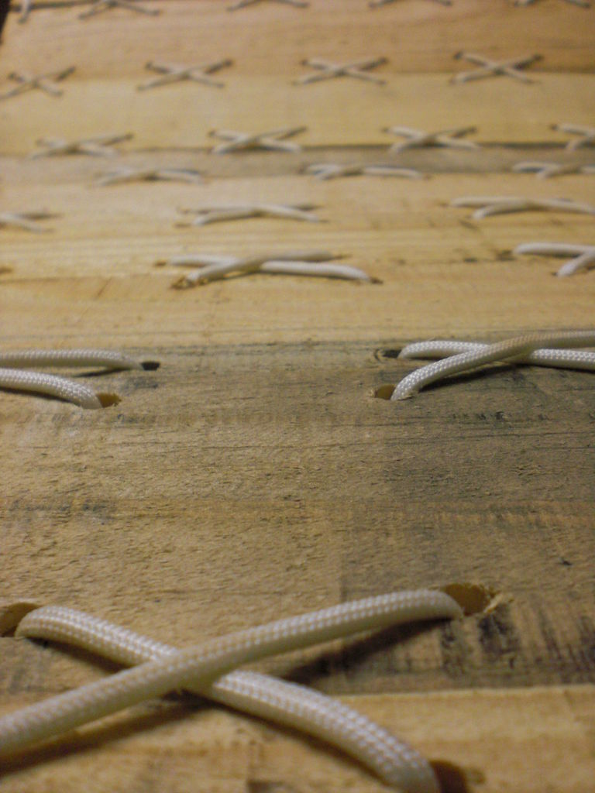

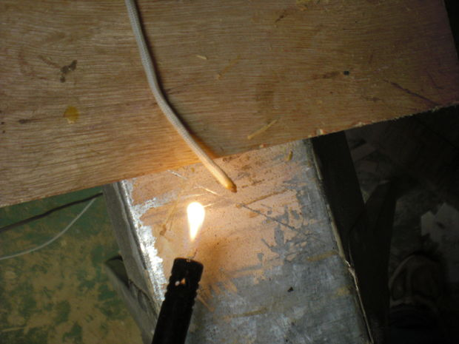
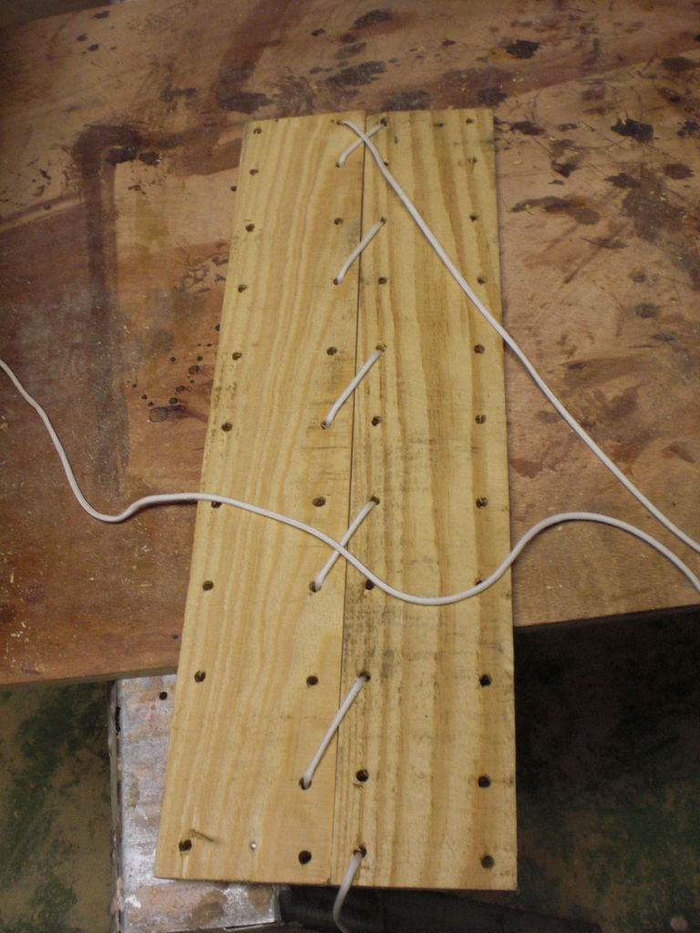

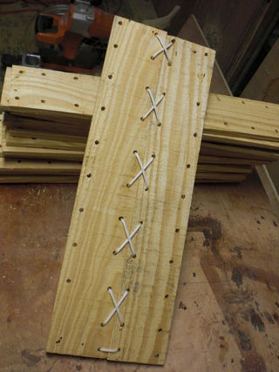

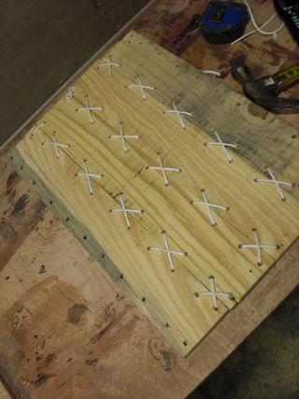

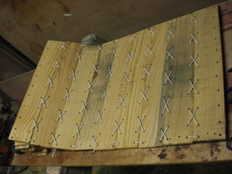

Now comes the fun part. Start by placing two of your boards next to one another. Now lace the paracord through them just as you would a pair of shoes. Once you reach the end cut the paracord, making sure you leave enough slack to tie a strong knot at the end. Now you can pull the paracord out and use it to measure the rest of the pieces you will need. When you cut the rest make sure you leave a little room for error, it's better to have too much and cut then to have too little and have to start over.
Once you have cut your paracord to size it is a good idea to melt the ends so that it is easy to get the cord through the holes.
Now you can start lacing boards together.
Things to watch as you're lacing:
-Make sure you are paying attention to what side it up and what side is down so that you end up with all the good looking sides facing up.
-It looks best to have all the knots on the bottom.
-Once you have finished a lace go back and pull each "X" to get the slack out

Step 8: Hang and Enjoy

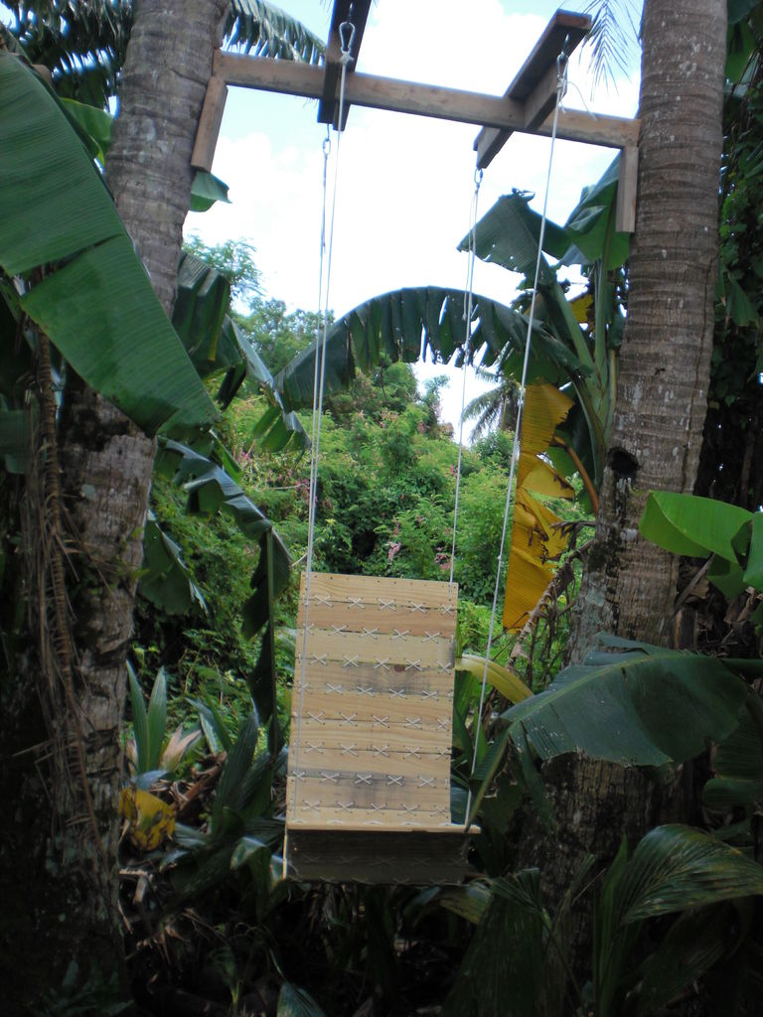

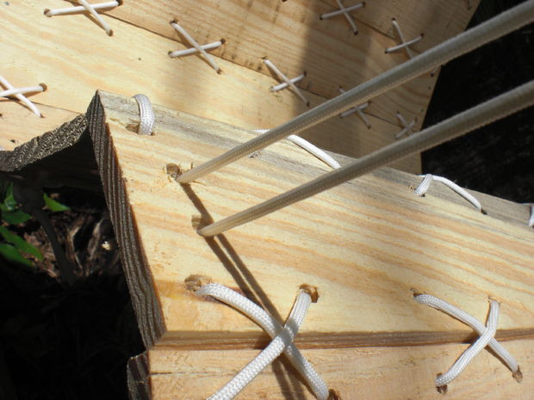




Now all you have to do is hang the chair from whatever structure you have available.
I used some 2x4's between the trees in my back yard (not the prettiest but it works).
Just drill a couple of holes in each of the four corners you would like to hang the chair from and thread the paracord through them. I put the front cords back one board from the end so that it would be more comfortable on the back of my legs.
For a somewhat laid back chair attach the front and back cords further apart from each other with the back cords low, for more of an upright chair, like mine, put them closer together with the back cords high.
The whole thing is completely adjustable to your liking,so tweak it till it's comfortable for you.
Note: I used two strands of paracord per corner, which is strong enough to hold me, but you might want to braid more together for some more strength.
-Getting into the chair can be a little tricky (kind of like getting into a hammock) but once you do relax and enjoy.

