Processing Wood Safely with Your Ax

by Todd Walker
Heating with wood warms you in three ways: harvesting, splitting, and burning. Here are few tips to warm your heart while splitting.
Sharp stuff is involved in getting round wood ready to burn. Your safety should be your main concern.
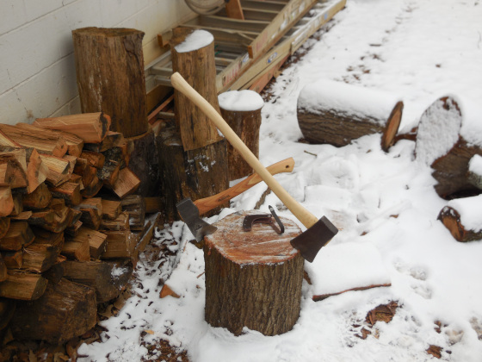
Snow in Georgia
Use a large ax to begin the splitting process. If you hate bending over to retrieve flying firewood after each swing, try this trick.
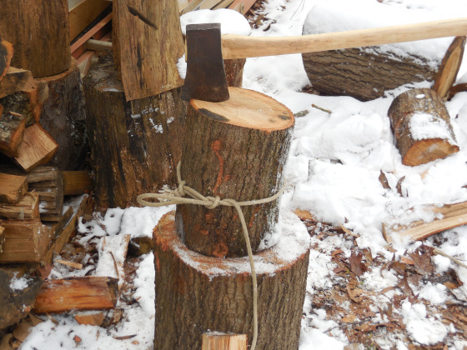
Here's the 'almost free' ax I re-handled
Place the round on your anvil (wooden chopping block). Tie a piece of rope around the wood. I use a Trucker's Hitch which is easy to tie and untie. My daddy calls this knot a 'hillbilly come-a-long'. Manny over at Survival News Online has a video tutorial if you'd like to learn to tie this knot.
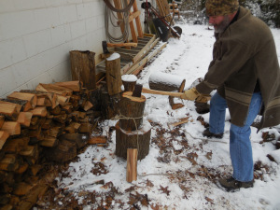
On your first strike, aim at the back edge of the round. You'll likely strike the center portion. Now turn the round with the first split perpendicular to you and begin slicing the round like a pizza. This red oak split easily with my 2# ax. Green splits easier than seasoned wood.
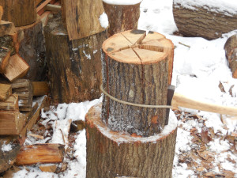
No flying firewood!
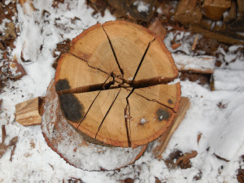
Pizza pie cut
Grab the whole bundle and dump it on the split stack.
For short, small rounds, I use a shorter ax for better accuracy.
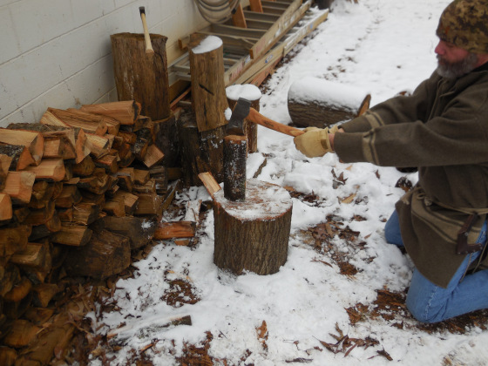
Notice that I'm on my knees with arms fully extended with a two-handed swing. The round is at the back of the anvil. If I miss or slice through the wood, my ax will strike the anvil, not my body.
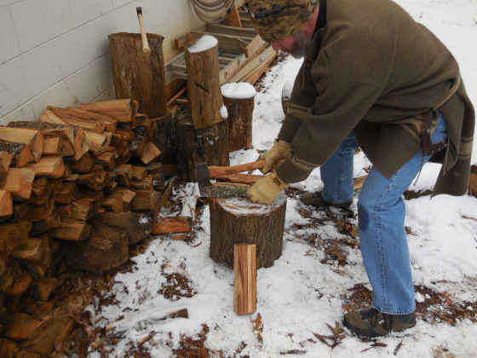
Once split, I process the other pieces flat on the far edge of my anvil. Less force is required to split.
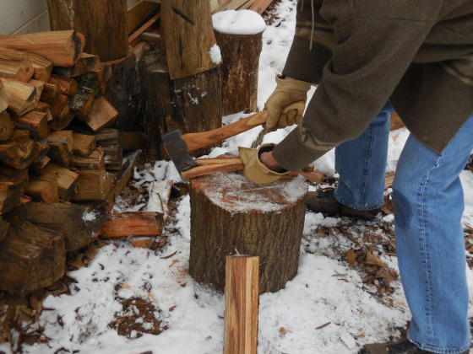
With the ax-head in the edge of the anvil, twist the wood with your off-hand to complete the split. This makes short work on kindling.
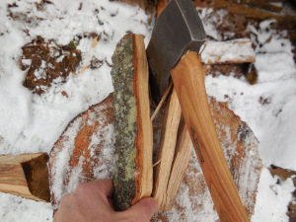
Wear gloves if you've got 'em
Another safe method is batoning. Use a piece of wood to strike the butt of your ax at the precise location you want to split. Never use a metal tool to strike your ax. Someone abused my 'almost free' ax-head using a hammer as a baton.
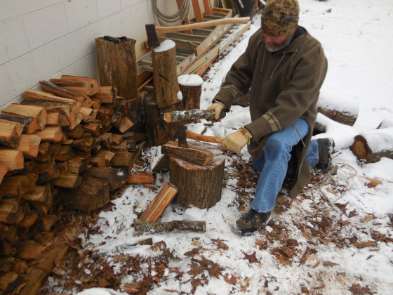
On thinner, longer rounds use the baton method for safe splitting.

