Soda Bottle Gas Mask
by Zombease
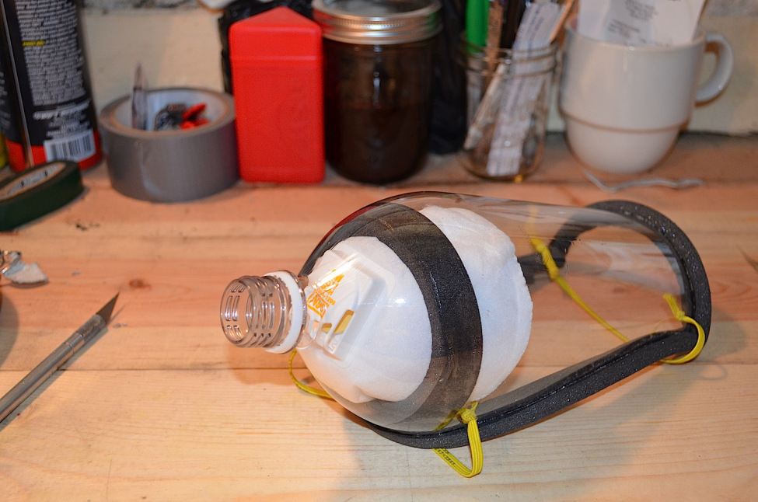
Many disasters, whether Zombie related or not, come with contamination in the air. This can be in the form of air-borne diseases and other infectious agents, chemicals, defensive sprays, smoke and particulates like ash, dust and more. Keeping your lungs clear and your mucous membranes (eyes, mouth, nose) free of these potentially harmful particulates is extremely important for both your physical comfort and long-term survival.
Luckily there is a wide variety of commercially available respirators and gas masks on the market today. These can be found at Army surplus outlets, outdoor stores, hardware stores and more. These commercially purchased respirators and masks can provide anything from mouth and nose protection to full face coverage, keeping out a number of particulates and contaminates depending on the rating and fit… but there is a downside.
Many of the masks and respirators available on the market today are on the more expensive side, even those that are designed for simple woodworking or painting, and many of them require filter cartridges that need frequent changing to be truly effective and worth wearing. While these commercial masks perform their duty beautifully when properly fitted, they may not be an option for everyone everywhere… and that’s where the Soda Bottle Gas Mask comes in.
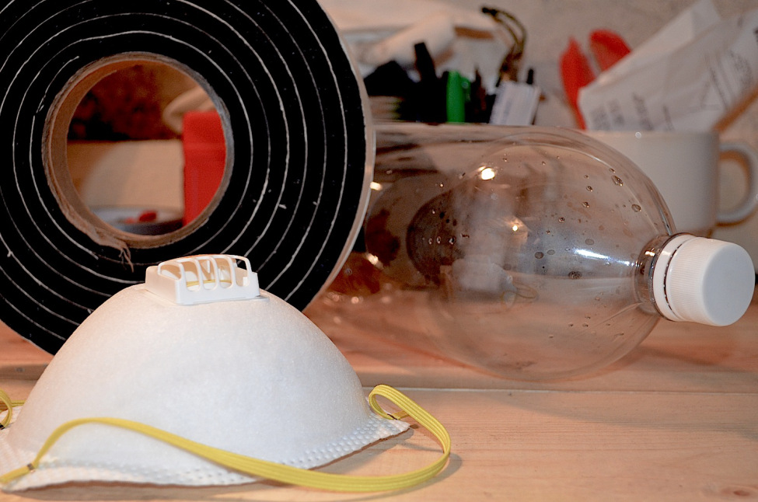
Tools: A cutting tool like a razor blade, exacto-knife or sharp scissors, glue and a permanent marker.
Materials: One 2-liter soda bottle, one roll of 1″ wide rubberized foam insulation strip, and one N95 particulate mask.
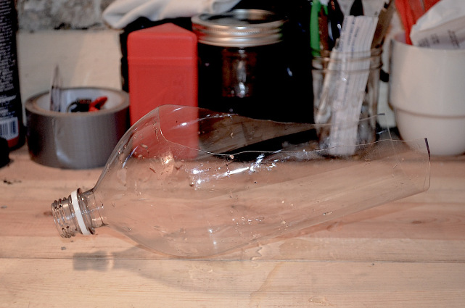
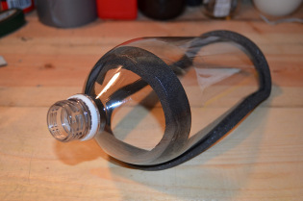
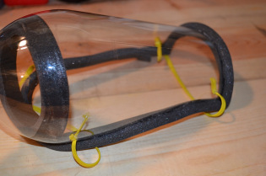
Based off of a design from a vintage DIY Gas Mask project, the Zombease Soda Bottle Gas Mask adds a few updates that, in our opinion, make a big difference. Make sure to check the end of the article for our instructional video and an important safety warning on the use of the Soda Bottle Gas mask.
Step 1. Thoroughly rinse the plastic bottle and remove the label from the outside. Use the permanent marker to draw out a U-shaped area just big enough to fit your face. You want the mask to fit snug against your face so start small and work your way up if you have to.
Step 2. Cut away the bottom of the bottle just above the start of the ridged footer area. Then carefully cut along the lines of the template to remove the U-shaped section from the bottle. This is a good point to clean away and dry any remaining residue from the inside of the bottle. Once you have the basic shape defined, hold the bottle up to your face to make sure it fits well. Make any necessary adjustments for an optimal fit. Again, you want it to be tight, but not uncomfortable.
Step 3. Using a single length of insulation, fold it over the edges of the bottle a little at a time until you work your way back to the beginning. Over-lap the insulation by at least 1/2″ to get a complete and secure seal. Make a circle of insulation inside the bottle roughly 2″ up from the spout. This will serve as a resting place for the N95 mask.
Step 4. Carefully remove the 2 elastic bands and metal bridge from the N95 mask. Set the elastic bands aside for later use, feel free to discard the metal bridge. Carefully remove the majority of the edging from the mask, leaving just enough to keep the edges sealed. Push the mask down into the neck of the bottle, angling the filter outwards and down towards the spout.
Step 5. Make 4 small holes in the sides of the mask, 2 near the top and 2 near the bottom. Feed the ends of the elastic bands through the body of the Soda Bottle Gas Mask and tie them off so they can be pulled back through. Seal the holes with a bit of glue to prevent leaks in the mask.
Step 6. Try the mask on and adjust the elastic bands as needed. When not in use, store the Soda Bottle gas mask in a well-sealed plastic bag with as much air removed as possible. This will help keep potential contaminates from working their way into the filter and reducing it’s over all effectiveness when you need it most.
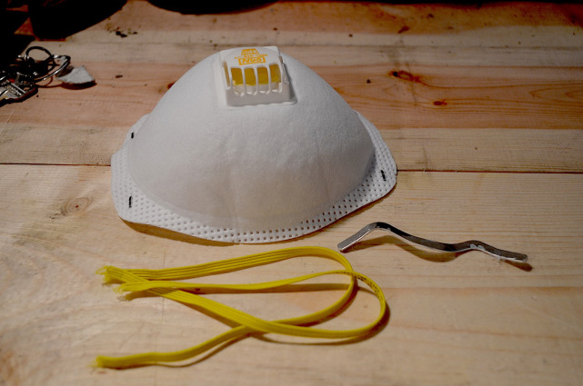
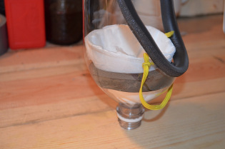
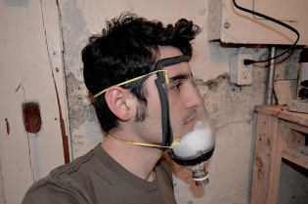
CAUTION: Contaminates such as viruses, pepper spray, tear gas, smoke, etc. can pose serious threats to the health and safety of an individual. The Soda Bottle Gas Mask should only be used during emergency situations when no other options are available and a mask of this nature is required. Zombease and the crew of Zombease can not be held responsible for improper use and/or application of the Soda Bottle Gas Mask or any potential injuries, side-effects, illness or otherwise directly or indirectly related to the use and/or application of the mask.
http://www.youtube.com/watch?feature=player_embedded&v=IjmwqXhyqA0

