Tires after an Economic Collapse‏
by FerFAL
Hi Fernando,
I’ve seen you write about criminals attacking cars using foam or other things to force a driver to stop so they could steal the car, did you ever see criminals attack a car’s tires? Also did new tires become hard to acquire or did they just go up in price like everything else did?
Sean
.
Hi Sean,
Thanks for your email. There’s actually a few things worth mentioning.
First, yes tires did become pretty expensive, even more so than in USA or Europe, especially if you wanted to get good ones and not some cheapo ones made in China.
You have to understand that once a country goes down like Argentina did after the economic collapse, there’s an amazing number of factor that come into play all at the same time and tires are just an example. A bankrupt government means very poorly kept roads. Roads fall apart surprisingly fast if not cared for. There’s potholes all over the place and are at times impossible to avoid. Sometimes they are downright craters that can not only ruin a tire or rim but break an axis as well. Suspensions need to be changed pretty frequently as well because of this. No money means no cleaning and the roads are full of all kinds of litter and debris, the chances of getting a punctured tire are pretty big. An economic collapse means people are desperate for money… including mechanics and tire shops. It was and still is pretty common for shops to “spike” the roads with nails so as to get more work repairing flat tires. At one point the roads were so full of nails you could easily get two or three flat tires a week until you realized which roads had been spiked.
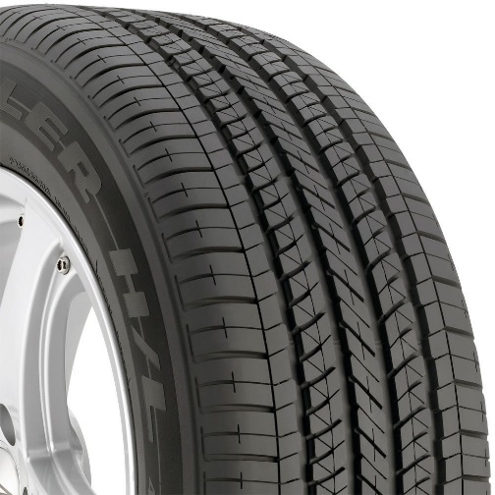
Bridgestone Dueler H/L 400 Run-flat All-Season Radial Tire
Criminals also use this same method to force you to stop and carjack you or mug you. The most sensible thing to do if you got a flat tire in an isolated part of the road was to keep driving anyway you could until you got to a gas station or more populated area so as to avoid getting attacked. Even then there were no guarantees but yes, it was a tactic commonly used by criminals as well. Maybe the most common one is to simply throw a brick through your windshield to force you to stop. People have been serious injured, even killed because of this.
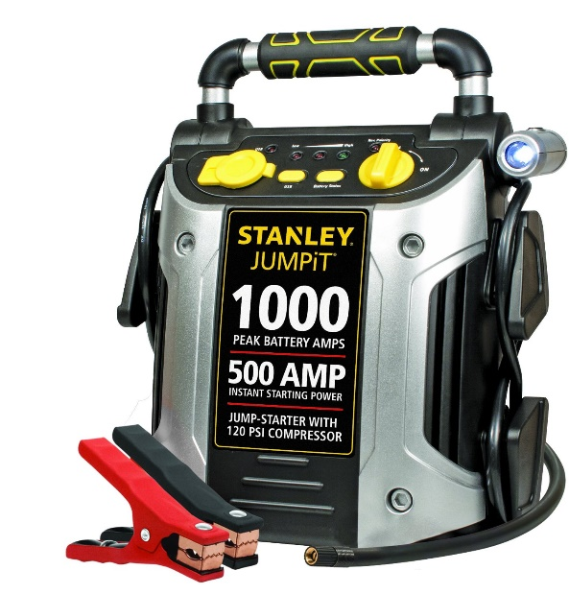
Stanley J5C09 1000 Peak Amp Jump Starter with Built in Compressor
This is yet another reason why I believe a SUV makes so much sense. A bigger car with bigger tires is more likely to have more rubber and hold on better against nails and such. If possible, I think it’s a great idea to get run flat tires just for this kind of situation. If anything, at least check your spare tire, have an inflator (or better yet a charger compressor combo like the one above) and know how to change a tire.

