Top 10 Modern Homesteader Bloggers of 2014
So many people from all over the country share their experiences and homesteading know how on blogs for us to enjoy and use their expertise to make our own homesteads a little bit better. We are so honored and humbled to present to you the 2014 Top 10 Modern Homestead Bloggers. We received hundreds of entries. And it was so difficult to narrow it down to just 10 (that is why we have an entire honorable mentions section that will be showcasing later).
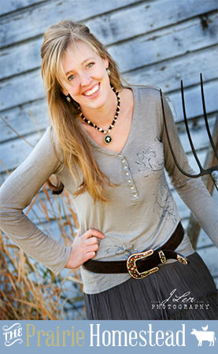
Jill Winger from The Prairie Homestead never intended to find herself growing organic veggies, milking a cow, or raising grass-fed beef, but found herself completely obsessed with the modern homesteading lifestyle after she and her husband purchased a tumble-down farmstead on the wide-open Wyoming. In 2010, she began journaling their experiences on her blog, The Prairie Homestead. She quickly discovered she wasn’t the only one enamored with chickens, mason jars, and home dairying, and the blog has grown into a vibrant community of like-minded home-steading enthusiasts all over the world.
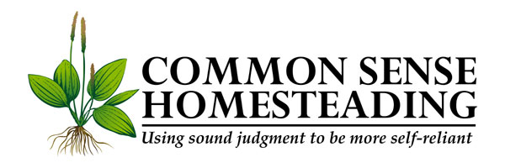
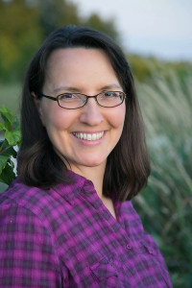
Laurie Neverman from Common Sense Homesteading has a BS in Math/Physics and an MS in Mechanical Engineering. She is a wife and mother with a passion for natural healing, homesteading and gardening. She and her husband, August, homeschool their two boys. They live in rural north-east Wisconsin in a Wisconsin Green Built and Energy Star certified home. The home has an array of “green” features, including:
- Solar Water Heating and Passive Solar Design
- An Attached Greenhouse
- Insulated Concrete Form construction
- Handicap Accessibility
- Environmentally Friendly Materials
There are also some old standbys, like a root cellar and an herbal apothecary. Her interests also include herbalism, wild crafting (using weeds for food and medicine), home brewing and live culture foods.
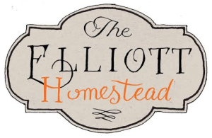
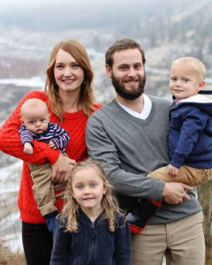
The Elliott Homestead is a blog that encompasses so many of the things that Shaye Elliott, who runs the blog, desperately loves – her bearded husband Stuart, their herd of little children, and life on the farm. They live on five acres in North Central Washington and rent that land, where they raise a dairy cow — Sally Belle — a giant flock of laying hens, meat chickens, hogs, sheep, turkeys, and a variety of produce in large, organic gardens. They farm to provide their family with as much homegrown food as possible – learning the ways of the land and the ways of the past while doing so. They preserve food, stock up the larder for winter, and are ever working towards growing more. The laundry hanging on the line may cause some to think they are old fashioned. And maybe that’s true. But Shaye is okay with that. “I wouldn’t trade this hard working farm life for anything in the world,” she said.

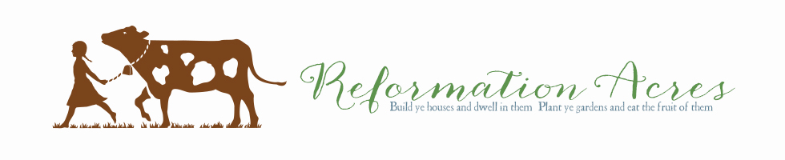
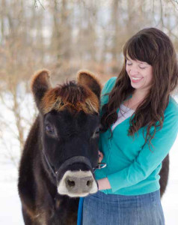
Like so many homesteads, Reformation Acres started with a chicken and the dream of an egg. What began so small has grown a 7 acre homestead in central Ohio. Quinn lives there with her family where they raise 8 children. They are devoted to living a simple agrarian life while working together to grow and raise most of their own food. They started a raw milk micro-dairy herd share last summer so others in their area could benefit from amazing, pasture-based Jersey milk.
When they’re not milking, you can find Quinn and the rest of the family in the gardens, preserving harvest, scratch cooking — seasonally! — In the cookery kitchen, rotating pasture fencing, laughing at ducks, scratching pigs’ backs or trying to find out where the free-ranging chickens are laying eggs now.

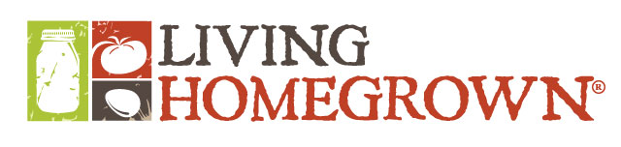
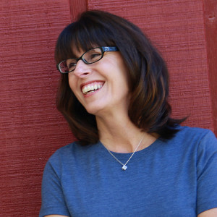
Theresa Loe from Living Homegrown didn’t grow up on a farm. Instead she came of age in Los Angles, in an average middle-class neighborhood. But, that didn’t stop her family from canning, preserving, vegetable growing and practicing other homesteading skills. Her parents, Loe said, just enjoyed that sort of “fresh-from-the-garden lifestyle” and Loe followed in their footsteps — even though it wasn’t cool when she was growing up. As a teenager, she shifted her focus from farming to engineering, following in the footsteps or her brother and father into technology. After pursuing a degree in engineering, she realized she missed that lifestyle. She still lives in LA, with two teenage boys and five chickens, but she’s growing food on a tenth of an acre while specializing in teaching homesteading on a small scale and how to can and preserve the harvest. In addition, Loe has managed to become a bit famous in the process: She’s the Co-Executive Producer for the national PBS series, “Growing where she also serves as the homesteading/canning expert on the show.
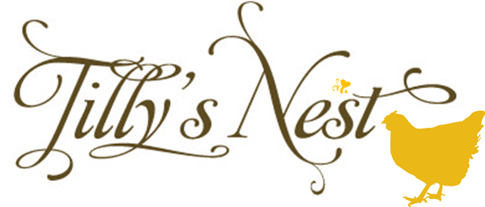
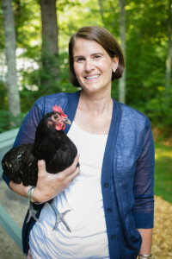
Melissa Caughey from Tilly’s Nest is another Los Angeles native, though she now calls Cape Cod, MA, home.
She lives there with her two kids, husband and a miniature schnauzer named Sara. She keeps chickens and bees, gardens and cooks. Despite all that work, she still finds time to write freelance for a variety of publications, like Country Living Magazine, HGTV, Grit, Community Chickens, and Keeping Backyard Bees. “I don’t believe you need to have a farm to enjoy homesteading, just a little bit of earth, curiosity, ideas, passion and love for getting back to the simpler joys of life,” she said.


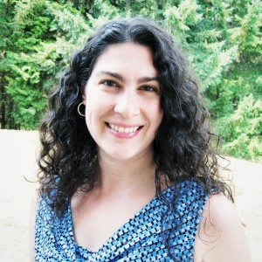
Wardee Harmon from Traditional Cooking School by GNOWFGLINS lives with her family in southwestern Oregon on 5-1/2 partially wooded acres. They raise sheep, goats and cows, along with chickens and a garden, too. “Our life is full of delicious, nutritious food, many blessings, and God’s love.” she said.
Wardee shares her life and passions through her Traditional Cooking School blog and online traditional cooking classes (plus books!). She shares her life and passions with others who love the traditional lifestyle and all the health and family benefits it brings.
Before there were factory farms and processed foods, there were nutrient-dense foods prepared traditionally.
“People of old knew how to bake with sourdough, create ‘good-for-you’ crunchy and sour pickles, make farmhouse cheeses and churn cultured butter.” Wardee said.
Wardee said her family has returned to those roots and old-fashioned skills, and she loves sharing it with others.
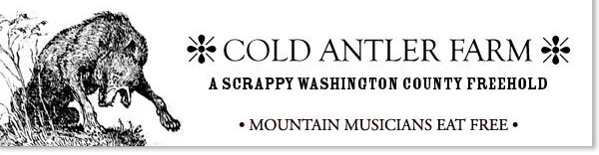
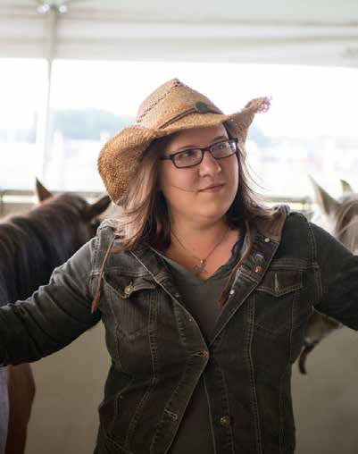
Jenna Woginrich is the curator, writer and blogger of Cold Antler. As a young writer living in Washington County, New York state, Woginrich spends her time raising animals, gardening and beekeeping.
She lends her lyrical style to a variety of topics: the Civil War, Mountain Music, local food and community of friends.
You can also watch her regular blog updates, where the young Ms. Jenna updates you on just about everything she’s doing, including fiber work and animal care. She’s currently taking care of chickens, rabbits, geese, ducks, turkeys, bees and more.
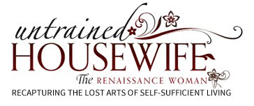
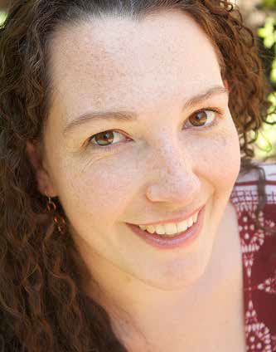
Angela England is a pro-blogger, author, speaker, and home-schooling mother of five living with her husband in Oklahoma. Angela is the Founder of Untrained Housewife, co-founder of the new Homestead Bloggers Network and managing editor of Blissfully Domestic online magazine. She is the author of Backyard Farming on an Acre (More or Less) (Alpha Books, 2013) and when she gets away from home, it’s usually to speak at a blog conference. She loves empowering others with whatever is the next step on their self-sufficiency journey but calls herself a get-it-done’ist, not a purist.
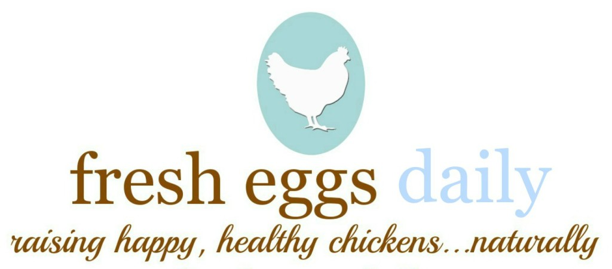
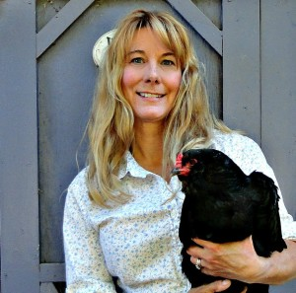
Lisa Steele, the creative mind behind the largest online natural chicken keeping resource Fresh Eggs Daily®, has been around chickens most of her life. A fifth generation chicken keeper, she returned to the country after graduating from college and doing a short stint on Wall Street. Now, happy living in the country on a farm she is truly proud to call home, Lisa encourages others to raise their own flocks naturally – without using antibiotics or chemicals. An aspiring herbalist, she incorporates herbs, weeds and edible flowers into the daily care of her flock and shares this advice on her blog and Facebook pages Fresh Eggs Daily and Duck Eggs Daily. She also shares recipes using fresh eggs and garden produce, DIY crafts and repurposing ideas. In her free time she also enjoys baking, gardening, knitting, canning and sewing. Lisa currently has a flock of a dozen chickens, a rooster and ten ducks. She and her husband also call two horses, a German shepherd, a Corgi and a tuxedo barn cat ‘family’ on their 6-acre farm in Virginia.

