Uses for Pine

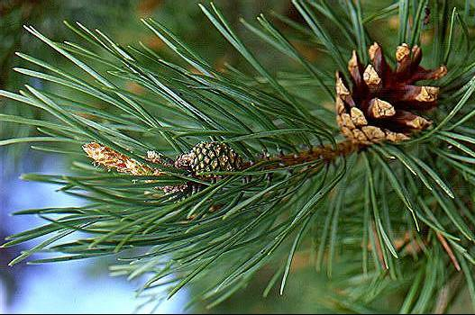

Pine (Pinus L.)
Description - There are about 115 species of pines worldwide, although different authorities accept between 105 and 125 species. Pines are native to most of the Northern Hemisphere. The leaves are persistent or deciduous, linear or needle-like. The bark is smooth tp scaly or farrowed. And the pine cones are the fruit. But because there are some many different kinds It is hard to do a basic description.
Time of Year: All year round
Location: All of North America
Click Here for map If it does not grow in your area do a search to see what kind does
USES
Cones, bark, inner bark, sap and needles
Pine sap has a lot of uses Click Here to learn how to extract it and many more of its uses
And Pine Pollen harvesting time is now (spring) learn about that Here
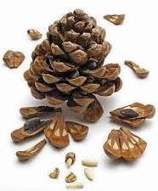
Editable uses
- Pine nuts can be harvested from the cones and used in cooking and baking (I LOVE PINE NUTS)
- The inner bark can be eaten raw and slices up as a snack
- The inner bark can be ground to a powder and added to soups and stews
- The powder of the inner bark can also be made into Bark Bread (many trees inner bark can be made into flour)
- The needles can be boiled in a tea for a Vitamin A and C drink
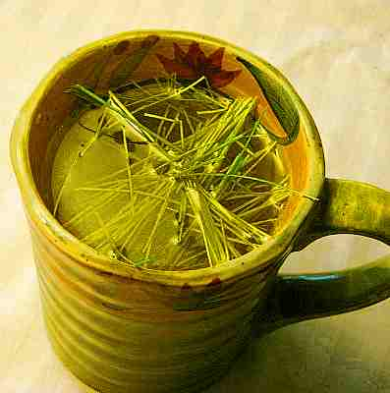

Medical Uses
- Tea from the needles help with soar throats and coughs and scurvy (me matey) PS they still use it in cough syrup
- Asthma tea...best stuff because it help with the body get rid of phlegm.
- Inner bark can be used as a poultice on the chest in treating strong colds. Not to mention that it can be applied to cuts and wounds because of its antiseptic quality's
- Pine tar soap works wonders on poison sumac, Ivy and oak!! I love the stuff!!
- Works wonders on acne, cuts burns
- Help with inflammation in a tincture form. Sprains, arthritis
- Saw dust ground down to a powder works wonders on chaffing and baby's bottoms.
- The tea from the needles and the inner bark helps with bladder issues and kidney issues.
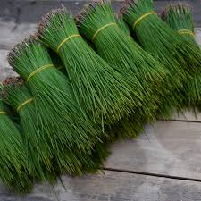

Other Uses
- Green and tan Dye are made from the needles
- Make bundles of the needle they make a great air freshener. And make a fire smells great to!
- You can make activated charcoal out of itclick here (in the post I have a great video on how to.) And this post actually has some other ways. Click Here
- The tar is used to make ink
- Uses in soaps and hygiene products
- Make your own glue out of it
- Sap it a great fire starter
- Pitch and resin can can be made into wax to coat boats and waterproof things

